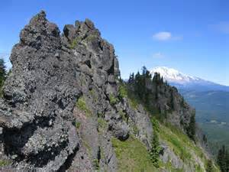

**A SUCCESS ON**

**ASSOCIATE PROJECT**

**MANAGER**

**EXAM**

**PREPARED BY: MD MOZAMMEL HOQUE, P.E.**

**NYC ENVIRONMENTAL PROTECTION**

**BUILDING MATERIALS**

**ASPHALT**

**Asphalt:** A brownish-black solid or semisolid mixture of bitumen obtained from native deposits or as a petroleum byproduct, used in paving, roofing, and waterproofing.

Mixed asphalt and crushed stone gravel or sand, used for paving or roofing.

**Asphalt tile:** A resilient, low-cost floor tile composed of asbestos fibers, finely ground limestone fillers, mineral pigments, and asphaltic or resinous binders. Requires waxing and buffing; set in mastic over wood or concrete subfloor; is not grease proof unless specially treated.

**Bitumen:** Any of various flammable mixtures of hydrocarbons and other substances, occurring naturally or obtained by distillation from coal or petroleum, that are a component of asphalt and tar and are used for surfacing roads and for waterproofing.

**Tar:** A dark, oily, viscous material, consisting mainly of hydrocarbons, produced by the destructive distillation of organic substances such as wood, coal, or peat.

**Asphalt emulsion slurry seal:** A mixture of slow-setting emulsified asphalt, fine aggregate, and mineral filter, with water added to produce a slurry consistency. Used on a slippery surface that requires a skid resistance surfacing material.

**Fog seal:** A very light spray application of SS1h emulsified asphalt diluted with water used on existing pavement as a seal to minimize raveling and to enrich the surface of dried out pavement. The asphalt emulsion shall be diluted with water prior to application. The dilution rate is one part of asphalt emulsion to four parts of water.

**Tack coat:** A tack coat is a very light application of asphalted emulsion or paving asphalt on an existing pavement surface. A tack coat is used to ensure a good bond between the existing pavement surface and the new asphalt concrete overlay and between the layers of each lift of asphalt concrete as well as vertical surfaces that the new pavement will be placed against. Emulsion consists of three basic ingredients: paving asphalt, water, and emulsifying agent.

**Seal coat:** Seal coating is the process of applying a coal tar emulsion over an asphalt pavement to prevent oxidation damage and prolong the life of a new, structurally sound, asphalt pavement. Emulsion consists of: coal tar, sand, water, and latex additive.

**Raveling:** In a bituminous asphalt pavement, the progressive separation of aggregate particles in a pavement from the surface downward or from the edges inward.

**Density of pavement distress:** Equivalent to the extent of occurrence of the defects.

**Additional information**

● Asphalt paving should generally be applied – Over an aggregate base.

● The maximum size of aggregate in a hot mix asphalt concrete surfacing and bases allowed by Federal Highway Administration Grading A is ----- 1 ½ inch.

● The bituminous pavement condition for the purpose of overlay design includes ride quality, structural capacity, skid resistance, and surface distress.

**BRICK**

A solid masonry unit, usually of clay, molded into a rectangular shape while plastic, and then treated in a kiln at an elevated temperature to harden it, so as to give it mechanical strength and to provide it with resistance to moisture; after being removed from the kiln, the brick is said to be *burnt, hard-burnt, kiln-burnt, fired*, or *hard-fired*. Bricks laid lengthwise in a wall are called **stretchers**; bricks laid crosswise to a wall are called **headers**. The current American brick is typically about 8 inches long, 33/4 inches wide, and 21/4 inches thick.

**BRICK BONDING**

**Stretcher bond**

**Stretcher bond** (also known as **running bond**) is the most common bond in modern times, as it is easy to lay, with little waste. It is entirely composed of stretcher bricks, set in rows (or "courses") that are offset by half a brick.

[](http://upload.wikimedia.org/wikipedia/commons/1/12/Running_bond.svg)

**English bond**

**English bond** is made up of alternating courses of stretchers and headers. This produces a solid wall that is a full brick in depth. English bond is fairly easy to lay and is the strongest bond for a one-brick-thick wall. If only one face of an English bond wall is exposed, one quarter of the bricks are not visible, and hence may be of low visual quality.

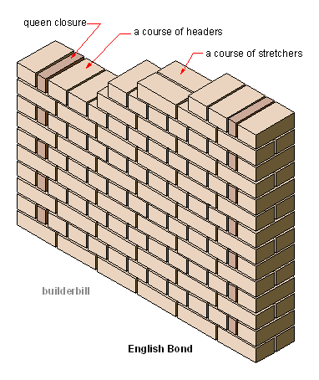

**Header bond.**

**Header bond** (also known as **Spanish bond**) was a very common bond for bearing walls. It is composed of header bricks, set in rows that are offset half a brick, which produces a solid easy to lay bond which is useful when building circular work. It is the most used bond in historical Spanish brick constructions.

[](http://upload.wikimedia.org/wikipedia/commons/5/5c/Spanish_bond.svg)

**Flemish bond**

**Flemish bond**, also known as **Dutch bond**, has historically always been considered the most decorative bond, and for this reason was used extensively for dwellings until the adoption of the cavity wall. It is created by alternately laying headers and stretchers in a single course. The next course is laid so that a header lies in the middle of the stretcher in the course below. Again, this bond is one brick thick.

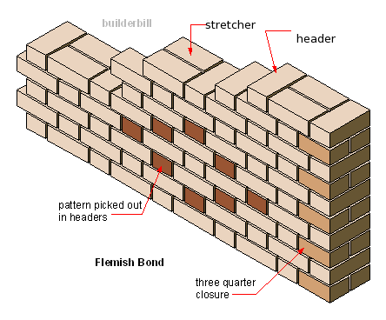

**Herringbone bond**

When bricks are laid on alternating angles, it is called a Herringbone. This is primarily a decorative style, more often used for [paving](http://en.wikipedia.org/wiki/Pavement_(architecture)) or fireplace reflectors than for walls. It is generally considered unsuitable for load-bearing structures, but may be found as [infill](http://en.wikipedia.org/wiki/Infill) in traditional [timber framed](http://en.wikipedia.org/wiki/Timber_framing) buildings. This style is also sometimes called by its Latin name: [Opus spicatum](http://en.wikipedia.org/wiki/Opus_spicatum).

[](http://upload.wikimedia.org/wikipedia/commons/e/e6/Herringbone_bond.svg)

**Basket bond**

This decorative pattern imitates the weave of a basket. It is also sometimes called **basket weave bond**, and there are many variations on the weave pattern, some very elaborate.

[](http://en.wikipedia.org/wiki/File:Basketweave_bond.svg)

**Brick positions and courses**

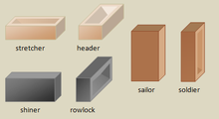

**Brick Veneer:** A facing of brick laid against the front side of an exterior wall but not bonded to it; provides a decorative, durable wall surface. Such bricks typically are laid lengthwise, so this type of construction is relatively thin, economical, and easy to lay.

|  |
| --- |
| f0139-02 |

**Wythe:** A **wythe** is a continuous vertical section of [masonry](http://www.answers.com/topic/masonry) one unit in thickness. A wythe may be independent of, or interlocked with, the adjoining wythe(s). A single wythe of [brick](http://www.answers.com/topic/brick) is referred to as a veneer.

**[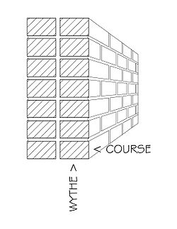](http://en.wikipedia.org/wiki/Image:Brick-terms-1.jpg)**

**Additional information**

● Face brick differs from building brick in the following way: more uniform in size and color.

● To construct an 8 inch thick masonry wall, concrete block might be selected instead of brick because it is less expensive, and faster to erect.

● No brick work below 400F.

● The minimum thickness between the core and the face of the brick shall not be less than ¾”.

**AGGREGATE**

**Fine aggregate:** That portion of an aggregate which passes through a 4.76-mm (No. 4) sieve and is predominantly retained on a 74-μm (No. 200) sieve. Natural sand and crushed stone are generally used.

**Sand:** Sand is a loose, fragmented, naturally-occurring material consisting of very small particles of decomposed rocks, corals, or shells. Sand is used to provide bulk, strength, and other properties to construction materials like [asphalt](http://www.answers.com/topic/asphalt) and concrete. It is also used as a decorative material in landscaping. Specific types of sand are used in the manufacture of glass and as a molding material for metal casting. Weight of one cubic foot dry sand is 110 pounds.

**Classification of Sand**

1. Fine sand = 0.075 to 0.425 MM  
2. Medium sand = 0.425 to 2 MM  
3. Coarse Sand = 2.0 to 4.75 MM

**Coarse aggregate:** Crushed stone or gravel used in concrete; will not, when dry, pass through a sieve with ¼-inch-diameter (6-millimeter) holes. Aggregate retained on a 4.76-mm (No. 4) sieve. Particle size between 3/8 inch and 1 ½ inch.

**Fineness Modulus:** A measure of the fineness of an aggregate; a factor obtained by adding the total percentages of an aggregate sample retained on each of the following sieves and dividing the sum by 100: No. 100 (150 μm), No. 50 (300 μm), No. 30 (600 μm), No. 16 (1.18 mm), No. 8 (2.36 mm), No. 4 (4.75 mm), 3/8 inch (9.5 mm), 3/4 inch (19.0 mm), 1½ inch (38.1 mm).

**Additional information**

● The size of coarse aggregate in a concrete mix is governed by the thickness of concrete section and space between reinforcing bars.

● In cold weather, aggregates shall be so heated that frozen lumps of ice and snow are eliminated. The use of steam jets for heating aggregates are not permitted.

● Lightweight aggregate: Perlite, Expanded shale, Pumice.

**CEMENT**

A building material made by grinding calcite limestone and clay to a fine powder, which can be mixed with water and poured to set as a solid mass or used as an ingredient in making mortar or concrete. One cubic meter of cement equals 30 bags (approximately).

**Portland cement** is the most common type of [cement](http://www.answers.com/topic/cement) in general use around the world, as it is a basic ingredient of [concrete](http://www.answers.com/topic/concrete), [mortar](http://www.answers.com/topic/mortar-masonry), [stucco](http://www.answers.com/topic/stucco) and most non-specialty [grout](http://www.answers.com/topic/grout). It is a fine [powder](http://www.answers.com/topic/powder) produced by [grinding](http://en.wiktionary.org/wiki/grinding) Portland cement [clinker](http://www.answers.com/topic/clinker-cement) (more than 90%), a limited amount of [calcium sulfate](http://www.answers.com/topic/calcium-sulfate-1) which controls the set time, and up to 5% minor constituents (as allowed by various standards). Density is 195 pounds per cubic foot.

**Type of cement**

**Type I (Normal Portland Cement)** Portland cement is known as common or general purpose cement. It is generally assumed unless another type is specified. It is commonly used for general construction especially when making precast and precast-pre-stressed concrete that is not to be in contact with soils or ground water.

**Type II (Modified Portland Cement)** is intended to have moderate [sulfate](http://www.answers.com/topic/sulfate) resistance with or without moderate heat of hydration. This type of cement costs about the same as Type I.

**Type III** (**High Early Strength Portland Cement)** is has relatively high early strength. The concrete using this type of cement a three day compressive strength equal to the seven day compressive strength of types I and II. Its seven day compressive strength is almost equal to types I and II 28 day compressive strengths. It is usually used for precast concrete manufacture, where high 1-day strength allows fast turnover of molds. It may also be used in emergency construction and repairs and construction of machine bases and gate installations.

**Type IV** **(Low Heat Portland Cement)** Portland cement is generally known for its low heat of hydration. The strength of the [concrete](http://www.answers.com/topic/concrete) develops slowly. After one or two years the strength is higher than the other types after full curing. This cement is used for very large concrete structures, such as dams, which have a low surface to volume ratio.

**Type V ( Sulfate Resistant Portland Cement)**  is used where sulfate resistance is important. This type is used in concrete that is to be exposed to [alkali](http://www.answers.com/topic/alkali) soil and ground water [sulfates](http://www.answers.com/topic/sulfate) which react with (C3A) causing disruptive expansion.

**Setting time of cement**

● Initial setting time should not be less than 45 minutes.

● Final setting time should not be more than eight hours.

**Additional information**

● Cement is composed primarily of Clay and Limestone heated to fusion.

● Cement in packages shall not be piled to a height exceeding 7 feet.

● Compressive strength of cement should not be less than 3,500 psi at 28 days.

**CONCRETE**

Concrete is a [hardened](http://www.answers.com/topic/hardened-2) building material created by combining a chemically inert mineral [aggregate](http://www.answers.com/topic/aggregate) (usually sand, [gravel](http://www.answers.com/topic/gravel), or crushed stone), a [binder](http://www.answers.com/topic/binder) (natural or synthetic cement), chemical additives, and water. Structural concrete normally contains one part cement to two parts fine mineral aggregate to four parts [coarse](http://www.answers.com/topic/coarse) mineral aggregate, though these proportions are often varied to achieve the strength and flexibility required in a particular setting. Weight of one cubic foot concrete is 150 pounds.

**Reinforced concrete:** Concrete in which steel is embedded in such a manner that the two materials act together in resisting forces. The reinforcing steel — rods, bars, or mesh — absorbs the tensile, shear, and sometimes the compressive stresses in a concrete structure. Plain concrete does not easily withstand tensile and shear stresses caused by wind, earthquakes, vibrations, and other forces and is therefore unsuitable in most structural applications. In reinforced concrete, the tensile strength of steel and the compressive strength of concrete work together to allow the member to sustain these stresses over considerable spans. The invention of reinforced concrete in the 19th century revolutionized the construction industry, and concrete became one of the world's most common building materials.

**Pre-stressed concrete:** Concrete reinforced by either pretensioning or posttensioning, allowing it to carry a greater load or span a greater distance than ordinary [reinforced concrete](http://www.answers.com/topic/reinforced-concrete). In pretensioning, lengths of steel wire or cables are laid in the empty mold and stretched. The concrete is placed and allowed to set, and the cables are released, placing the concrete into compression as the steel shrinks back to its original length. In posttensioning, the steel in the concrete is stretched after the curing process. Prestressing places a concrete member in compression; these compressive stresses counteract the tensile bending stresses of an applied load.

**Air entrained concrete:** Air entrainment will help concrete resist damage from both freeze-thaw and sulfate attack by reducing permeability.

**Precast concrete:** Concrete that has been cast into a form which is later incorporated into a structure. A concrete structure may be constructed by casting the concrete in place on the site, by building it of components cast elsewhere, or by a combination of the two. Concrete cast in other than its final position is called [precast](http://www.answers.com/topic/precast).

**Cement factor:** The quantity of cement contained in a unit volume of concrete or mortar, preferably expressed as weight, but frequently given as bags of cement per cubic yard of concrete, e.g., a 6 ½-bag mix

**Workability:** That property of freshly mixed concrete, plaster, or mortar which determines the ease and homogeneity with which it can be mixed, applied, compacted, spread, or finished; **place ability**.

**Curing:** Once it is placed and compacted, the concrete must cured before it is finished to make sure that it doesn't dry too quickly. Concrete's strength is influenced by its moisture level during the [hardening](http://www.answers.com/topic/hardening) process: as the cement solidifies, the concrete shrinks. If site constraints prevent the concrete from contracting, [tensile](http://www.answers.com/topic/tensile) stresses will develop, weakening the concrete. To minimize this problem, concrete must be kept [damp](http://www.answers.com/topic/damp) during the several days it requires to set and harden.

**Water-cement ratio:** Is the ratio of weight of [water](http://www.answers.com/topic/water) to the weight of [cement](http://www.answers.com/topic/cement) used in a [concrete](http://www.answers.com/topic/concrete) mix. It has an important influence on the quality of concrete produced. A lower water-cement ratio leads to higher strength and durability, but may make the mix more difficult to place. Placement difficulties can be resolved by using [plasticizer](http://www.answers.com/topic/plasticizer). The water-cement ratio is independent of the total cement content (and the total water content) of a concrete mix. Generally used as 0.4.

**Plasticizer:** An admixture used with concrete or mortar mix to make it workable with relatively little water.

**Admixture:** A material other than water, aggregates, lime, or cement, used as an ingredient of concrete or mortar, and added to the batch immediately before or during its mixing; used as a water repellent, as a coloring agent, as a [retarder](http://www.answers.com/topic/retarder-1) or [accelerator](http://www.answers.com/topic/accelerator) (to modify its setting rate), etc.

**Retarding agent:** Used when pouring concrete in hot weather.

**Concrete Masonry Unit:** A **concrete masonry unit (CMU)** [US], **concrete block**, **cement block** or **foundation block** [US] is a large rectangular [brick](http://www.answers.com/topic/brick) used in [construction](http://www.answers.com/topic/construction). Concrete blocks are made from [cast](http://www.answers.com/topic/cast) [concrete](http://www.answers.com/topic/concrete), i.e. [Portland cement](http://www.answers.com/topic/portland-cement) and [aggregate](http://www.answers.com/topic/construction-aggregate), usually [sand](http://www.answers.com/topic/sand) and fine [gravel](http://www.answers.com/topic/gravel) for high-density blocks.

[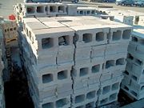](http://en.wikipedia.org/wiki/Image:Concreteblocks.jpg)

**Glass Fiber Reinforced Concrete** (**GFRC**): is a type of [fiber reinforced concrete](http://www.answers.com/topic/fiber-reinforced-concrete-1). Glass fiber concretes are mainly used in exterior building façade panels and as architectural precast concrete. This material is very good in making shapes on the front of any building and it is less dense than steel.

**Class A concrete:** 1:2:3 (4000 psi in 28 days).

**Laitance:** The accumulation of fine particles on the surface of fresh concrete resulting from an upward movement of water in the concrete; occurs when excessive water is used in the mixing of the concrete.

**Burlap:** A strong, coarsely woven cloth made of fibers of jute, flax, or hemp used to make bags and generally used for curing of concrete.

**Screed:** **A screed** is a flat board, or a purpose made aluminium tool, used to smooth [concrete](http://www.answers.com/topic/concrete) after it has been placed on a surface. Also used to assist in leveling the application of plaster.

Screeding is the process of cutting off excess wet concrete to bring the top surface of a slab to the proper grade and smoothness.

[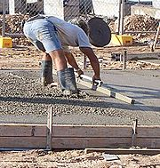](http://en.wikipedia.org/wiki/Image:Screeding-concrete.jpg)

**Slip form:** Process of pouring concrete into a moving form. The concrete has a low slump so that the concrete does not lose the shape of the form.

**Tremie:** A pipe or tube through which concrete is deposited under water, having at its upper end a hopper for filling and a bail by means of which the assembly can be handled by a derrick.

|  |
| --- |
| http://content.answers.com/main/content/img/McGrawHill/atchitecture/f1014-03.png |

**Slump test:** Determining the consistency of concrete by filling a conical mold with a sample of concrete, then inverting it over a flat plate and removing the mold; the amount by which the concrete drops below the mold height is measured and this represents the slump. Maximum slump is allowed up to 6”.

The upper diameter of slump cone is 4 inch, lower diameter is 8 inch, and height is 12 inch. Freshly mixed concrete is to be placed in 3 layers into the slump cone and each of the layers shall be temped 25 times by a 5/8 inch diameter rod.

A procedure using a [slump cone](http://www.answers.com/topic/slump-cone-1) for measuring the slump of concrete.

|  |
| --- |
| f0901-02 |

**Walking on concrete:** You can walk on concrete usually after 24 hours of pouring.

**Mixing, transporting, and handling of concrete:**

Mixing, transporting, and handling of concrete should be carefully coordinated with placing and finishing operations. Concrete should not be deposited more rapidly than it

can be spread, struck off, consolidated, and bull floated. Concrete should be deposited continuously as near as possible to its final position. In slab construction, placing should be started along the perimeter at one end of the work with each batch placed against previously dispatched concrete. Concrete should not be dumped in separate piles and then leveled and worked together; nor should the concrete be deposited in large piles and moved horizontally into final position.

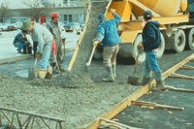

**Consolidation of concrete:** In some types of construction, the concrete is placed in forms, then consolidated. Consolidation compacts fresh concrete to mold it within the forms and around embedded items and reinforcement and to eliminate stone pockets, honeycomb, and entrapped air. It should not remove significant amounts of intentionally entrained air. Vibration, either internal or external, is the most widely used method for consolidating concrete. When concrete is vibrated, the internal friction between the aggregate particles is temporarily destroyed and the concrete behaves like a liquid; it settles in the forms under the action of gravity and the large entrapped air voids rise more easily to the surface. Internal friction is reestablished as soon as vibration stops.

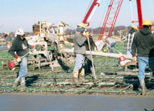

**Finishing of concrete:** Concrete that will be visible, such as slabs like driveways, highways, or patios, often needs finishing. Concrete slabs can be finished in many ways, depending on the intended service use. Options include various colors and textures, such as exposed aggregate or a patterned-stamped surface. Some surfaces may require only strikeoff and screeding to proper contour and elevation, while for other surfaces a

broomed, floated, or troweled finish may be specified. In slab construction, screeding or strikeoff is the process of cutting off excess concrete to bring the top surface of the slab to proper grade. A straight edge is moved across the concrete with a sawing motion and advanced forward a short distance with each movement.

**Compressive strength test of concrete**

A strength shall be the average of the strengths of two cylinders made from the same sample of concrete and tested at 28 days or at the test age designated for the determination of fc'.

**Relation between cylinder and cube strength of concrete:**

fc'=0.8 fck

fck=1.25 fc'  
  
fc' = strength of cylinder   
fck = strength of cube

**Additional information**

● Qualities of light weight concrete: Good thermal insulation, excellent fire resistant.

● Maximum deflection for concrete beam = L/180.

● At 500F the earliest forms can be removed in 24 hrs.

● Fresh concrete surface should be screeding, floating, brooming, and trowelling.

● Concrete that has becomes partly set in the mixer should be discarded and not used at all.

● In hot weather, newly placed concrete will set better when it is covered with wet burlap.

● The one which will lengthen the setting time of concrete is increased in proportion of water used.

● Quick drying of concrete will most likely cause cracks.

● The best way to prepare an old concrete surface for a new layer of concrete is to clean it and apply a rich cement mortar.

● Tool that is used to finish concrete so that a very smooth surface is obtained is a trowel.

● A concrete mix can be made more workable without reducing its strength by adding cement and water to the mix.

● forms for concrete are usually oiled to make stripping easier.

● The head of a bar that was used to break concrete has been redressed and tempered. This is usually bad practice because it should not be tempered.

● Concrete driveways shall have a minimum thickness of 7 inches.

● Air entraining agent: Improve the resistance of the concrete to freezing and thawing conditions.

● If a batch of concrete is very stiff, its main characteristics is that it has a low slump.

● The main difference between reinforced concrete and plain concrete is that plain concrete uses larger aggregates for reinforcing.

● The main advantage of using large coarse aggregates in a concrete mix is that there is saving of cement.

● Concrete shall not be placed exceeding 18 inches in thickness.

● Place concrete in layers not exceeding 18 inches in thickness.

● Concrete placements of 4 feet thickness or greater shall be considered mass concrete.

● With regard to the placing of concrete, the contractor is generally permitted to choose his own method of placing of concrete.

● The best reason for using vibrators in concrete construction is to consolidate the concrete.

● If there is a small amount of water on the surface of a newly laid concrete sidewalk, the recommended procedure before finishing is to allow it to evaporate.

● In the concrete for reinforced concrete, coarse aggregate greater than a specified size is not permitted primarily because large size coarse aggregate may not pass between the reinforced bars.

● Capacity of a concrete truck is, the largest usual size is 9 cubic yards, the smaller are about 3 cubic yards.

● Vermiculite concrete is a light weight concrete.

**GLASS**

**Glass** is an [amorphous](http://en.wikipedia.org/wiki/Amorphous) (non-[crystalline](http://en.wikipedia.org/wiki/Crystallinity)) [solid](http://en.wikipedia.org/wiki/Solid) material which is often transparent and has widespread practical, technological, and decorative usage in things like window panes, tableware, and optoelectronics. The most familiar, and historically the oldest, types of glass are based on the chemical compound [silica](http://en.wikipedia.org/wiki/Silicon_dioxide) (silicon dioxide), the primary constituent of [sand](http://en.wikipedia.org/wiki/Sand). The term *glass*, in popular usage, is often used to refer only to this type of material, which is familiar from use as window glass and in glass bottles.

**TYPE OF GLASS**

**Sheet Glass**

**Flat glass**, **sheet glass**, or **plate glass** is a type of [glass](http://en.wikipedia.org/wiki/Glass), initially produced in plane form, commonly used for [windows](http://en.wikipedia.org/wiki/Window), glass doors, transparent walls, and [windshields](http://en.wikipedia.org/wiki/Windshield).

[https://encrypted-tbn1.gstatic.com/images?q=tbn:ANd9GcTFznIhV0JBN4sy3YfFjtxEFZV4LIoKB8aUK5_Wa-30Q8azM_9xvkWix_c](http://www.google.com/url?url=http://www.menards.com/main/building-materials/acrylic-glass-sheeting/clear-glass/shape-products-24-x-36-clear-glass-sheet/p-1977224.htm&rct=j&frm=1&q=&esrc=s&sa=U&ei=KmUZVbe2LMuYNpbHg6AH&ved=0CDoQ9QEwBg&usg=AFQjCNF49ms38CatU7My8muQAyLCEm8bqg)

**Tempered Glass**

Tempered glass is one of two kinds of [safety glass](http://www.wisegeek.com/what-is-safety-glass.htm) regularly used in applications in which standard glass could pose a potential danger. Tempered glass is four to five times stronger than standard glass and does not break into sharp shards when it fails. Tempered glass is manufactured through a process of extreme heating and rapid cooling, making it harder than normal glass.

The brittle nature of tempered glass causes it to shatter into small oval-shaped pebbles when broken. This eliminates the danger of sharp edges. Due to this property, along with its strength, tempered glass is often referred to as safety glass.

As a result of its safety and strength, toughened glass is used in a variety of demanding applications, including [passenger vehicle](http://en.wikipedia.org/wiki/Passenger_vehicle) windows, shower doors, architectural glass doors and tables, refrigerator trays, as a component of [bulletproof glass](http://en.wikipedia.org/wiki/Bulletproof_glass), for [diving masks](http://en.wikipedia.org/wiki/Diving_mask), and various types of plates and cookware. It cannot be cut after the glass is tempered.

[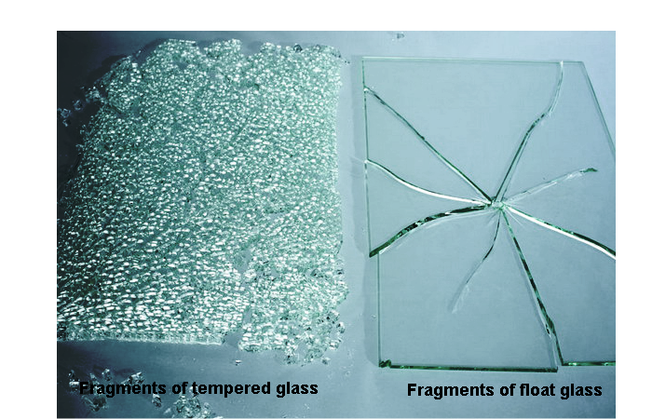](http://www.bonitaglassshoppe.com/wp-content/uploads/2014/08/tempered-glass.png)

**Patterned Glass**

Is a kind of decorative translucent glass with embossed patterns on one or both surfaces. Pattern Glass or **Decorative Glass** or Rolled Glass is generally used where privacy or obscurity is desired but light transmission is still important. With the special property of decoration, patterned glass can allow light to pass through, at the same time, it can also prevent clear view. Usually it transmits only slightly less light than clear glass.

[](http://www.bearglassnj.com/images/gallery/Clear-Flora-Pattern-Glass.jpg)

[**Reinforced glass**](http://www.klaasissepa.ee/en/products/glass/safety-glass/reinforced-glass/)

Reinforced glass has a steel wire mesh inside it to make it stonger and in some cases fireproof.  If the glass is broken, the mesh will hold the pieces together. Reinforced glass is a simple and cost-effective solution against environments such as fire and smoke.

**Float Glass**

Ninety percent of the world's flat glass is produced by the [float glass](http://en.wikipedia.org/wiki/Float_glass) process invented in the 1950s by Sir [Alastair Pilkington](http://en.wikipedia.org/wiki/Alastair_Pilkington) of [Pilkington Glass](http://en.wikipedia.org/wiki/Pilkington_Glass), in which molten glass is poured onto one end of a molten [tin](http://en.wikipedia.org/wiki/Tin) bath. The glass floats on the tin, and levels out as it spreads along the bath, giving a smooth face to both sides. The glass cools and slowly solidifies as it travels over the molten tin and leaves the tin bath in a continuous ribbon. The glass is then annealed by cooling in an oven called a [lehr](http://en.wikipedia.org/wiki/Lehr_(glassmaking)). The finished product has near-perfect parallel surfaces.



The side of the glass that has been in contact with the tin has a very small amount of the tin embedded in its surface. This quality makes that side of the glass easier to be coated in order to turn it into a mirror, however that side is also softer and easier to scratch.

Laminated glass is manufactured by bonding two or more layers of glass together with layers of [PVB](http://en.wikipedia.org/wiki/Polyvinyl_butyral), under heat and pressure, to create a single sheet of glass. When broken, the PVB interlayer keeps the layers of glass bonded and prevents it from breaking apart. The interlayer can also give the glass a higher [sound insulation](http://en.wikipedia.org/wiki/Sound_insulation) rating.

**REINFORCEMENT**

**A rebar, or reinforcing bar**, is a common [steel](http://www.answers.com/topic/steel) bar, and is commonly used in [reinforced concrete](http://www.answers.com/topic/reinforced-concrete) and reinforced [masonry](http://www.answers.com/topic/masonry) structures. It is usually formed from [carbon steel](http://www.answers.com/topic/carbon-steel-3), and is given ridges for better mechanical anchoring into the concrete. It can also be described as **reinforcement** or **reinforcing steel**.

[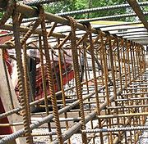](http://en.wikipedia.org/wiki/Image:Trebar.jpg)

**Grades of rebar:** The grade designation is equal to the minimum yield strength of the bar in [ksi](http://www.answers.com/topic/pounds-per-square-inch-1) (1000 psi) for example grade 60 rebar has a minimum yield strength of 60 ksi. Rebar is typically manufactured in grades 40, 60, and 75.

**Rebar Chair:**

[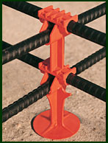](http://www.edgeworthconstruction.com/products.asp##)

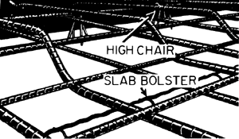

**Reinforcement Ratio:** At any section of a reinforced concrete structural member, the ratio of the effective area of the reinforcement to the effective area of the concrete.

**STRUCTURAL STEEL SECTION**

1. **Wide-flanged beam:** A structural beam of rolled steel or concrete having a shape whose cross section resembles the letter H; has wider flanges than an I-beam, designated as W. W 30 X 124 means total depth is 30 inch, and weight per foot is 124 pounds.

|  |
| --- |
| f1069-02 |
| **wide-flange beam** |

**B) American standard beam:** A type of I-beam of hot-rolled structural steel; designated by the prefix S placed before the size of the member.

**C) American standard channel:** A C-shaped structural member of hot-rolled structural steel; designated by the prefix C placed before the size of the member.

|  |
| --- |
| f0032-01 |

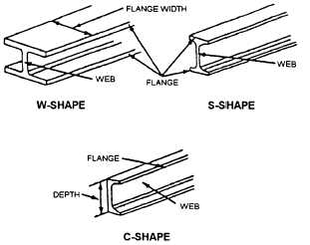

**Bending Schedule:** A chart showing the shapes and dimensions of every reinforcing bar and the number of bars required on a particular job; prepared by the designer or detailer of the reinforced concrete structure.

**Dowel:** A reinforcing bar that connects one pour of concrete to another. It may also act as a lap splicing bar to avoid having long reinforcing bars sticking out of pour.

**Wire mesh:** A series of longitudinal and transverse wires arranged at right angles to each other and welded together at all points of intersection; used as reinforcement in **reinforced concrete**. Specified in pounds per 100 square feet.

|  |
| --- |
| http://content.answers.com/main/content/img/McGrawHill/atchitecture/f1065-02.png |

**Additional information**

● Steel is most frequently used in the category of miscellaneous metal work.

● When stored on the job, open-web steel joists should be placed

– with their chords upright.

● Steel is particularly well suited for structural framing because of its relative

– strength, and low cost.

● The purpose of galvanizing iron and steel is to – protect against deterioration.

● Features applied to metal decking:

It can support normal live and dead loads.

It can serve as permanent formwork for a concrete slab.

It is generally corrugated or ribbed.

● In a 6 x 19 wire rope, 6 indicates the number of strands and 19 represents the diameter of the strands in mm.

● The structural steel shape most often used as a purlin is a Channel.

● To find the number of reinforcing bars that should be in a slab, the inspector should refer to the reinforcing steel detail drawings.

**MORTAR**

Is a workable paste formed by mixture of [cement](http://www.answers.com/topic/cement), [water](http://www.answers.com/topic/water) and fine aggregate [masonry](http://www.answers.com/topic/masonry) to bind construction blocks together and fill the gaps between them. The blocks may be [stone](http://www.answers.com/topic/rock), [brick](http://www.answers.com/topic/brick), [breeze blocks](http://www.answers.com/topic/concrete-masonry-unit) (cinder blocks), etc. Mortar is a mixture of [sand](http://www.answers.com/topic/sand), a binder such as [cement](http://www.answers.com/topic/cement) or [lime](http://www.answers.com/topic/lime-mineral), and water and is applied as a [paste](http://www.answers.com/topic/paste-4) which then sets hard. Mortar can also be used to fix, or *point* masonry when the original mortar has washed away.

**Scratch coat:** It is generally the first plaster coat. It consists of sand, plaster, and water. The first layer of plaster applied to a surface; the surface is scratched to improve the bond with the next coat.

**Brown coat/Floating coat:** The coat of roughly finished plaster beneath the finish coat; in three-coat work, the second coat of plaster, applied over a scratch coat and covered by the finish coat; in two-coat work, the base-coat plaster applied over lath or masonry; may contain a greater proportion of aggregate than the [scratch coat](http://www.answers.com/topic/scratch-coat).

**Finish coat:** The final or last coat of plaster, which provides a decorative surface or a base for decoration, usually about to 3/32 in. thick.

**Mortar strength:** Type of Mortar Compressive strength

M 2500 psi

S 1800 psi

N 750 psi

O 350 psi

K 75 psi

**Vermiculite:** A plaster using very fine exfoliated vermiculite as the aggregate; used as a fire-retardant covering on steel beams, concrete slabs, etc.

**Additional information**

● A mortar mixture of Portland cement, sand, and water, but no hydrated lime, would probably produce a mortar with – insufficient water retention.

● Vermiculite is sometimes added to a plaster mix in order to enhance the mixture’s

- fire-resistance.

● In a remodeling project, there exist a number of rough concrete basement walls that require a plastered finish.

Before plastering, metal lath should be installed over furring channels, which are firmly attached to the concrete walls, in order to provide a plumb surface with adequate bond.

● Both Keene’s cement plaster and ceramic tiles are suitable to use on the walls of an institutional shower room. One might select the plaster over the tiles because it is

- less expensive.

● No plastering below 500F.

● Mortar joint flush with brick called cut.

● Three coat plaster thickness: 1st coat (scratch coat) 3/8”, 2nd coat (brown coat) 3/8”, and 3rd coat (finish coat) 1/8”.

● In a 1 : 1.5 : 7 mortar mix, 1 represents cement, 1.5 represents lime and 7 represents sand.

● A wooden strip of mortar placed on a wall or ceiling at intervals to gage the thickness of plastering is called a Screed.

**BUILDING MATERIALS SYMBOLS**

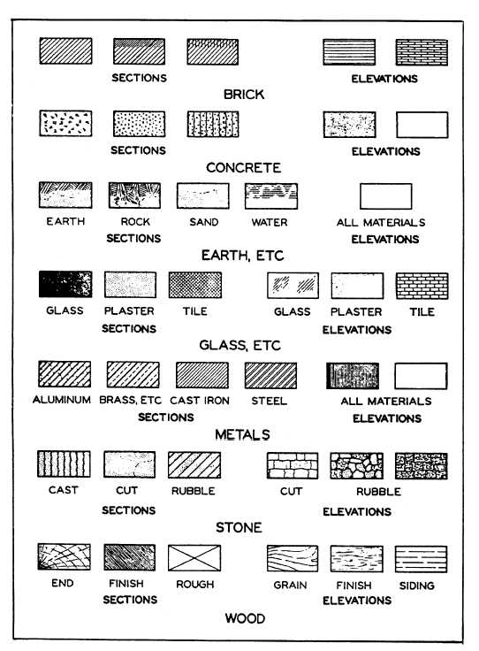

**BRIDGE COMPONENTS**

**Abutment:** Substructure unit supporting the ends of a bridge and, usually, retaining the approach embankment.

**Pier:** Intermediate support for a bridge superstructure, lying between the abutments.

**Wing Wall:** A subordinate wall, one end of which is built against an abutment; usually acts as support for the abutment and as a retaining wall.

**Approach:** Portion of the highway immediately before or after the bridge.

**Load rating:** A value that indicates the live load capacity of bridge.

**Shear connector:** Studs or similar components used to connect the concrete deck to the bridge beams, allowing them to act compositely.

**Bearing plate:** A steel slab which is placed under a beam, column, girder, or truss to distribute the end reaction from the beam to its support.

**Catwalks:** Temporary foot bridges, used by bridge workers to spin the main cables (several feet above each catwalk), and to attach the suspender cables that connect the main cables to the deck.

**Diaphragm:** Bracing that spans between the main beams or girders of a bridge or viaduct and assists in the distribution of loads.

**Gabion:** A galvanized wire box filled with stones used to form an abutment or retaining wall.

**Haunch:** The enlarged part of a beam near its supported ends that results in increased strength; visible as the curved or angled bottom edge of a beam.

**Spandrel:** The roughly triangular area above an arch and below a horizontal bridge deck. A closed spandrel encloses fill material. An open spandrel carries its load using interior walls or columns.

**Stiffener:** On plate girders, structural steel shapes, such as an angle, are attached to the web to add intermediate strength.

**Substructure:** The substructure consists of all parts that support the superstructure. The main components are:

* Abutments or end-bents
* Piers or interior bents
* Footings
* Piling

**Superstructure:** The superstructure consists of the components that actually span the obstacle the bridge is intended to cross. It includes:

* Bridge deck,
* Structural members
* Parapets, handrails, sidewalk, lighting and drainage features

# ****Web Stiffener:**** A small member welded to a beam web to prevent buckling of the web.

# 

# BUDGET

**Budget:** As an aspect of the managerial function, a budget is described as a type of management plan expressed in quantitative terms.

♦ The budget presents an estimate of expenditures to be made in future.

♦ Standards on which budgets are developed should be based primarily on analytical studies.

**Line Item Budget:** Budget typically used by governmental entities in which budgeted financial statement elements are grouped by administrative entities and object. These budget item groups are usually presented in an incremental fashion that is in comparison to previous periods. Line item budgets are used also in private industry for the comparison and budgeting of selected object groups and their previous and future estimated expenditure levels within an organization.

♦ It clearly specify what the money is buying.

**Program Budget:** Method of budgeting expenditures to meet programmatic objectives rather than on a line-item basis. In program budgeting, specific performance objectives are used in formulating systematic costs for all related functions, as opposed to totaling line-item requests. It lend itself to review and analysis. The budget includes measurable objectives.

♦ Provides the most flexibility in the use of appropriate funds.

♦ Encourages managers to relate their decisions to the agency’s long-range goals.

♦ Advantage: 1. Forces the administrator to think through his total operation. 2. Measurable objectives. 3. Closer estimates of future costs.

**Performance Budget:** Medium to short range budget used in governmental accounting. It is typical of the type incorporated by a Program Planning-Budgeting System (PPBS) but without references to long range goals. The type of budget which particularly measures input of resources as compared to output of service.

♦ Focuses primary attention upon general character and relative importance of the work to be done or the service to be rendered.

♦ Should be the identification of work programs that are meaningful for management purposes.

**Capital budget:** The budget which shows the money to be spent to build and equip a new facility. Includes rent, salaries, furniture, operating cost etc.

**Operating budget:** The budget for leasing or rental facilities.

**Factors in developing budget for the next year:**

♦ Adequacy of the current year’s budget.

♦ Changes in workload that can be anticipated.

♦ Budget restrictions indicated in the memorandum covering budget preparations.

**Cash system:** If the agency’s bookkeeping system records incomes when it is received and expenditures when the money is paid out.

**Audit:** Check on the legality of the expenditures and is based on the appropriations act.

**Allotment:** Is designed to prevent waste. Schedules of allotment is most generally the responsibility of the budget unit only.

**Purpose of quarterly allotment system:** Enable the head of the executive branch to control the rate at which the operating agencies obligate and expend funds.

**General information:**

♦ New York City’s budgeting procedure is unusual that budget appropriations are considered in two parts, as follows: expense budget and capital budget.

♦ Budget planning is most useful when it achieves cost control.

♦ Reason for budget a new calculating machine for an office: The machine would save time and money.

♦ Participation in the preparation of a Government agency’s budget should generally involved all levels of the organization.

♦ Analysis of budget estimates for the coming fiscal year is a comparison with approximations as amended for the current fiscal year.

♦ Line managers often request more funds for their unit than are actually required to attain their current objectives. Reason behind is that expectation that budget examiners will exercise their prerogative of budget cutting.

♦ The percentage of budget fund allocated to fixed overhead costs can be most effectively reduced by increasing the amount of work performed.

♦ A weakness of many budgetary system today is that they are subjectively determined by those most directly involved.

♦ Standards on which budgets are developed should be based primarily on analytical studies.

♦ After a budget has been developed, it serves to provide a yardstick against with actual costs are measured.

♦ Major objective of operational audit is recommending opportunities for improving operating and management practices.

**CHANGE ORDERS**

In [project management](http://en.wikipedia.org/wiki/Project_management), a **change order** is a component of the [change management](http://en.wikipedia.org/wiki/Change_management) process whereby changes in the Scope of Work agreed to by the Owner, Contractor and Architect/Engineer are implemented.

A change order is work that is added to or deleted from the original scope of work of a contract, which alters the original contract amount and/or completion date. A change order may fork a new project to handle significant changes to the current project.

**Common causes of change orders**

Drawings error and/or omissions.

Design changes.

Specification changes.

Unforeseen conditions.

Materials substitutions.

**CONSTRUCTION EQUIPMENTS**

**Backhoe:** A **backhoe**, also called a **rear actor** or **back actor**, is a piece of excavating equipment consisting of a digging bucket on the end of a two-part articulated arm. They are typically mounted on the back of a [tractor](http://www.answers.com/topic/tractor) or [front loader](http://www.answers.com/topic/loader-equipment). The section of the arm closest to the vehicle is known as the boom, and the section which carries the bucket is known as the dipper or dipper stick. The boom is attached to the vehicle through a pivot known as the kingpost, which allows the arm to slew left and right, usually through a total of around 200 degrees. Modern backhoes are powered by [hydraulics](http://www.answers.com/topic/hydraulics).

[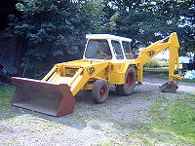](http://en.wikipedia.org/wiki/Image:S2300039.JPG)  **Bull dozer:** A heavy, driver-operated machine for clearing and grading land, usually having continuous treads and a broad hydraulic blade in front.

[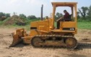](http://www.rockanddirt.com/perl/search.pl?method=detail&invnum=26839856&db=equipdb&srch=&db=equipdb&catnum=1027&make=HYUNDAI&start=&method=search)

**Cherry picker:** A machine for lifting men or materials on a platform at the end of an extendable boom; usually mounted on a carrier with wheels to provide mobility.

[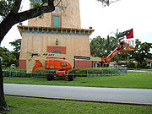](http://en.wikipedia.org/wiki/Image:Cherrypicker.jpg)

**Clamshell Bucket:** two-sided bucket used in a type of excavator to dig in a vertical direction; the bucket is dropped while its leaves are open and digs as they close. Also known as clamshell grab.

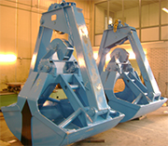

**Compaction Roller**

* 1. **Sheepsfoot roller:** A cylindrical steel drum to which knob-headed spikes are fastened;used for compacting earth. Also known as tamping roller. Used for cohesive soil.

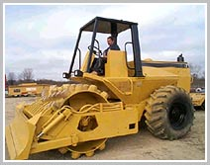

* 1. **Rubber-tired roller:** A heavy self-propelled or towed vehicle which rolls on a parallel series of pneumatic tires set on one or two axles; used to compact soil. Used for sandy soil.

[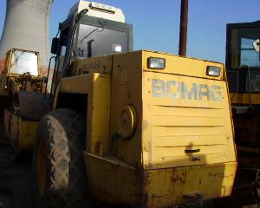](javascript:amplImg('http://www.minutemachine.com/fotosmaq/v2/13551/135375mm_1',%20700,%20525))

* 1. **Grid roller:** Towed grid rollers are suitable for medium to large scale civil engineering projects, road construction, landfill or dam compaction applications. The grid drum can be applied to compact cohesive soils such as silt, clay and their mixtures.

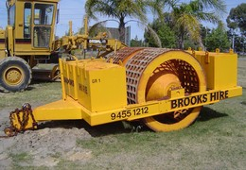

**D. Smooth-wheel Roller:** Used for final finish for the compaction.



**Concrete Pump:** A **concrete pump** is a tool for transferring liquid [concrete](http://www.answers.com/topic/concrete) by [pumping](http://www.answers.com/topic/pump). There are two main classifications of concrete pumps.

The first type of concrete pump is attached to a [truck](http://www.answers.com/topic/truck). It is known as a truck-mounted boom pump because it uses a [remote-controlled](http://www.answers.com/topic/remote-control) articulating [robotic](http://www.answers.com/topic/robot) arm (called a boom) to place concrete with pinpoint accuracy. Boom pumps are used on most of the larger construction projects as they are capable of pumping at very high [volumes](http://www.answers.com/topic/volume) and because of the [labor](http://www.answers.com/topic/work) saving nature of the robotic arm.

The second main type of concrete pump is mounted on a [trailer](http://www.answers.com/topic/trailer), and it is commonly referred to as a trailer pump or line pump. This pump requires [steel](http://www.answers.com/topic/steel) or [rubber](http://www.answers.com/topic/rubber-disambiguation) concrete placing [hoses](http://www.answers.com/topic/hose-tubing) to be manually attached to the outlet of the machine. Those hoses are linked together and lead to wherever the concrete

needs to be placed. Trailer pumps normally pump concrete at lower volumes than boom pumps and are used for smaller volume concrete placing applications such as [swimming pools](http://www.answers.com/topic/swimming-pool), [sidewalks](http://www.answers.com/topic/sidewalk-1), and single family home concrete slabs.

[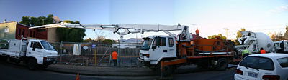](http://en.wikipedia.org/wiki/Image:Concrete_pumper.jpg)

**Concrete Transport Truck:** Special concrete transport [trucks](http://www.answers.com/topic/truck) (**in–transit mixers**) are made to transport and mix concrete from a factory/plant to the construction yard. They are charged with dry materials and water, with the mixing occurring during transport. (Although, more modern plants load the truck with 'Ready Mixed' concrete. With this process, the material has already been mixed, and then is loaded into the truck. The ready mix truck maintains the material's liquid state, through agitation, or turning of the drum, until delivery.) The interior of the drum on a concrete truck is fitted with a [spiral](http://www.answers.com/topic/spiral) [blade](http://www.answers.com/topic/blade). In one rotational direction, the concrete is pushed deeper into the drum. This is the direction the drum is rotated while the concrete is being transported to the building site. This is known as "charging" the mixer. When the drum rotates in the other direction, the [Archimedes screw](http://www.answers.com/topic/archimedes-s-screw)-type arrangement "discharges", or forces the concrete out of the drum. From there it may go onto chutes to guide the viscous concrete directly to the job site. If the truck cannot get close enough to the site to use the chutes, the concrete may be discharged into a [concrete pump](http://www.answers.com/topic/concrete-pump-1) connected to a flexible hose, or onto a conveyor belt which can be extended some distance (typically ten meters). A pump provides the means to move the material to precise locations, multi-floor buildings, and other distance prohibitive locations.

[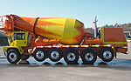](http://en.wikipedia.org/wiki/Image:1384mixer.jpg)

**Excavator:** An **excavator** is an [engineering vehicle](http://www.answers.com/topic/engineering-vehicle) consisting of an articulated arm (boom, stick), bucket and [cab](http://www.answers.com/topic/cab-1) mounted on a [pivot](http://www.answers.com/topic/pivot) (a rotating platform, like a [Lazy Susan](http://www.answers.com/topic/lazy-susan)) atop an undercarriage with tracks or [wheels](http://www.answers.com/topic/wheel). Their design is a natural progression from the [steam shovel](http://www.answers.com/topic/steam-shovel).



**Grader:** A multipurpose machine used for leveling and crowning, mixing and spreading, ditching and bank sloping, and side casting material, or for light stripping operations; not intended for heavy excavation.

|  |
| --- |
| f0469-02 |

**Scrapers:** In [civil engineering](http://en.wikipedia.org/wiki/Civil_engineering), a **wheel tractor-scraper** is a piece of [heavy equipment](http://en.wikipedia.org/wiki/Heavy_equipment) used for [earthmoving](http://en.wikipedia.org/wiki/Earthworks_(engineering)). The rear part has a vertically moveable [hopper](http://en.wikipedia.org/wiki/Hopper) (also known as the bowl) with a sharp horizontal front edge. The hopper can be [hydraulically](http://en.wikipedia.org/wiki/Hydraulics) lowered and raised. When the hopper is lowered, the front edge cuts into the [soil](http://en.wikipedia.org/wiki/Soil) or [clay](http://en.wikipedia.org/wiki/Clay) like a [cheese slicer](http://en.wikipedia.org/wiki/Cheese_slicer) and fills the hopper. When the hopper is full (8 to 34 m³ (10 to 45 yd³) heaped, depending on type) it is raised, and closed with a vertical blade (known as the apron). The scraper can transport its load to the fill area where the blade is raised, the back panel of the hopper, or the ejector, is hydraulically pushed forward and the soil or clay load tumbles out. Then the empty scraper returns to the [cut](http://en.wikipedia.org/wiki/Cut) site and repeats the cycle.

[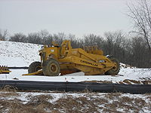](http://en.wikipedia.org/wiki/File:Scraper_in_winter.jpg)

**Power shovel:** A large, usually mobile earthmoving machine having a boom and a hinged bucket for excavating. Also called steam shovel. A power-operated machine used to excavate and load dirt, rock, or debris by means of an open-ended bucket at the end of an arm which is suspended from a boom; cables or hydraulic rams force the arm (and therefore the bucket) forward and upward, into the material; then the bucket is raised and its load is dumped.

|  |
| --- |
| f0757-02 |
| **power shovel** |

**CONSTRUCTION CONTRACT**

**Bid submission requirements:**

1. Bid Form

2. Bid Security

**Technical specifications**

● Quality of materials.

● Standard of workmanship.

● Methods of installation and erection.

● Quality control and quality assurance procedures.

**Pre-bid conference:**

Failure to attend a mandatory pre-bid conference shall constitute grounds for the rejection of bid.

**Bid evaluation and award:**

To the lowest responsible bidder whose bid meets the requirements and evaluation criteria set forth in the invitation for Bid, and whose bid price is either the lowest responsive and responsible bid price or if the invitation for bid so stated, the lowest evaluated responsive, and responsible bid price. A bid may not be evaluated for any requirement or criterion that is not disclosed in the invitation for bid.

**○ Negotiations with the apparent lowest responsive and responsible bidder:**

□ Contracting officer may elect to open negotiations with the selected bidder in an effort to improve the bid to the City with respect to the price only.

□ In the event the apparent lowest responsive and responsible bidder declines to negotiate, the contracting officer may elect to either award the contract to the apparent lowest responsive and responsible bidder or may,

upon written approval by the agency Chief Contracting Officer, reject all bids in accordance with the PPB ( Procurement Policy Board ) Rules.

**Late bids, late withdrawals and late modifications**

○ Any bid received at the place designated in the solicitation after the time and date set for receipt of bids is late and shall not be considered.

○ Any request for withdrawal or modification received at the place designated in the solicitation after the time and date set for receipt of bids is late and shall not be considered.

○ Late bids and modifications shall not be opened until after registration of the contract, because unsuccessful bid might be good.

○ The exception to this provision is that a late modification of a successful bid that makes the bid terms more favorable to the City shall be considered at any time it is received and may be accepted upon approval of the Agency Chief Contracting Officer.

**Withdrawal of bid**

○ A bidder may not withdraw its bid before the expiration of 45 days after the date of the opening of bids.

○ A bidder may withdraw his bid only in writing and in advance of an actual work.

○ If, within 60 days after the execution of the Contract, the Commissioner fails to fix the date of the commencement of work by written notice to the bidder, the bidder, at his option, may ask to be relieved of his obligation to performed the work called for by written notice to the Commissioner. If such notice is given, and request to withdraw is granted, the bidder waives all claims in connection with this Contract.

**Mistakes in competitive sealed bids**

○ Mistakes discovered before bid opening: A bidder may correct mistakes discovered before the time and date set for bid opening by withdrawing or correcting the bid.

○ Mistakes discovered after bid opening:

□ Mistakes where intended correct bid is evident: If the mistake and the intended correct bid are clearly evident on the face of the bid document, the bid shall be corrected to the intended correct bid and may not be withdrawn.

Examples are topographical errors, errors in extending unit prices, transposition errors, and arithmetical errors.

□ Mistakes where intended correct bid is not evident: Mistakes may not be corrected after bid opening. The sole remedy the bid mistake discovered after bid opening shall be withdrawal of that bid, and return of the bid bond or other security.

**Low tie bid**

○ When two or more low responsive bids from responsible bidders are identical in price, meeting all the requirements and criteria set forth in the invitation for bid, the Agency

Chief Contracting Officer will break the tie in the following manner:

□ Award to a certified New York City small, minority, or women owned business entity bidder.

□ Award to a New York City bidder.

□ Award to a certified New York State small, minority, or women owned business entity bidder.

□ Award to a New York State bidder.

○ If two or more bidder still remain equally eligible after application of rule above, award shall be made by a drawing by lot limited to those bidders. The bidders involved shall be invited to attend the drawing. A witness shall be present to verify the drawing and shall certify the results on the bid tabulation sheet.

**Rejection of bids**

○ Rejection of individual bids:

□ If the bidder fails to furnish any of the information required.

□ If the bidder is determined to be not responsible pursuant to the Procurement Policy Board (PPB).

□ if the bidder is determined to be non-responsive pursuant to the PPB.

□ If the bid, in the opinion of the Agency Chief Contracting Officer, contains unbalanced bid prices and is thus non-responsive.

○ Rejection of all bids: The Agency Chief Contracting Officer (ACCO) may reject all bids and may elect to solicit by bid or by other method authorized by the Procurement Policy Board (PPB) Rules.

**Changed conditions:**

□ Subsurface conditions at the site materially differing from any shown on the Contract

□ For the conditions which will materially affect the cost of the work to be done under the contract, the attention of the Commissioner must be called immediately to such conditions before they are disturbed. The Commissioner shall thereupon promptly investigate the conditions. If the Commissioner finds they do so materially differ, or that they could not reasonably have been anticipated by the contractor and were not anticipated by the City, the contract may be modified with the written approval.

**Reasons for breach of Construction Contract**

**•** Refusal to carry out work.

• Abandoning the site.

• Removing plant from the site.

• Failure to make payments.

• Employing others to carry out work.

• Failure to allow access to the site.

• Failure to proceed regularly and diligently.

• Failure to remove or rectify defective work.

**CONTRACT ADMINISTRATION**

● **Addendum:** A written or graphic instrument issued prior to the execution of the [contract](http://www.answers.com/topic/contract) which modifies or interprets the bidding documents, including [drawings](http://www.answers.com/topic/drawings), and [specifications](http://www.answers.com/topic/specifications-2), by additions, deletions, clarifications or corrections; becomes part of the [contract documents](http://www.answers.com/topic/contract-documents-1) when the construction contract is executed.   
● **Add-0ns:** A term commonly used in construction estimating to described the taxes, overhead, and profit added to the estimate after all other costs have been calculated.

● **Application and certificate for payment:** The document that authorizes payment to the contractor.

**● As-built drawings:** Record drawings completed by the contractor and turned over to the owner at the end of the project identifying any changes or adjustments made to the conditions and dimensions to the work relative to the original plans and specifications.

● **Back charge:** An amount of money charged against a sub-contractor for work that the general contractor performed because the sub-contractor failed to do so.

● **Call back:** A request from the owner that a contractor return to the job site to correct or redo some item of work.

● **Canvassing:** Before a contract award is made, the bids must be carefully studied and evaluated by the owner and architect-engineer, the process is referred to as canvassing.

● **Change order:** A written order to the [contractor](http://www.answers.com/topic/contractor) signed by the [owner](http://www.answers.com/topic/owner) and the [architect](http://www.answers.com/topic/architect), issued after the execution of the contract, authorizing a [change](http://www.answers.com/topic/change) in the work or an adjustment in the [contract sum](http://www.answers.com/topic/contract-sum-1) or the [contract time](http://www.answers.com/topic/contract-time-1) as originally defined by the contract documents; may add to, subtract from, or vary the scope of work. A change order may be signed by the architect alone (provided he has written authority from the owner for such procedure and that a copy of such written authority is furnished to the contractor upon request), or by the contractor if he agrees to the adjustment in the contract sum or the contract time.

● **Change order requirements:** To correct a detail of the design that contained an error or omitted information. To add scope required by the owner.  
● **Claim:** A issue that occur during construction and remains unsolved after the job is complete.

● **Closed Bid:** A competitive process in which the owner (or his representative) limits the lists of bidders on a building contract to those he has selected for bidding. Used with private projects and is not open to public.

● **Contract:** An agreement based on sufficient consideration between two or more competent parties to do or not to do something that is legal.

**● Commissioning:** A process of testing and checking all equipment and systems within the facility at the end of a project to assure proper functioning and operation.

May also include the training of owner personnel in the operation and maintenance of the equipment.

● **Contract abrogation:** Repeal the Contract by the Authority.

● **Cost overrun:** Cost overrun is defined as excess of actual [cost](http://www.answers.com/topic/cost) over [budget](http://www.answers.com/topic/budget). Cost overrun is also sometimes called "[cost escalation](http://www.answers.com/topic/cost-escalation)," "cost increase," or "budget overrun." However, cost escalation and increases do not necessarily result in cost overruns if [cost escalation](http://www.answers.com/topic/cost-escalation) is included in the budget.

● **Direct cost:** Materials, labor, equipment, and subcontracts.

● **Drawings:** The portion of the [contract documents](http://www.answers.com/topic/contract-documents-1) showing in graphic or pictorial form the design, location, and dimensions of the elements of a [project](http://www.answers.com/topic/project); usually include plans, elevations, details, and schedules, as well as graphical and pictorial portions of the [contract documents](http://www.answers.com/topic/contract-documents-1).

**● Due diligence:** The process of identifying any problems associated with the project early on so that those problem can be factored into the decision making that occurs during the pre-construction stage.

● **Field observation report (FOR):** Report any work item suspected of being installed incorrectly or failing to meet quality or safety standards.

● **Field order:** A written order to authorize minor change in the field which does not change time and cost of the project.

● **Final payment:** Documents needed for final payment are As built drawing, Operation and maintenance manuals, Product and equipment warranties, Test reports, Surplus materials, Permits, Lien waivers.

● **Indirect cost:** Supervision, temporary utilities, testing and inspection, safety supplies, cleanup, bonds and insurances, job site trailer, and security fencing etc.

● **Kick-off meeting:** A meeting at the beginning of the project or at the beginning of a major phase of the project to align peoples' understanding of project objectives, procedures and plans, and to begin the [team-building](http://www.visitask.com/team-building.asp) process.

A [kick-off meeting](http://www.visitask.com/project-kick-off-meeting.asp) is typically a workshop type meeting and it may last from 1 to 3 days. It generally include several activities such as a [project charter](http://www.visitask.com/project-charter-g.asp), a [business plan](http://www.visitask.com/Business-plan-decison-making-tool.asp) review, team building exercises, a team charter, [risk analysis](http://www.visitask.com/risk-analysis.asp) etc.

●**Lead time:** The amount of time it takes for a product or equipment to be delivered to the job site.

● **Liquidated damage:** A sum specified in a contract whereby damages in the event of breach are to be determined. In a **construction contract**, liquidated damages usually are specified as a fixed sum per day for failure to complete the **work,**  within a specified time.

● **Material safety data sheet (MSDS):** An information sheet documenting pertinent chemical information on various products used in construction.

● **Mock-up:** A model of an object in the course of design, as a section of a window or its parts; built to scale or at full size, for purposes of studying construction details, judging appearance, and/or testing performance.

● **Notice to proceed:** The owner authorizes the contractor to begin work on a project on a particular day or as soon as possible.

**● Official end of the project:** When the architect release a certificate of substantial completion.

● **Open Bid:** A competitive bidding requirements for all public projects. One that is advertised publicly and allows any qualified contractor to submit a bid.

● **Payment request process:** Request for payments are made by the contractor, to the owner via the architect on a monthly basis. Project manager is responsible for compiling the request.

● **Perspective drawings:** A three dimensional drawing representing width, length, and height of structure.

● **Procurement Policy Board (PPB):** Is a permanent agency of the City of New York whose functions are to establish comprehensive and consistent procurement policies and rules which shall be broad application throughout the City. Also set the rules to cancel the bid.

● **Quality assurance:** Addressed the quality at the process level. Deals with policies and procedures associated with hiring, training, safety, subcontracting, and procurement.

● **Quality control:** Addressed quality at the project level. Deals with conformance to the plans and specifications through submittals, mock-ups, shop drawings, inspections, and testing.

● **Quantity surveyor:** Individuals who are responsible for counting up and calculating all of the quantities of materials, labor, and equipment necessary to build a construction project.

● **Quantity take-off:** A term commonly used in the construction industry to describe the process of measuring the plans to quantifying materials, labor, and equipment.

● **Query list:** A list of questions needed clarification by an estimator as reviews the plans and specifications during the estimating process.

● **Request for information (RFI):** A written request for clarification regarding the details presented in the plans and specifications. The requests are usually made by sub-contractors through the general contractor to the architect.

● **Request for proposal (RFP):** Document sent by a potential buyer to potential vendors soliciting price quotes; also called Request for Quotation. Commonly referred to as an RFP, it includes all of the buyer's product or service requirements as well as a description of the required format, timing and content of the price quotes to be submitted. RFP's enable the buyer to ensure that all vendors have an equal understanding of the requirements and that the bids can easily be compared. This is especially important for highly complex products and services that require customization to meet the unique needs of the buyer.

● **Request for qualification (RFQ**): A document issued by the owner prior to an RFP to solicit contractor or design builder qualifications. May be used by the owner to shortlist potential proposers.

● **Resolving construction contract disputes**: Through Meditation, Mini trial, and Arbitration.

● **Responsive Bid:** A bid or proposal package that meets all of the requirements of the soliciting instruments.

● **Retainage:** In a construction [Contract](http://www.answers.com/topic/contract), money earned by a [Contractor](http://www.answers.com/topic/contractor) but not paid to the contractor until the completion of construction or some other agreed-upon date. The amount is held back as assurance for the quality of the work.

● **Schedule of values:** A budget template established early in the project against which progress payments are measured. The schedule summarizes the total project cost by the various division of work.

**● Selection of subcontractors:** Price is only one of the factors to be considered. Selected by the general contractor.

● **Shop drawings:** A shop drawing is a drawing or set of drawings produced by the [contractor](http://www.answers.com/topic/contractor), [supplier](http://www.answers.com/topic/supplier-disambiguation), [manufacturer](http://www.answers.com/topic/manufacturing), [subcontractor](http://www.answers.com/topic/subcontractor), or [fabricator](http://www.answers.com/topic/fabricator-1). Shop drawings are typically required for pre-fabricated components. Examples of these include: elevators, structural steel, trusses, pre-cast, windows, appliances, cabinets, air handling units, and millwork. Also critical are the installation and coordination shop drawings of the MEP trades of Divisions 15 and 16 such as sheet metal ductwork, piping, plumbing, fire protection, and electrical. Shop drawings are not produced by [architects](http://www.answers.com/topic/architect) and [engineers](http://www.answers.com/topic/engineer) under their contract with the owner. The shop drawing is the manufacturer’s or the contractor’s drawn version of information shown in the construction documents.[[1]](http://www.answers.com/topic/shop-drawing-1#cite_note-shopdrawing-0#cite_note-shopdrawing-0) The shop drawing normally shows more detail than the construction documents. It is drawn to explain the [fabrication](http://www.answers.com/topic/fabrication-1) and/or installation of the items to the manufacturer’s production crew or contractor's installation crews.

● **Short listing:** Narrowing the field of offers through the selection of the most qualified proposers on the basis of qualifications.

● **Soft cost:** Overhead and supervision.

● **Specifications:** A part of the [contract documents](http://www.answers.com/topic/contract-documents-1) contained in the [project manual](http://www.answers.com/topic/project-manual-1) consisting of written descriptions of a technical nature of materials, equipment construction systems, standards, and workmanship. Under the [uniform system](http://www.answers.com/topic/uniform-system-1), the **specifications** comprise sixteen **divisions.**

**● Stop order:** A formal, written notification to a contractor to discontinue some or all work on a project for reasons such as safety violations, defective materials or workmanship, or cancellation of the contract.

**● Submittals: Submittals in** [**Construction Management**](http://www.answers.com/topic/construction-management-1) are [shop drawings](http://www.answers.com/topic/shop-drawing-1), material data, and samples. Product data submittals, samples, and shop drawings are required primarily for the [architect](http://www.answers.com/topic/architect) and [engineer](http://www.answers.com/topic/engineer) to verify that the correct products will be installed on the project.

**● Substantial completion:** The point at which all punch list work has been completed and the owner can occupy or take possession of the new facility.

**●Unforseen condition:** Unknown physical conditions at the site that were not anticipated by the owner or the contractor.

● **Variance:** The cost or time difference between the actual project performance and the planned project performance.

● **Will-call:** Acts as a verbal confirmation of an order that has been placed prior to the date it is actually due to delivery. Generally made by superintendent, occurs just before the scheduled delivery date.

**● Work breakdown structure (WBS):** A work breakdown structure (WBS) in [project management](http://www.answers.com/topic/project-management) and [systems engineering](http://www.answers.com/topic/systems-engineering), is a tool used to define and group a [project](http://www.answers.com/topic/project)'s discrete work elements (or [tasks](http://www.answers.com/topic/task)) in a way that helps organize and define the total work scope of the project.

**● Working Drawings:** The final detailed drawings used for construction. Also called contract document.

● **Work package:** In [project management](http://www.answers.com/topic/project-management), a **work package** is a subset of a project that can be assigned to a specific party for execution. Because of the similarity, work packages are often misidentified as projects.

Similar to a [work breakdown structure](http://www.answers.com/topic/work-breakdown-structure), a work package is part of a Plan Breakdown Structure, representing a collection of work actions necessary to create a specific result.

**ADDITIONAL INFORMATION**

● In lieu of a performance and completion bond and labor and material bond, a contractor may deposit with the Comptroller money, or obligations of the City of New York which the Comptroller shall approve as of equal value with the amount of the performance and completion bond required.

● A percentage of the payment for a contractor is held back until the job is completed for one year. The main reason for the practice is to insure that the contractor will return to correct defective work after the job is completed.

● There are four separate major contracts on a certain building construction project. The major disadvantage of this practice, as compared to the practice of having a single contract is the difficulty in coordinating the work.

● A contract requires that the prime contractor do a certain minimum percentage of the work with his own forces. The best reason for this requirement is to discourage bidders who may not have the ability to do the job.

● In computing an extra based on the actual cost of work done, the three major items that go into the cost are Labor, material, and equipment.

● A contractor to be penalized if he exceeds a certain completion date. There is a major strike lasting a month that shuts down all construction. Under these conditions, the completion date should be made one month later than the original date.

● The most practical control the inspector or resident engineer has over the contractor when the inspector is not satisfied with the quality of the work is to discuss withholding payment on that part of the work that is unsatisfactory.

● Frequently, payments due the contractor are delayed many months because of a backlog of work in the agency. This practice is considered poor because the contractor will raise their bids in the future to compensate for the added cost.

● Provisions are made in contract for payment for certain items when delivered to the job before installation. The main reason for this practice is to prevent bottlenecks during construction.

● The four major contracts on a building project are General construction, Electrical, Plumbing & Drainage, Heating, Ventilating & Air conditioning.

● The general contractor is required to submit a progress schedule before starting work. The best reason for this requirement is to enable the inspector to determine whether the contractor is on schedule.

● In order to bind a subcontractor to its bid price, the prime contractor must provide

- Prime contractor relied on the subcontractor’s offer when making its own bid.

- Subcontractor submitted a clear and definite bid.

● Material only warranty: Is used to limit the manufacturer’s responsibility in a construction contract.

● Important difference between drawings and specifications: Specification segregate information in order to aid in forming subcontract.

● Purpose of an agreement:

- State the work to be done and the price to be paid for it.

- Specifically formalize the construction contract.

- Act as a single instrument that brings together all of the contract segments by

reference.

● Test and code requirements is usually described in the contract specifications.

● Drawings: Shows interrelation of materials, equipment, and space.

● Special warranty applies to subcontractor.

● Type of specification: Proprietary, Descriptive, Performance.

● When negotiating a cost-plus fee contract, the owner and contractor must pay particular attention to each of the following:

- A list of job costs to be reimbursable to the contractor.

- A common understanding regarding the accounting methods to be used.

- A definite and mutually agreeable subcontract letting procedure.

● Guaranty: A promise by a party called the guarantor to make the good the mistake, debt, or default of another party.

● Means of providing financial protection to contractor are Escalation clause and Escape clause.

● After a contract is awarded and work is about to begin, the contractor usually prepares and submits for approval shop or working drawings.

● When the specifications require shop tests of equipment at the manufacturer’s plant, city contracts usually require that the test data be witnessed by a representative of the city agency.

● The usual contract for board work includes a section entitled, “Instruction to bidders” which state that the contractor agrees that he has made his own examination and will make no claim for damage on account of errors or omissions.

● Changes in the general conditions of a contract are expressed in the form of supplementary conditions.

● The listing of subcontractors is often troublesome for the contractors when it comes to bidding with alternates.

● Typical rights assigned to an owner under the terms of a construction contract are:

- Inspect the work as it proceeds.

- Terminate the contract for cause.

- Retain a specific portion of the contractor’s periodic payment.

● In most states, oral purchase agreements are not enforceable when the price of goods is $500 or more.

● A retainage arrangement cannot serve an owner protection against breach of contract.

● A contractor on a large construction project usually receives partial payments based on estimates of completed work.

● Under the terms of a liquidated damages bid bond, the surety agrees to pay the entire bond amount as damages for the contractor’s default on a bid.

● A construction contract may be terminated on the grounds of the doctrine of impossibilities of performance. This can be unexpected site conditions found that make the construction impracticable.

● For a contractor, the main disadvantage associated with lump sum contracts is that adverse change in the contractor’s project costs will not be compensated.

● In a cost-plus-fee contract, it is especially important that the work must be such a nature that it can be fairly well defined and a reasonably good estimate of cost can be approximated at the time of negotiations.

● When several prime contracts are desired in a construction project, the limits of each prime contract will usually be established in the specifications.

● Historically, most costly claims have been either for delays or alleged changed conditions.

● Dispute arising between a contractor and the owing agency are inevitable.

● Document not required in invitation to bid is Plans & Specifications.

**CONTRACT TYPES**

1. **Unit price contract** – This contract type is based on anticipated quantities of items which are counted in the project in addition to their unit prices. The final price of the project depends upon the quantities required to carry out the work. Generally, this contract is suitable only for construction and supplier projects which involve accurate identification of different types of items, but not their numbers, in the contract documents.
2. **Lump sum contract** – Under this contract type, the engineer or contractor agrees to perform the specified and described project for a fixed price. This type of contract is also referred to as a “Fixed Price Contract” and is very often used in engineering contracts. A Lump Sum or Fixed Price contract is appropriate where scope and schedule of the project are defined sufficiently thus allowing the contractor or engineer to estimate the costs of the project.

Generally used by School and Housing project

1. **Cost plus contract** – The cost plus contract is an agreement which involves the buyer’s consent to pay the complete cost for material and labor in addition to the amount for contractor overhead and profit. This contract type is favored where the scope of work is highly uncertain or indeterminate in addition to the types of labor, material, and equipment being similarly uncertain in nature.
2. **Incentive contracts** – The incentive contracts feature compensation based on the contracting and/or engineering performance in accord with an agreed target – schedule, quality, and budget. Incentive contracts commonly fall into one of two common categories: Fixed Price Incentive Contracts and Cost Reimbursement Incentive Contracts.
3. **Percentage of construction contracts**- This contract type is common for engineering contracts. The compensation involved in these contracts is based on a percentage of the cost of construction.

**JOB ORDER CONTRACTING (JOC)**

**Job order contracting (JOC)** is a way for organizations to get numerous, commonly encountered construction projects done quickly and easily through multi-year contracts. JOC reduces unnecessary levels of engineering, design, and contract procurement time along with [construction project](http://en.wikipedia.org/wiki/Construction) procurement costs by awarding long-term contracts for a wide variety of renovation, repair and construction projects.

With an emphasis on partnering and team work between owners and contractors, JOC provides the methodology to execute a wide variety of [indefinite delivery, indefinite quantity](http://en.wikipedia.org/wiki/IDIQ), [fixed-price](http://en.wikipedia.org/wiki/Fixed-price_contract), multiple simultaneous orders for renovation, rehabilitation and repair work for large facilities and infrastructures.

JOC contractors are selected on qualifications and performance at a best value or low price or low bid depending on local, state or federal statutes. The JOC contractor provides “on call” construction services from concept to close-out.

**CONTRACT DOCUMENTS**

|  |  |  |  |
| --- | --- | --- | --- |
|  | **Contract Document** | **Project Manual** | **Bidding Document** |
| **Bidding Requirements** |  | **X** | **X** |
| **Contract Forms** | **X** | **X** | **X** |
| **Contract Conditions** | **X** | **X** | **X** |
| **Specifications** | **X** | **X** | **X** |
| **Drawings** | **X** |  | **X** |
| **Addenda** | **X** | **X** | **X** |
| **Contract Modifications** | **X** | **X** |  |

**DOOR COMPONENTS**

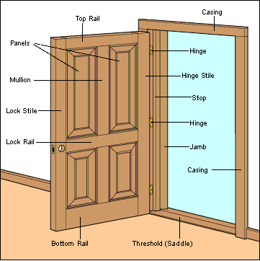

**DOOR TYPES**

[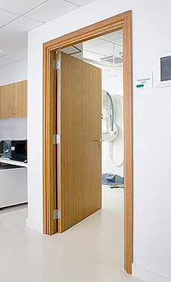](http://www.wardray-premise.com/images/products/large/doors/hinged_door.jpg) [](http://www.google.com/url?url=http://slidingdoorsrepair.com/&rct=j&frm=1&q=&esrc=s&sa=U&ei=ssj1VKLtM4K9ggTd_YKQDA&ved=0CEQQ9QEwBA&usg=AFQjCNF2aCEXsO9BLVMNIYgPSlDJX1oTsw) [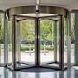](http://www.google.com/url?url=http://www.dorma.com/gb/en/products/opening_closing/revolving_curved_sliding_doors/ktv_secure_en/index-23222-23263-23266.html&rct=j&frm=1&q=&esrc=s&sa=U&ei=KMn1VJC7AYrEggSz4IPQDg&ved=0CC0Q9QEwBQ&usg=AFQjCNHRowudBlyu337tC8bw574GWmraBw)

Hinged Door Sliding Door Revolving Door

[](http://www.google.com/url?url=http://www.zebian.ae/galleries/automatic-door/&rct=j&frm=1&q=&esrc=s&sa=U&ei=mcn1VOnrHougNpe7gKgC&ved=0CB8Q9QEwAQ&usg=AFQjCNF6oh5eeeAKK4t8M-DDk7TIhdg8Jg) [](https://www.google.com/url?url=https://www.pinterest.com/dcaliendo529/french-doors-to-deck/&rct=j&frm=1&q=&esrc=s&sa=U&ei=Msr1VIOUNIilgwTAroTIAg&ved=0CDYQ9QEwAg&usg=AFQjCNFkgkyynOJxeaplhd6j2ITBP4tm5A) 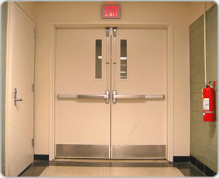Automatic Door French Door Fire Door

**Door Closer:** A device that makes use of a spring for closing, and a compression chamber from which liquid or air escapes slowly, to close a door at a controlled speed.

[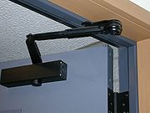](http://en.wikipedia.org/wiki/File:Door_closer_manual_dscn1666a.jpg) 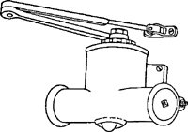

**Dead bolt:** A type of door lock; the bolt, which is square in cross section, is operated by

the door key or a turn piece.

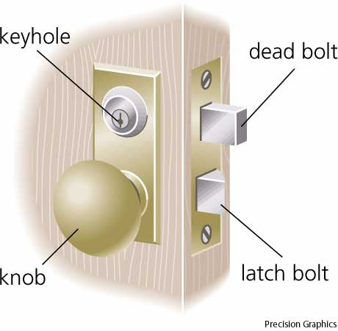

**Latch:**  Is a type of mechanical fastener that is used to join two (or more) objects or surfaces together while allowing for the regular or eventual separation of the objects or surfaces.

[](http://en.wikipedia.org/wiki/Image:Latch_lock.jpg)

**Panic bolt**

[](http://www.google.com/url?url=http://www.ironmongeryforyou.co.uk/briton-376-vertical-panic-bolt.html&rct=j&frm=1&q=&esrc=s&sa=U&ei=zTAUVZ7jE8yhgwTW4oCgCQ&ved=0CCkQ9QEwAA&usg=AFQjCNFq_IZH7Akio4H4PC8qyJ7J3OEwew)

A bar that spans an emergency exit door on its interior and opens the latch when pressure is applied.

**ELECTRICAL SAFETY**

Electrical hazards can cause burns, shocks and electrocution (death).

* Never touch a fallen overhead power line. Call the electric utility company to report fallen electrical lines.
* Stay at least 10 feet (3 meters) away from overhead wires during cleanup and other activities.
* Never operate electrical equipment while you are standing in water.
* Never repair electrical cords or equipment unless qualified and authorized.
* Have a qualified electrician inspect electrical equipment that has gotten wet before energizing it.
* If working in damp locations, inspect electric cords and equipment to ensure that they are in good condition and free of defects, and use a ground-fault circuit interrupter (GFCI).
* Always use caution when working near electricity.

**ESTIMATES**

|  |  |  |  |
| --- | --- | --- | --- |
| **Estimate Class** | **Name** | **Purpose** | **Project Definition Level** |
| Class 5 | Order of Magnitude | Screening or Feasibility | 0% to 2% |
| Class 4 | Intermediate | Concept Study or Feasibility | 1% to 15% |
| Class 3 | Preliminary | Budget, Authorization, or Control | 10% to 40% |
| Class 2 | Substantive | Control or Bid/Tender | 30% to 70% |
| Class 1 | Definitive | Check Estimate or Bid/Tender | 50% to 100% |

**EXCAVATION**

**Sheeting: 1.** Members of wood, concrete, or steel (horizontal or vertical) used to hold up the face of an excavation.   
**2.** Boards which form the surface of concrete form-work.   
**3.** Same as **sheetpiling.**  **4.** Any material in the form of sheets.   
**5.** A rock structure in which there are numerous small closely spaced fractures.

|  |
| --- |
| f0880-02 |
| horizontal **sheeting** |

**Closed sheeting:** A continuous frame with vertical or horizontal sheathing planks placed side by side to form a continuous retaining wall used to hold up the face of an excavation.

|  |
| --- |
| f0221-01 |

**Open sheeting:** Horizontal or vertical planks or boards placed at intervals along the face of an excavation; used where the soil is sufficiently firm to make close sheeting unnecessary and where groundwater is not a problem.

|  |
| --- |
| f0679-02 |

**Wellpoint:** A method of keeping an excavated area dry by intercepting the flow of [groundwater](http://www.answers.com/topic/groundwater) with pipe wells located around the excavation area. Intercepting the flow before it reaches the excavated area also improves the stability of the edge of the excavation.

Wellpoint systems are most effective in coarse-grained soils, such as [gravel](http://www.answers.com/topic/gravel) or sand. They are not effective in fine soils, such as silts and clays, where the small size of the pores between grains restricts the flow of water.

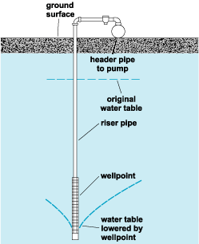  
*Components of a wellpoint system.*

The basic components of a [wellpoint](http://www.answers.com/topic/wellpoint-civil-engineering) system are the wellpoint, the [riser](http://www.answers.com/topic/riser) pipe, the [header](http://www.answers.com/topic/header) pipe or [manifold](http://www.answers.com/topic/manifold), and the pump (see illustration). The wellpoint consists of a perforated pipe equipped with a ball valve to regulate the flow of water, a screen to prevent the entry of sand during pumping, and a jetting tip. The steel riser pipe brings the groundwater to the surface, where it is collected by the horizontal manifold pipe or header pipe. The pumps are located above the water table and collect the water from the header pipes for discharge away from the excavation area.

**Additional information**

● Construction procedure for excavation generally performed in the sequence of :

Grub roots **→** Stockpile topsoil → Rough grade → Erect batter boards → Excavate.

● An excavation with a depth of 5 feet or more should be supported as per NYC Building Code.

**EXCAVATION SAFETY**

Trench (Trench excavation) means a narrow excavation (in relation to its length) made below the surface of the ground. In general, the depth is greater than the width, but the width of a trench (measured at the bottom) is not greater than 15 feet (4.6 meters).

**Dangers of Trenching and Excavation**

Cave-ins pose the greatest risk and are much more likely than other excavation-related accidents to result in worker fatalities. Other potential hazards include falls, falling loads, hazardous atmospheres, and incidents involving mobile equipment. One cubic yard of soil can weigh as much as a car. An unprotected trench is an early grave. Do not enter an unprotected trench.

**Trench Safety Measures**

Trenches 5 feet (1.5 meters) deep or greaterrequire a protective system unless the excavation is made entirely in stable rock. If less than 5 feet deep, a competent person may determine that a protective system is not required. Trenches 20 feet (6.1 meters) deep or greater require that the protective system be designed by a registered professional engineer or be based on tabulated data prepared and/or approved by a registered professional engineer.

**Competent Person**

OSHA standards require that employers inspect trenches daily and as conditions change by a competent person before worker entry to ensure elimination of excavation hazards. A competent person is an individual who is capable of identifying existing and predictable hazards or working conditions that are hazardous, unsanitary, or dangerous to workers, soil types and protective systems required, and who is authorized to take

prompt corrective measures to eliminate these hazards and conditions.

**Access and Egress**

OSHA standards require safe access and egress to all excavations, including ladders, steps, ramps, or other safe means of exit for employees working in trench excavations 4 feet (1.22 meters) or deeper. These devices must be located within 25 feet (7.6 meters) of all workers.

**General Trenching and Excavation Rules**

• Keep heavy equipment away from trench edges.

• Identify other sources that might affect trench stability.

• Keep excavated soil (spoils) and other materials at least 2 feet (0.6 meters) from trench edges.

• Know where underground utilities are located before digging.

• Test for atmospheric hazards such as low oxygen, hazardous fumes and toxic gases when > 4 feet deep.

• Inspect trenches at the start of each shift.

• Inspect trenches following a rainstorm or other water intrusion.

• Do not work under suspended or raised loads and materials.

• Inspect trenches after any occurrence that could have changed conditions in the trench.

• Ensure that personnel wear high visibility or other suitable clothing when exposed to vehicular traffic.

**Protective Systems**

There are different types of protective systems.

1. **Benching** means a method of protecting workers from cave-ins by excavating the sides of an excavation to form one or a series of horizontal levels or steps, usually with vertical or near vertical surfaces between levels. Benching cannot be done in Type C soil.
2. **Sloping** involves cutting back the trench wall at an angle inclined away from the excavation.
3. **Shoring** requires installing aluminum hydraulic or other types of supports to prevent soil movement and cave-ins.
4. **Shielding** protects workers by using trench boxes or other types of supports to prevent soil cave-ins. Designing a protective system can be complex because you must consider many factors: soil classification, depth of cut, water content of soil, changes caused by weather or climate, surcharge loads (e.g., spoil, other materials to be used in the trench) and other operations in the vicinity.

**FIRE PROTECTION**

**Fire damper**

**Fire dampers** are [passive fire protection](http://en.wikipedia.org/wiki/Passive_fire_protection) products used in heating, ventilation, and [air conditioning](http://en.wikipedia.org/wiki/Air_conditioning) (HVAC) ducts to prevent the spread of fire inside the ductwork through [fire-resistance rated](http://en.wikipedia.org/wiki/Fire-resistance_rating) walls and floors. **Fire/smoke dampers** are similar to fire dampers in fire resistance rating, and also prevent the spread of smoke inside the ducts. When a rise in temperature occurs, the **fire damper** closes, usually activated by a thermal element which melts at temperatures higher than ambient but low enough to indicate the presence of a fire, allowing springs to close the damper blades.

[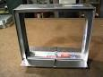](http://www.google.com/url?url=http://www.arlandamper.com/id38.html&rct=j&frm=1&q=&esrc=s&sa=U&ei=ftn1VKmNOc32gwTuoYPoCQ&ved=0CDAQ9QEwAA&usg=AFQjCNFsJR6o2jlAfoT-5UiG_G9939sVXg)

**Fire extinguisher**

[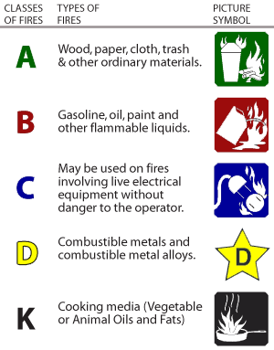](http://www.station09.com/content/pages/fireext/types.png)

**Fire Hydrant**

A **fire hydrant** is an [active fire protection](http://www.answers.com/topic/active-fire-protection) measure, and a source of water provided in most urban, suburban and rural areas with [municipal](http://www.answers.com/topic/municipality-3) water service to enable [firefighters](http://www.answers.com/topic/firefighter) to tap into the municipal water supply to assist in extinguishing a fire. Buildings near a hydrant may qualify for an [insurance](http://www.answers.com/topic/insurance) discount since firefighters should be able to more rapidly extinguish a fire on the insured property.

[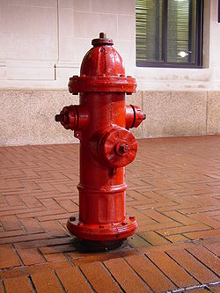](http://en.wikipedia.org/wiki/File:Downtown_Charlottesville_fire_hydrant.jpg)

**Fire rating**

**Class A – 3 hours.**

**Class B – 1 ½ hours.**

• One 5/8” standard gypsum board has ½ hour fire rating.

• One 5/8” type “X” gypsum board has 1 hour fire rating.

45 Minute fire rating

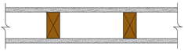

½” Standard Gypsum Board on both sides and 2” X 4” stud.

One Hour fire rating

 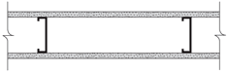

5/8” Type “X” Gypsum Board on both sides and 2” X 4” wood stud or

3-5/8” steel studs.

Two Hour fire rating

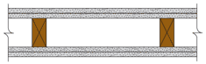 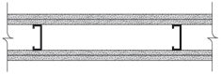

Two 5/8” Type “X” Gypsum Board on both sides and 2” X 4” wood stud or

1-5/8” steel studs.

**FIRE SPRINKLER SYSTEMS**

1. **Wet pipe system:**

The most commonly used system in commercial buildings is a **wet pipe system**, which is composed of [steel](http://science.howstuffworks.com/iron.htm) pipes that are always filled with water (hence, the term "wet"). The water in the pipes is under a moderate amount of pressure. When the sprinkler head is activated, the pressurized water in the pipes is immediately released, providing a faster reaction time than any other type of system.

Since the pipes are always filled with water, they're not recommended for locations where the pipes might freeze or in residential environments where accidental leaks could be detrimental.

1. **Dry pipe system:**

In a **dry pipe system**, the pipes are not filled with water they're actually filled with compressed air. When the sprinkler head is activated, a valve releases the compressed air through the sprinkler head. Once all of the air is released, the pressure in the pipe changes, allowing water to fill the system. Dry pipe systems have a slower reaction time (up to a minute delay). To make up for this, dry pipe systems release a larger amount of extremely pressurized water, which requires larger pipes (and a larger budget). And, while a leaky pipe in a dry pipe system doesn't pose a flooding threat, maintenance to the system is more complicated and costly.

1. **Deluge sprikler system:**

A deluge system is similar to a pre-action system except the sprinkler heads are open and the pipe is not pressurized with air. Deluge systems are connected to a water supply through a deluge valve that is opened by the operation of a

smoke or heat detection system. The detection system is installed in the same area as the sprinklers. When the detection system is activated water discharges through all of the sprinkler heads in the system. Deluge systems are used in places that are considered high hazard areas such as power plants, aircraft hangars and chemical storage or processing facilities. Deluge systems are needed where high velocity suppression is necessary to prevent fire spread.

**Stand pipe**

In North America, a **standpipe** is a type of rigid [water](http://en.wikipedia.org/wiki/Water) [piping](http://en.wikipedia.org/wiki/Piping) which is built into multi-story buildings in a vertical position or bridges in a horizontal position, to which [fire hoses](http://en.wikipedia.org/wiki/Fire_hose) can be connected, allowing manual application of water to the fire. Within the context of a building or bridge, a standpipe serves the same purpose as a [fire hydrant](http://en.wikipedia.org/wiki/Fire_hydrant).

**Siamese connection**

A **Siamese connection** or **splitter** in [fire protection engineering](http://en.wikipedia.org/wiki/Fire_protection_engineering) is a [pipe fitting](http://en.wikipedia.org/wiki/Pipe_fitting) that allows two or more [fire hoses](http://en.wikipedia.org/wiki/Fire_hose) to be connected to a single [standpipe](http://en.wikipedia.org/wiki/Standpipe) riser at the same general location.

It is so-called due to the visual allegory to [Siamese twins](http://en.wikipedia.org/wiki/Siamese_twins).

[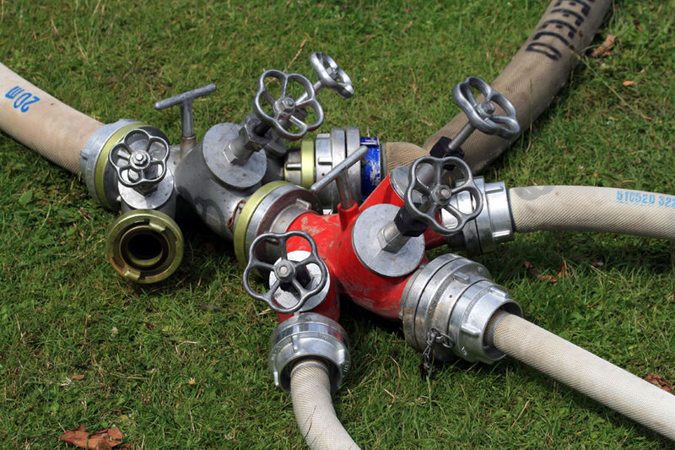](http://upload.wikimedia.org/wikipedia/commons/9/9a/Schlauchverteiler_Feuerwehr.jpg)

**FLASHING**

A strip of metal used to stop water from penetrating the junction of a roof with another surface.

**Cap Flashing/Counter Flashing**

A thin [strip](http://www.dictionaryofconstruction.com/definition/strip.html) of metal frequently inserted into [masonry](http://www.dictionaryofconstruction.com/definition/masonry.html) construction and [bent](http://www.dictionaryofconstruction.com/definition/bent.html) down over other [flashing](http://www.dictionaryofconstruction.com/definition/flashing.html) to prevent water from [running](http://www.dictionaryofconstruction.com/definition/runner.html) down the masonry and behind the upturned edge of the [base flashing](http://www.dictionaryofconstruction.com/definition/base-flashing.html).

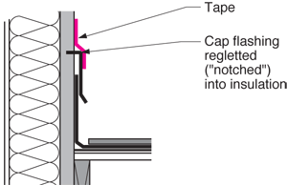

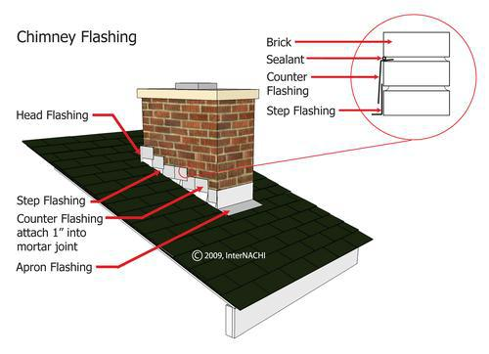

**FOUNDATION**

**SHALLOW FOUNDATION**

**1. Strip Footing:**

A strip footing is provided for a load-bearing wall. A strip footing is also provided for a row of columns which are so closely spaced that their spread footings overlap or nearly touch each other. In such a case, it is more economical to provide a strip footing than to provide a number of spread footings in one line. A strip footing is also known as continuous footing.

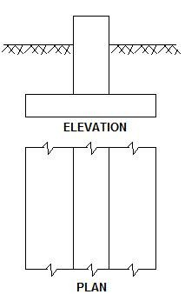

**2. Spread or Isolated Footing:**

A spread footing (or isolated or pad) footing is provided to support an individual column. A spread footing is circular, square or rectangular slab of uniform thickness. Sometimes, it is stepped or haunched to spread the load over a large area.

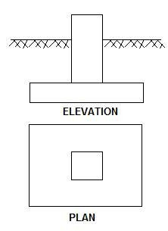

**3. Combined Footing:**

A combined footing supports two columns. It is used when the two columns are so close to each other that their individual footings would overlap. A combined footing is also provided when the property line is so close to one column that a spread footing would be eccentrically loaded when kept entirely within the property line.

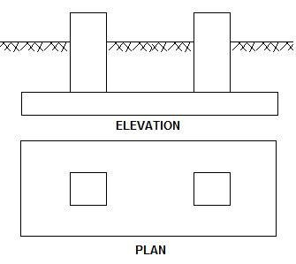

**4. Strap or Cantilever footing:**

A strap (or cantilever) footing consists of two isolated footings connected with a structural strap or a lever. The strap connects the two footings such that they behave as one unit. The strap is designed as a rigid beam. The individual footings are so designed that their combined line of action passes through the resultant of the total load. a [strap footing](http://theconstructor.org/geotechnical/strap-footing/7532/) is more economical than a combined footing when the allowable soil pressure is relatively high and the distance between the columns is large.

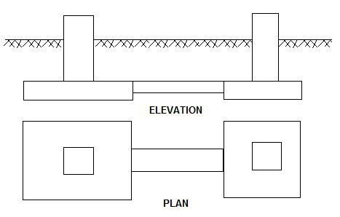

**5. Mat or Raft Foundations:**

A mat or raft foundation is a large slab supporting a number of columns and [walls](http://theconstructor.org/structural-engg/wall/) under the entire structure or a large part of the structure. A mat is required when the allowable soil pressure is low or where the columns and walls are so close that individual footings would overlap or nearly touch each other.

Mat foundations are useful in reducing the differential settlements on non-homogeneous soils or where there is a large variation in the [loads](http://theconstructor.org/structural-engg/structural-design/loads/) on individual columns.

**DEEP FOUNDATION**

1. **Pile Foundation**

Pile foundations are relatively long and slender members constructed by driving preformed units to the desired founding level, or by driving or drilling-in tubes to the required depth – the tubes being filled with [concrete](http://theconstructor.org/practical-guide/material-testing/concrete-material-testing/) before or during withdrawal or by drilling unlined or wholly or partly lined boreholes which are then filled with concrete.

[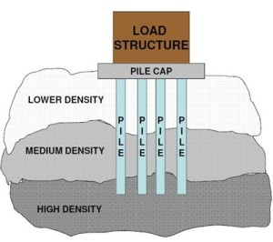](http://grimtech.com/blog/wp-content/uploads/2014/09/Pile-Foundations_load.jpg)

1. **Caisson Foundation**

Caissons are hollow substructures designed to be constructed on or near the surface and then sunk as a single unit to their required level.

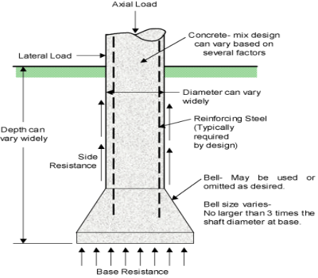

**GANTT CHART**

A **Gantt chart** is a type of [bar chart](http://en.wikipedia.org/wiki/Bar_chart), developed by [Henry Gantt](http://en.wikipedia.org/wiki/Henry_Gantt) in the 1910s, that illustrates a [project schedule](http://en.wikipedia.org/wiki/Schedule_(project_management)). Gantt charts illustrate the start and finish dates of the terminal elements and summary elements of a [project](http://en.wikipedia.org/wiki/Project). Terminal elements and summary elements comprise the [work breakdown structure](http://en.wikipedia.org/wiki/Work_breakdown_structure) of the project.

Each task has three time estimates: the optimistic time estimate (O), the most likely or normal time estimate (M), and the pessimistic time estimate (P). The expected time (TE) is estimated using the [beta probability distribution](http://en.wikipedia.org/wiki/Beta_distribution#Project_management:_task_cost_and_schedule_modeling) for the time estimates, using the formula (O + 4M + P) ÷ 6.

This Gantt chart example shows a simple list of items in preparation for an inspection. This is a simple project chart, prepared in a laundry list fashion with task items numbered 1 through 16.

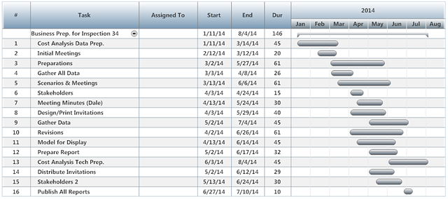

**EXAMPLE**

For a construction work, the progress chart is given below:

|  |  |  |  |  |  |  |  |  |  |  |  |  |  |  |  |
| --- | --- | --- | --- | --- | --- | --- | --- | --- | --- | --- | --- | --- | --- | --- | --- |
| **WORK** | **JAN** | | **FEB** | **MAR** | | **APR** | **MAY** | **JUNE** | **JULY** | **AUG** | **SEP** | **OCT** | **NOV** | | **DEC** |
| **Security fence** |  |  |  |  | |  |  |  |  |  |  |  |  | |  |
|  |  | |  |  | |  |  |  |  |  |  |  |  | |  |
| **Demolition** |  |  |  |  | |  |  |  |  |  |  |  |  | |  |
|  |  | |  |  | |  |  |  |  |  |  |  |  | |  |
| **Removal** |  | |  |  | |  |  |  |  |  |  |  |  | |  |
|  |  | |  |  | |  |  |  |  |  |  |  |  | |  |
| **Excavation** |  | |  |  |  |  |  |  |  |  |  |  |  | |  |
|  |  | |  |  | |  |  |  |  |  |  |  |  | |  |
| **Concrete work** |  | |  |  |  |  |  |  |  |  |  |  |  | |  |
|  |  | |  |  | |  |  |  |  |  |  |  |  | |  |
| **Plumbing work** |  | |  |  | |  |  |  |  |  |  |  |  | |  |
|  |  | |  |  | |  |  |  |  |  |  |  |  | |  |
| **Electrical work** |  | |  |  | |  |  |  |  |  |  |  |  | |  |
|  |  | |  |  | |  |  |  |  |  |  |  |  | |  |
| **Finishing work** |  | |  |  | |  |  |  |  |  |  |  |  |  |  |
|  |  | |  |  | |  |  |  |  |  |  |  |  | |  |
| **Planting** |  | |  |  | |  |  |  |  |  |  |  |  | |  |
|  |  | |  |  | |  |  |  |  |  |  |  |  | |  |
| **Ornamental fence** |  | |  |  | |  |  |  |  |  |  |  |  |  |  |

● The minimum time needed for the following work (15 days) – Security fencing, Excavation, and Ornamental fence.

● The maximum time needed for the work (3 ½ months) – Concrete work, and finishing work.

● The time needed to finish the demolition is 1 ½ month.

● Total duration of the project is 11 months.

**Critical path**

Longest sequence of [activities](http://www.businessdictionary.com/definition/activity.html) in a [project plan](http://www.businessdictionary.com/definition/project-planning.html) which must be [completed](http://www.businessdictionary.com/definition/completed.html) on time for the [project](http://www.businessdictionary.com/definition/project.html) to complete on [due date](http://www.businessdictionary.com/definition/due-date.html). An activity on the critical path cannot be started until its predecessor activity is complete; if it is delayed for a [day](http://www.businessdictionary.com/definition/day.html), the entire project will be delayed for a day unless the activity following the delayed activity is completed a day earlier.

** When CPM is used on a construction project, updates are most commonly made monthly.

**Float**

In [project management](http://en.wikipedia.org/wiki/Project_management), **float** or **slack** is the amount of time that a task in a [project network](http://en.wikipedia.org/wiki/Project_network) can be delayed without causing a delay to:

* subsequent tasks ("free float")
* project completion date ("total float")

An activity on critical path has "zero free float", but activity that has zero free float might not be on the critical path.

**EXAMPLE**

**10 3**

**B**

**E**

**5 4 3**

**C**

**G**

**A**

**6 3**

**F**

**D**

**Find the Critical Path and the duration. Also find the floats of all the Activities.**

**SOLUTION**

Path ABEG = 5 + 10 + 3 + 3 = 21

Path ACFG = 5 + 4 + 3 + 3 = 15

Path ADFG = 5 + 6 + 3 + 3 = 17

Path ABEG is the Critical Path (Longest path).

|  |  |  |
| --- | --- | --- |
| **Early Start (ES)** | **Duration** | **Early Finish (EF)** |
| **Activity** | | |
| **Late Start (LS)** | **Float** | **Late Finish (LF)** |

**Float = ES ~ LS = EF ~ LF  
Forward Pass**

Activity A

For the starting activity, early start is always zero.

Early finish = Early start + Duration = 0 + 5 = 5

**\*\*Early finish is the early start of the following activity.**

Activity B

Early finish = Early start + Duration = 5 + 10 = 15

Activity C

Early finish = Early start + Duration = 5 + 4 = 9

Activity D

Early finish = Early start + Duration = 5 + 6 = 11

**\*\*If there is more than one preceding activity, then use the largest number.**

Activity E

Early finish = Early start + Duration = 15 + 3 = 18

Activity F

Early finish = Early start + Duration = 11 + 3 = 14

Activity G

Early finish = Early start + Duration = 18 + 3 = 21

**5 10 15 15 3 18**

**E**

**B**

**0 5 5 5 4 9 18 3 21**

**G**

**C**

**A**

**5 6 11 11 3 14**

**F**

**D**

**Backward Pass**

**\*\*Early finish is the late finish of the last activity.**

Activity G

Late start = Late finish - Duration = 21 - 3 = 18

Activity F

Late start = Late finish - Duration = 18 - 3 = 15

Activity E

Late start = Late finish - Duration = 18 - 3 = 15

**\*\*If there is more than one preceding activity, then all activities will have the same late finish.**

Activity D

Late start = Late finish - Duration = 15 - 6 = 9

Activity C

Late start = Late finish - Duration = 15 - 4 = 11

Activity B

Late start = Late finish - Duration = 15 - 10 = 5

Activity A

Late start = Late finish - Duration = 5 - 5 = 0

Then calculate the float of the each activity using the following formula

$Float=Early start \sim Late start=Early finish \sim late finish$

**5 10 15 15 3 18**

**E**

**B**

**5 0 15 15 0 18**

**0 5 5 5 4 9 18 3 21**

**C**

**G**

**A**

**0 0 5 11 6 15 18 0 21**

**5 6 11 11 3 14**

**F**

**D**

**9 4 15 15 4 18**

**INSURANCES AND BONDS**

**Liability Insurance:** Any type of insurance policy that protects an individual or business from the risk that they may be sued and held legally liable for something such as malpractice, injury or negligence. Liability insurance policies cover both legal costs and any legal payouts for which the insured would be responsible if found legally liable. Intentional damage and contractual liabilities are typically not covered in these types of policies.

**Example:** Abel slipped on a broken step on the walkway in an apartment complex owned by Baker. Baker's liability insurance pays Abel for the pain and suffering and medical expenses.

**Property Insurance:** Insurance on the work at the site against loss or damage caused by perils of fire, lightning, extended coverage (wind, hail, explosion, except steam boiler explosion, riot, civil commotion, aircraft, land vehicles, and smoke), vandalism and malicious mischief, and additional perils (as otherwise provided or requested).

**Workmen’s Compensation Insurance:** Insurance covering liability of an employer to his employees for compensation and other benefits required by workmen’s compensation laws with respect to injury, sickness, disease, or death arising from their employment.   
Some states mandate that employers buy workers compensation insurance from a state fund, but some offer a choice of a state fund, self insurance, or commercial insurance.

**Special hazards Insurance:** Additional perils insurance to be included in property insurance (as provided in [contract documents](http://www.answers.com/topic/contract-documents-1) or requested by contractor or at option of owner) such as sprinkler leakage, collapse, water damage, all physical loss, or insurance on materials and supplies at other locations and/or in transit to the site.

**Bid Bond:** Bond required of a contractor submitting the lowest bid on a project. If the contractor then refuses to undertake the project, the bid bond assures that the developer will be paid the difference between the lowest bid and next lowest bid. The bid bond encourages contractors to make serious bids and live up to their obligations.

**Performance Bond:** A bond of the contractor in which a surety guarantees to the owner that the work will be performed in accordance with the [contract documents](http://www.answers.com/topic/contract-documents-1); frequently combined with the [labor and material payment bond](http://www.answers.com/topic/labor-and-material-payment-bond-1); except where prohibited by statute. For example, a contractor may issue a bond to a client for whom a building is being constructed. If the contractor fails to construct the building according to the specifications laid out by the contract, the client is guaranteed compensation for any monetary loss.

**Example:** The contract requires the [Contractor](http://www.answers.com/topic/contractor) to put up a $100,000 performance bond. If the contractor fails to do the job, the property owner has assurances of compensatory payment from the insurance company.

**Fidelity Bond:** A **fidelity bond** is a form of protection that covers policyholders for losses that they incur as a result of fraudulent acts by specified individuals. It usually insures a business for losses caused by the dishonest acts of its employees. Also called blanket bond.

While called [bonds](http://www.answers.com/topic/surety-bonds), these obligations to protect an employer from employee-dishonesty losses are really insurance policies. These insurance policies protect from losses of company monies, securities, and other property from employees who have a manifest intent to cause the company loss. There are also many other forms of crime-insurance policies (burglary, fire, general theft, computer theft, disappearance, fraud, forgery, etc.) to protect company assets.

**Labor and Material Payment Bond:** A bond of the [contractor](http://www.answers.com/topic/contractor) in which a [surety](http://www.answers.com/topic/surety) guarantees to the [owner](http://www.answers.com/topic/owner) that the contractor will pay for labor and materials used in the performance of the contract. The claimants under the bond are those having direct contracts with the contractor or any subcontractor.

**Surety Bond:** A legal instrument under which one party agrees to answer to another party for the debt, default, or failure to perform of a third party.

**Additional Information**

● Main advantage associated with the bid bonds as surety for submitted

proposal is don’t immobilize appreciable sums of a contractor’s money.

● In a typical surety bond arrangement written into construction contract,

the principal is the contractor.

**LUMBER SIZE**

**General rule converting nominal to actual softwood dimensions**

* subtract 1/4 inch for dimensions under 2 inches
* subtract 1/2 inch for dimensions under 8 inches
* subtract 3/4 inch for larger dimensions

**MIL**

Unit of length thousandth of an inch.

**NAIL CHART**

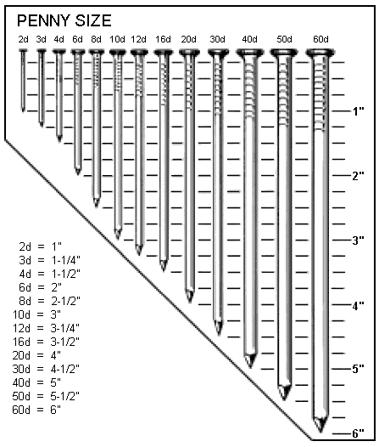**Note 1:** 12d & 16d are different.

**Note 2:** Drywall nails are specially designed, with oversized heads, for greater holding power. The drywall nail most frequently used is the annular ring nail. This nail fastens securely into wood studs and joists. When purchasing such nails, consider the thickness of the layer or layers of drywall, and allow additional length for the nail to penetrate the underlying wood 3/4 inch.

**One penny nail:** Weight 1 lb. per thousand nails.

**PAYMENT REQUISITION**

A contractor working on a project submitted the payment request for the following work. No payment shall be made for partially completed work which is on lump sum contract. Calculate the amount of money payable to contractor.

**Work Quantity Rate**

Security fence 100% complete lump sum $5,000

Demolition 100% complete lump sum $20,000

Removal 50% complete lump sum $8,000

Concrete work 100 Cubic Yard $3,000/Cubic Yard

Brick work 50 Cubic Yard $1,500/Cubic Yard

**Solution**

Security fence $5,000

Demolition $20,000

Concrete work 100 x 3,000 = $300,000

Brick work 50 x 1,500= $75,000

------------------------------------

Total= $400,000

NB: If there is a provision of retainage described in the problem, you have to

deduct that amount from the total.

**PROJECT STAGES**

**Planning:**

□Gather and analyze the facts of the current project situation.

□ Set project objectives (desired results).

□ Develop possible of alternative courses of action.

□ Identify the negative consequences of each course of action.

□ Decide on a basic course of action.

□ Develop strategies (priorities, sequence, timing of major steps).

□ Determine when and how overall progress will be measured.

**Organizing:**

□ Identify and analyze the various tasks necessary to implement the project.

□ Define scope of relationships, responsibilities, and authority of new positions.

□ Establish qualifications for new positions.

□ Determine the allocation of resources (including budget, facilities, etc.).

**Implementing:**

□ Find qualified people to fill positions.

□ Train and develop personnel for new responsibilities/authority.

□ Develop individual performance objectives which are mutually agreeable to the

individual and his/her manager.

□ Assign responsibility / authority / accountability.

□ Co-ordinate day to day activities.

**Controlling:**

□ Measure progress toward, and/or deviation from the project’s goal.

□ Measure individual performance against performance objectives and standards.

□ Take corrective action on the project (recycle project plan).

□ Deliver appropriate consequences for individual performance.

**REPORT WRITING**

● In making a field report, it is poor practice to erase information on the report in order to make a change because there is a question of what was changed and why it was changed.

● It is preferable to print information on a field report than write it out longhand mainly because printing is usually easier to read than longhand writing.

● The one that is most important of a written report is accuracy.

● A written report to your superior contains many spelling errors, readers of the report will get a poor opinion of the writer of the report.

● Written report to your superior should have the general arrangements and layout. The reason for this is person who reads the report will know where to look for information on the report.

● The first paragraph of a report usually contains detailed information on the subject of the report. The reason for this is to enable the reader to quickly find the subject of the report.

● A written report about a problem should contains description of problem, the location, the details of the problem, and the recommendation.

● The best engineering report is one that is detailed, accurate, grammatically correct, and prompt.

● The most important requirement of a good inspectional report is that it should be clear and brief.

● Best way of organizing a final report: Begin the report with overall summary and then place findings and recommendations in several sections.

● Serious disadvantage of oral report is a lack of permanent record to which one may later refer.

● Draft report should be submitted to key people for review, discussion, modification, and then resubmission in final form.

● Elements of a Survey report:

- Definite course of action to be followed.

- Listing of benefits to be gained through implementation.

- Review of opinions as differentiated from facts (least important).

- Summary of conclusions.

● The chief purpose in preparing an outline for a report is usually to insure that principal and secondary points will be properly integrated.

**ROOF COMPONENT**

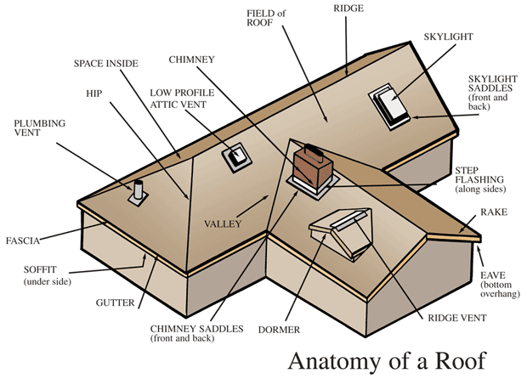

**ROOF CONSTRUCTION**

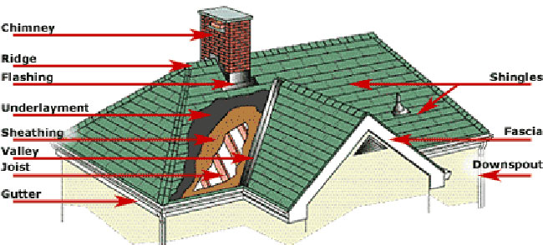

**ROOF FRAMING SYSTEM**

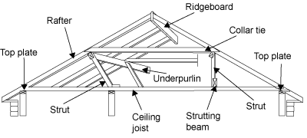

**Knee Brace:** A corner brace; a diagonal member placed across the angle between two members that are joined; serves to stiffen and strengthen a framework so constructed.

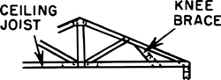

**Built-up Roof:** A continuous roof covering made up of laminations or plies of saturated or coated roofing felts, alternated with layers of asphalt or coal-tar pitch and surfaced with a layer of gravel or slag in a heavy coat of asphalt or coal-tar pitch or finished with a [cap sheet](http://www.answers.com/topic/cap-sheet-1); generally used on flat or low-pitched roofs.

|  |
| --- |
| f0151-01 |

**Collar Beam:** A horizontal member which ties together (and stiffens) two opposite common rafters, usually at a point about halfway up the rafters in a collar beam roof.

|  |
| --- |
| f0229-01 |
|  |

**Crown molding:** Any molding serving as a corona or otherwise forming the crowning or finishing member of a structure.

|  |
| --- |
| f0284-01 |

**Eaves:**

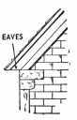

An eave is the edge of a roof. Eaves usually project beyond the side of the building. Some buildings, such as [Craftsman Bungalows](http://architecture.about.com/library/bl-bungalow.htm), have very wide eaves with decorative brackets.

**Fascia:** A board that is nailed vertically at the ends of roof rafters; sometimes supports a gutter; also called a fascia board.

|  |
| --- |
| f0354-01 |

**Frieze:** In house construction, a horizontal member connecting the top row of the siding with the underside of the cornice.

**Gable:** A vertical surface commonly situated at the end of a building, usually adjoining a pitched roof; its shape depends on the type of roof and parapet, although most often it is triangular; often extends from the level of the cornice up to the ridge of the roof. If the gable is on the façade rather than the back end, the building is said to be front-gabled.

**Rafter:** One of a series of inclined structural members from the ridge of the roof down to the eaves, providing support for the covering of a roof.

**Hip roof:** A four-sided roof having sloping ends and sides.

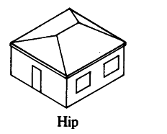

**Hip rafter:** A rafter placed at the junction of the inclined planes forming a hipped roof.

|  |
| --- |
| f0511-01 |

**Jack rafter:** Any rafter that is shorter than the usual length of the rafters used in the same building; esp. occurs in hip roofs.

**Purlin:** A horizontal beam running along the length of a roof to support the rafters or roof-boards. The purlin is supported at the ends by gables and at various points along its length by crucks or frames.

**Roof scuttle:** Opening at the roof for access into the building.



**SAFE AND HEALTHFUL WORKING CONDITIONS**

● The contractor shall be responsible for safety of the Contractor’s employees, the public and all other persons at or about the site of the work.

● The contractor shall employ a properly qualified safety professional familiar with all work under the specified Contract.

● The safety representative shall have no other duties except those directly related to safety and the safety representative shall not be the project manager, engineer, superintendent, or anyone else working on the project.

● The contractor shall have a written Health And Safety Plan (HASP) prepared, signed, and sealed by a safety professional.

● The contractor shall have a safety professional active on the job at all times while work is in progress.

● The contractor shall stop work whenever a work procedure or a condition at a work site is deemed unsafe by the safety staff.

● The safety practice that is required on the construction job site is safety helmets must be worn by all workers.

● Safety on the job is the concern of all parties on the job.

**SEQR**

**(STATE ENVIRONMENTAL QUALITY REVIEW)**

**Environmental Impact Assessment in New York State**

In New York State, most projects or activities proposed by a state agency or unit of local government, and all discretionary approvals (permits) from a NYS agency or unit of local government, require an environmental impact assessment. SEQR requires the sponsoring or approving governmental body to identify and mitigate the significant environmental impacts of the activity it is proposing or permitting.

On completing an EAF, the lead agency determines the significance of an action's environmental impacts. The agency then decides whether to require (or prepare) an Environmental Impact Statement and whether to hold a public hearing on the proposed action.

**Who Enforces SEQR**

The Legislature has made SEQR self-enforcing; that is, each agency of government is responsible to see that it meets its own obligations to comply.

**What happens if an agency does not comply with SEQR?**

If an agency makes an improper decision or allows a project that is subject to SEQR to start, and fails to undertake a proper review, citizens or groups who can demonstrate that they may be harmed by this failure may take legal action against the agency.

**How does DEC assist agencies in implementing the SEQR process?**

DEC provides informal interpretations and guidance about the conduct of SEQR. These informal interpretations are based on the experience of DEC staff. DEC, however, cannot provide formal legal opinions about the conduct of SEQR by other agencies. State and local agencies and other interested parties should consult with their own legal counsel for formal interpretations of SEQR law and regulations.

**SHORING, UNDERMINING, AND UNDERPINNING**

**Bracing:** Structural elements installed to provide restraint or support (or both) to other members, so that the complete assembly forms a stable structure; may consist of knee braces, cables, rods, struts, ties, shores, diaphragms, rigid frames, etc., singly or in combination.

**Needle Beam:** A crossbeam supporting a load; used in [underpinning](http://www.answers.com/topic/underpinning) foundation walls; attached to columns at its ends, clear of the existing footing.

**Shoring:** shoring, placing of props or braces, called shores, against or beneath a structure for support. Shoring is often used to stabilize a building when it is to undergo structural modification or repair. Commonly made of timbers measuring 12 in. (30.5 cm) by 12 in., shores are placed in an inclined position, bearing against the external walls of the building. The upper ends, which are sometimes capped with steel, fit into niches cut in brickwork, and the lower ends rest on bases or platforms, frequently of steel plate. The application of wedges or steel jacks between the lower ends of the shores and the platforms shifts part of the weight of a building from its foundation to the shoring. Shores are frequently used as supplemental support for buildings damaged by fire or by underpinning failure.

**[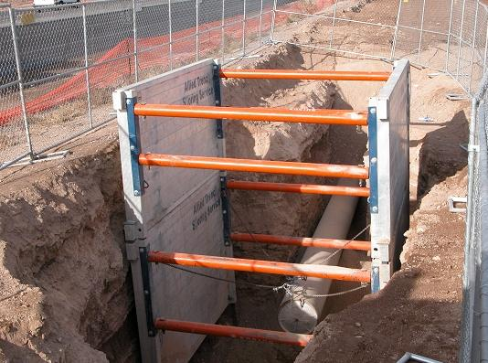](http://www.gme-shields.com/products/aluminum/2aex)**

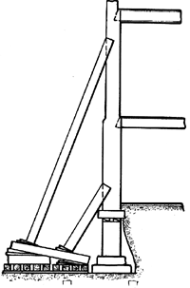

**Undermining:** Erosion along the base of a cliff by the wearing away of softer layers, thus removing the support for the upper mass which breaks off into large blocks and falls from the cliff face. Also known as undermining.

**Underpinning:** In [construction](http://www.answers.com/topic/construction), **underpinning** is the process of strengthening and stabilizing the [foundation](http://www.answers.com/topic/foundation-engineering-1) of an existing [building](http://www.answers.com/topic/building) or other [structure](http://www.answers.com/topic/structure). Underpinning may be necessary for a variety of reasons:

* The original foundation is simply not strong or stable enough, e.g. due to decay of wooden piles under the foundation.
* The usage of the structure has changed.
* The properties of the [soil](http://www.answers.com/topic/soil) supporting the foundation may have changed (possibly through [subsidence](http://www.answers.com/topic/subsidence)) or were mischaracterized during planning.
* The construction of nearby structures necessitates the excavation of soil supporting existing foundations.
* It is more economical, due to land price or otherwise, to work on the present structure's foundation than to build a new one.

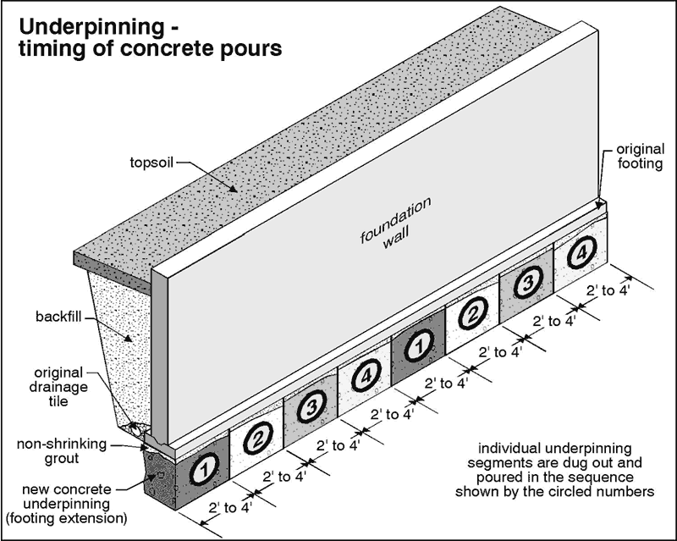

**Additional information**

● Underpinning an existing wall might involve Needle beams.

**SAMPLE SPECIFICATIONS**

● The minimum time of mixing shall be 1 minute per cubic yard after all the materials, including the water, has been placed in the drum, and the drum shall be reversed for an additional 2 minutes. Mixing water shall be added only in the presence of the inspector.

1. From the above specification it is reasonable to conclude that, the total mixing time of all the materials, including the water, shall be at least 3 minutes for a 1 yard batch.
2. The above specification requires the presence of inspector at the time of mixing water is added. The primary reason for this is that he should check the amount of water added.
3. The above specification most likely refer to transit mix concrete.

● Rough grading shall consists of cutting or filling to the elevation herein established with a permissible tolerance of 2 inches plus or minus. This tolerance shall be so used that within any area 100 ft. by 100 ft., it will not be necessary for a later contractor performing fine grading to remove excess or bring in additional fill to meet the required elevation.

1. From the above specification it is reasonable to conclude that, the total amount of excavation in rough grading should equal the total volume of excavation needed to meet the required elevation.
2. Of the following, the best reason for specifying the above paragraph is that, it establishes limits for the rough grading contractor.

● All present walls, cellar floors, foundations, footing and other existing structural items shall be removed as follows: Within 3 ft. of all new building walls, areas and ramp walls, the above work shall be removed to the depth of new construction. Under new footings the above work shall be entirely removed.

1. From the above specification it is reasonable to conclude that, an existing foundation must be completely removed if located under a new footing.
2. The above specification most likely refers to removal of walls and footings of demolished buildings.
3. Of the following titles, the one that is most appropriate for the section in which the above specification appears is, “Preparation of site”.

● Coarse aggregate shall consist of clean hard gravel or crushed stone and shall be graded from 1/8 inch to 3/8 inch with not less than 95% passing a 3/8 inch sieve and not more than 10% passing a No. 8 sieve.

Of the following, the coarse aggregate that would meet the above specification is

* 1. All of the aggregate is between 1/8 inch and 3/8 inch in size.
  2. 50% of the aggregate is 1/8 inch diameter.
  3. 5% of the aggregate is sand.

**STAIR COMPONENETS**

[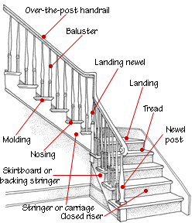](http://fashions.toprate10.com/joss/stair-parts-diagram)

**STOP WORK ORDER**

The Department issues a Stop Work Order when Inspectors find hazardous or unsafe work and/or conditions. Stop Work Orders are issued to protect workers, tenants, the public as well as buildings and properties from unsafe conditions.

**Full Stop Work Order**  
Stops all work on a construction site or building, excluding any necessary remedial work to make the site safe.

**Partial Stop Work Order**  
Stops a certain type of work or work on a particular section of the construction site or building. A partial Stop Work Order does not stop all work on the site and certain work is still allowed to continue.

**Lifting a Stop Work Order**

To lift a Stop Worker Order:

1. Correct all the violating conditions that resulted in the issuance of the Stop Work Order.
2. Request a re-inspection from the unit that issued the Stop Work Order to verify that all the violating conditions have been corrected.
3. Pay any applicable civil penalties.

**SUPERVISION**

● If a foreman does not understand the instructions that are given to him by the district engineer, the best thing to do is to ask that the instructions be repeated and clarified.

● The best foreman is the one who can get the most work out of the men.

● Complementing a man for good work is good practice since it will give the man an incentive to continue working well.

● The best method of making assignments of technicians would be ordinarily to make them according to technician’s ability to do the work.

● The best way to correct a mistake made by your subordinate is to correct the mistake yourself and privately explain correction to subordinate.

● If a draftsman cannot possibly complete a drawing on time, then the best action for him to take is notify the supervisor.

● The best thing for a supervisor to do when a subordinate has done a very good job is to praise his work.

● The best method of getting an employee who is not working up to his capacity to produce more work is to privately criticize his production but encourage him to produce more.

● The behavior characteristic of a supervisor, that is most likely to lower the morale of the men he supervises is favoritism.

● The most important quality required of a good supervisor is leadership.

● It is often said that a supervisor can delegate authority but never responsibility. This means more nearly that a supervisor can assign someone else to do his work, but in the last analysis, the supervisor himself must take the blame for any actions followed.

● One of your men who is habitual complainer asks you to grant him a minor privilege. Before granting or denying such a request, you should consider the merits of the case.

● A supervisory practice on the part of a foreman which is most likely to lead to confusion and inefficiency is for him to relay his orders to the men through coworkers.

● It would be poor supervision on a foreman’s part if he allowed a cooling-off period of several days before giving one of his men a deserved reprimand.

● Your orders to your crew are most likely to be followed if you explain the reasons for these orders.

● In order to be a good supervisor, you should see to it that your men get what they are entitled to.

● In giving instructions to a crew, you should speak quietly, clearly and courteously.

● When making an inspection of one of the buildings under your supervision, the best procedure to follow in making a record of the inspection is to write down all the important facts during or as soon as you complete the inspection.

● Assume that your supervisor has directed you to make certain changes in your established procedure. After using this modified procedure on several occasions, you find that the original procedure was distinctly superior and you wish to return to it. You should complete definite data and information to prove your case to your supervisor.

● Assume that one of the foreman in a training course, which you are conducting proposes a poor solution for a maintenance problem. The best course of action for you to take is to try to get the class to reject this proposed solution and develop a better solution.

● As a supervisor, you should be seeking ways to improve the efficiency of shop operations by means such as changing established procedures. The following actions you should consider in changing established procedures:

I. Discuss changes with your supervisor before putting them into practice.

II. Standardize any operation which is performed on a continuous basis.

III. Secure expert guidance before instituting unfamiliar procedures.

● A supervisor determined that a foreman, without informing his supervisor, delegated responsibility for checking time cards to a member of his gang. The supervisor called the foreman into his office where he reprimanded the foreman. The action of the supervisor in reprimanding the foreman was proper, because the checking of time cards is the foreman’s responsibility and should not be delegated.

● A supervisor makes it a practice to apply fair and firm discipline in all cases of rule infractions, including those of a minor nature. This practice should primarily be considered good, because not applying discipline for minor infractions can lead to a more serious erosion of discipline.

● When a conference or group discussion is tending to turn into a bull session without constructive purpose, the best action to take is to redirect the discussion to the business at hand.

● Assume that you have been assigned responsibility for a program in which a high production rate is mandatory. From past experience, you know that your foreman do not perform equally well in the various types of jobs given to them. The method should you use in selecting foreman for the specific types of work involved in the program assign each foreman to the he does best.

● When subordinates request his advice in solving problems encountered in their work, a certain chief occasionally answers the request by first asking the subordinates what he thinks should be done. This action by the chief is, on the whole, desirable, because it stimulates subordinates to give more thought to the solution of problems encountered.

● Reprimanding a crew member before other workers is a bad practice, people usually resent criticism made in public.

● The action which is least likely to promote good work is for the group leader to threaten to recommend discharge of workers who are below standard.

● A supervisor notices that a member of his crew has skipped a routine step in his job. The best action for the supervisor to take is to promptly question the worker about the incident.

● Assume you have been told to show a new worker how to operate a piece of equipment. Your first step should be to demonstrate the operation of the equipment for the worker.

● Whenever a new man is assigned to his crew, the supervisor should introduce him to all other crew members, take him on a tour of the plant, tell him about bus schedules and places to eat. This practice is good; the new man is made to feel welcome.

● The most important factor in successful leadership is the ability to make crew members want to do what should be done.

● Explaining the reasons for departmental procedure to workers tend to increase their interest in their work.

● If you want a job done well, do it yourself. For a supervisor to follow this advice would be bad; a supervisor should train his men, not do their work.

● When a supervisor discovers a mistake in one of the jobs for which his crew is responsible, it is most important to him to find out how to prevent similar mistakes in the future.

● A supervisor who has to explain a new procedure to his crew should realize that questions from the crew usually show that they are interested in the explanation.

● A good way for a supervisor to retain the confidence of his or her employees is to make no promises unless they will be fulfilled.

● Good supervision is essentially a matter of skill in human relations.

● It is most important for an employee who has been assigned a monotonous task to take measures to prevent mistakes in performing the task.

● One of your employees has violated a minor agency regulation. The first thing you should do ask the employee to explain his or her actions.

● One of your employees tells you that he feels you give him much more work than the other employees, and he is having trouble meeting your deadlines. You should review his recent assignments to determine if he is correct.

● A supervisor assigns one of his crew to complete a portion of a job. A short time later, the supervisor notices that the portion has not been completed. The best way for the supervisor to handle this is to ask the crew member why he has not completed the assignment.

● Suppose that a member of your crew complains that you are playing favorites in assigning work. The best method of handling the complaint is to ask the worker for examples to prove his point and try to clear up any misunderstanding.

● A member of your crew comes to you with a complaint. After discussing the matter with him, it is clear that you have convinced him that his complaint was not justified. At this point, you should permit him to drop the matter.

● Suppose that a supervisor has in his crew an older man who works rather slowly. In other respects, this man is a good worker, he is seldom absent, works carefully, never loafs, and is cooperative. The best way for the supervisor to handle this worker is to permit him to work at his own speed.

● Suppose that a member of your crew comes to you with a suggestion he thinks will save time in doing a job. You realize immediately that it won’t work. Under these circumstances, your best action would be to explain to the worker why you think it won’t work.

● During field inspectional duty on a project under construction, an engineer has the authority to suspend the performance of work if it is being performed in an improper manner.

● Assume that you are supervising several junior engineers. The good supervisory practice is to handle each individual in the manner best suited to him.

● An employee under your supervision continually asks questions on a job assignment. The best action for you to take is to explain the work carefully but encourage him to use his own judgment.

● As a supervisor, you can best ensure good morale and earn the respect of your men always being impartial and fair.

● During field inspectional duty on a project under construction, an engineer should be primarily concern with checking whether the workmanship being performed is of the proper quality.

● An inspector on a job under your supervision reports that a water line has been installed in a location which the plans show for an electrical pull box. The best action for you to take in this situation would be to study the conditions to see whether the box can be relocated, and, if so, secure the approval for the change.

● Assume that you are in charge of a group of junior engineers. A new employee is assigned to your squad who must be broken in the work done by the unit. The best procedure to follow in orienting the new employee is to allow him reasonable time to become acquainted with office standards, specifications, drawings, and other work done by the unit before giving him assignments.

● A squad boss would best earn the confidence of his men by impressing upon them that they are free to ask questions related to the work.

● In performing field inspectional work, an inspector is the contact man between the public and the board, and it is his job to secure compliance through the maximum utilization of persuasion and education and the application of coercion. According to the statement, an inspector performing inspectional duties should seek to obtain voluntary compliance and use coercion only as a last resort.

● A contractor on a job on which you are the inspector volunteers to do your certain personal favors. It appears that he is trying to influence you, and in general acts as if he were leading up to an attempt to bribe you. In such a situation you should turn down his favors and indicate that you will report the details to your superiors if he continues.

● Your superior orders you to do a job in a manner which you, as the inspector on the job, believe will result in the acceptance of inferior work. You are unable to persuade your superior that such an order is wrong. In this situation, your proper action is to carry out the order exactly as given, indicating your superior’s direction in tour reports.

● The most proper way for an inspector to promote good relations between the department and the contractor is to stress the fact that codes and ordinances are enforced for the good of all.

● A supervisor who wishes to attain established objectives should concentrate on planning work assignment.

● A usually competent employee complains that he does not understand the procedures to be followed in performing a certain task although the supervisor has explained them twice and has demonstrated them. The best course of action for the supervisor to take is to have the employee perform the job while he watches and give additional instructions.

● Generally, in order to be completely qualified as a supervisor, a person should know the basic principles and procedures of the jobs he supervises.

● The best practice to follow when training a new employee is to encourage him to feel free to ask questions at any time.

**TRAFFIC SAFETY**

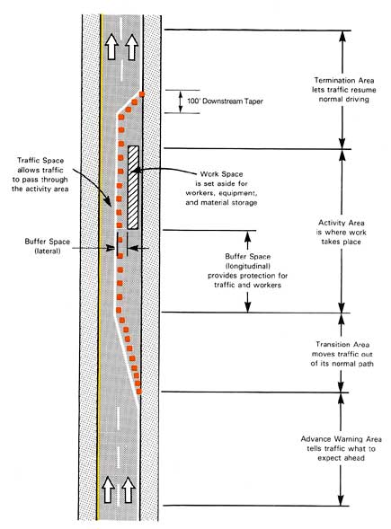

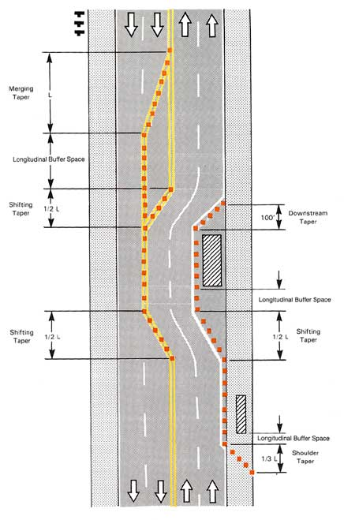

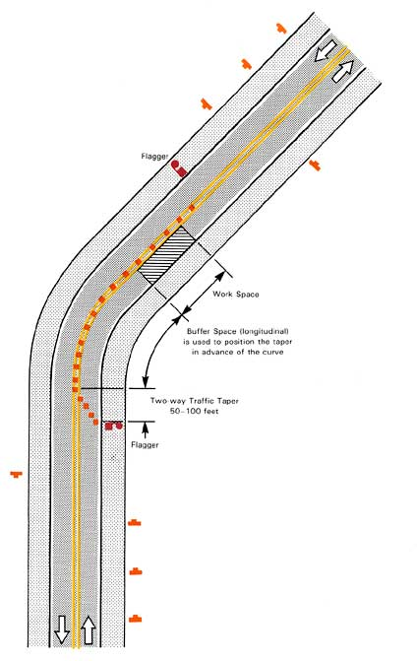

**WALL COMPONENT FRAMING**

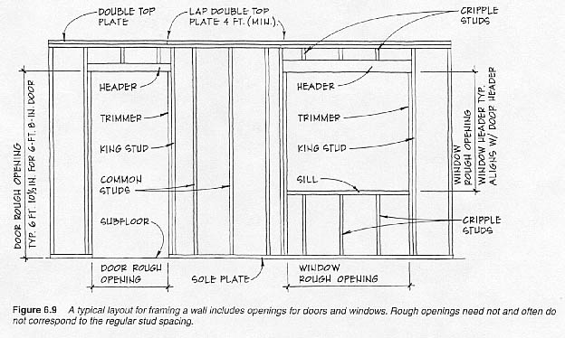

**WHEEL CHAIR RAMP**

Minimum slope = 1:20

Recommended slope = 1:12

Maximum slope =1:12

Minimum clear width = 36 inches

**WELDING SYMBOLS**

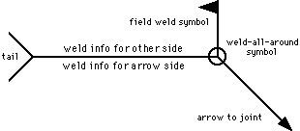

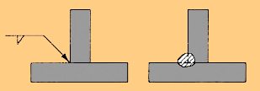  
 SYMBOL MEANING

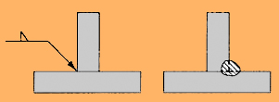

SYMBOL MEANING

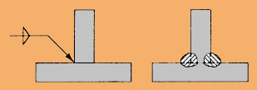

SYMBOL MEANING

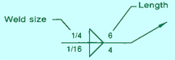

**ARROW TO THE JOINT**

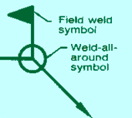

**ARROW TO THE JOINT**

Load capacity of the welding, **P** = **l x t x f**

Where, l = Length of the weld

t = Thickness of the weld

f = Allowable stress of the weld material

**WINDOW COMPONENTS**

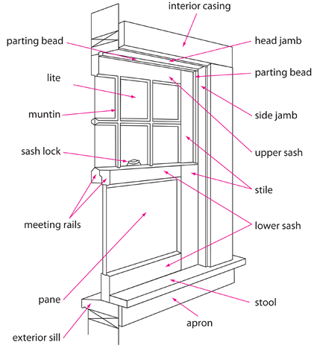

**WINDOWS TYPES**

 

Slider

 [](http://www.google.com/url?url=http://visihow.com/Decorate_a_Bay_Window_Properly&rct=j&frm=1&q=&esrc=s&sa=U&ei=l9D1VOmQJMKpgwTO8oK4CA&ved=0CDMQ9QEwAQ&usg=AFQjCNEll6wvDDd2Um4hzxpLT-iED8Wsvw) [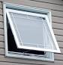](http://www.google.com/url?url=http://www.statewideenergysolutions.com/awning_windows&rct=j&frm=1&q=&esrc=s&sa=U&ei=79D1VK6YHIGrgwSJxoHoAQ&ved=0CDMQ9QEwAw&usg=AFQjCNFSRNPzQBz7-QZqiwICgASSrFe5-Q)

Casement Bay Awning

[](http://www.jlmcomposites.com/uploads/images/gallery/SA508685_280314111214_704.JPG) [](http://www.seans.com/Photos/Shed03/21-Windows.jpg)

**Dormer Clerestory**

**IMPORTANT INFORMATION**

● **Transite:** A concrete product that contains Asbestos.

● **Decibel:** Unit of measurement of noise.

● **EIS:** Environmental Impact Statement.

● **SEQR:** State Environmental Quality Review.

● **Project health and safety plan:** Required on all Contracts.

● **Wire mesh** is specified in pound per hundred square feet.

● A federal safety requirement on construction site is that **safety hats** must be worn.

● **Safety shoes** are the shoes that have a metal covering over the toe.

● When **painting steel**, red lead is used mainly as a prime coat to protect the steel from rusting.

● **Cast iron pipes** are most frequently cut with a diamond point chisel.

● If the **reading of the oil pressure gage on a gasoline motor** should suddenly drop to zero, the first thing the operator should do is to stop the motor.

● A **tractor** is to be stored for two months, in order to keep it best condition, it should be started up periodically and run until warm.

● The **blades of a lawn mower** should be set so that the blades barely touch the bed knife.

● **Erosion of side slopes** caused by the action of water is greatest when the soil is silt.

● The City aims to supply **“potable” water**. As used in this sentence, the word potable means most nearly “drinkable”.

● Water, after being purified, should not be **“turbid”.** As used in this sentence, the word turbid means most nearly “cloudy”.

● The flow of water is **“impeded”** by the silt in the bottom of the stream. As used in this sentence, the word impeded means most nearly “hindered”.

● When **issuing a violation** to a member of the public, it is most important that a Foreman be courteous and explain what must be done to correct the violation.

● The best reason for **compacting backfill** is to prevent settlement.

● **B. S & A:** Board of Standards and Appeals.

● The **best first aid treatment for a second degree of burn** is to cover the burn with a thick and sterile dressing.

● If a **laborer feels faint,** the best advice to give him is to advise him to lie flat with his head low.

● The **greatest number of injuries** from equipment used in construction work result from carelessness of the operator.

● When **lifting a heavy object**, a man should not place his feet wide apart.

● A **pneumatic jack hammer** is powered by compressed air.

**● Cement brought on the job** in bags should be put on a platform and covered with water proof covering.

● **Grout** is used mainly to fill surface impressions and imperfections.

● The **strongest method for sheeting a trench** is vertical sheeting.

● The **structural steel shape**, that is most often used as a stringer on a flight of stairs is a Channel.

● The **ends of wood fence posts** that are to be set into the ground are most often treated with Creosote.

● **Planimeter:** An approved means of obtaining the area of irregular figure.

● The thickness **17 gage steel** can best checked with a Micrometer.

**● Brinell Number:** A number which is a measure of metal’s hardness.

●**Masonite** is a wood product.

● To **void a contract** means most nearly to Nulify.

● The method most often used to keep a record of progress of construction of a project is a **Bar Chart.**

● The ability of an employee to take the first step and follow through on a job is known as **Initiative.**

● The **supplement of the angle** 620 is an angle of 1180.

● The **complement of the angle** 620 is an angle of 280.

● **Babbit metal:** The alloy of tin, antimony, and copper.

● **Brass:** The alloy of copper and zinc.

● The **designations AA and AAA** are used to specify Lead pipe.

● **Putty:** The compound most often used by a glazier to seal glass in a wooden frame.

● **Pyrometer:** Commonly used to measure the temperature.

● The technique of using arrow diagram in the planning and scheduling of construction work is called the **CPM method.**

● The personality traits, that best describes the ability of a subordinate who skillfully and promptly solves difficult problem is **Resourceful.**

● An applicant is to be hired for a provisional position requiring **drafting ability**. The best method of evaluating the applicant’s drafting skill is by asking him to make a sample drawing.

● The safest **horizontal distance between the base of the ladder and the wall** is ¼ of the height of the ladder.

● **Panic bolt:** A safety device used most often on a door.

● **Underwriter Laboratories:** The organization whose major purpose is to examine and test devices, systems, and materials for safety.

● **Modulus of Elasticity of steel** is most nearly 30 X 106 psi.

● **Thermostat:** An instrument which senses air temperature change.

● **Electrolyte:** The liquid solution in a lead acid storage battery.

● **Malleability:** The property of a material that allows the material to be hammered into a thin sheet.

● **Stainless steel** is an alloy mostly of Iron and Chromium.

● With regard to **placing of concrete**, the contractor is generally permitted to choose his own method of placing the concrete.

● The most practical method of being sure that the architect will be satisfied with the appearance of the exterior brick work of the building is to **build a sample wall section,** for the architect’s approval, with the brick that is delivered to the site.

● The **most frequent problem that will arise during the construction** of building is Interference in piping and ductwork.

● To find the number of reinforcing bars that should be in a slab, the inspector should refer to the **Reinforcing steel detail drawings**.

● The specification for a building state that a certain brick type shall be stark brick type XX or equal. The best reason for **inserting the or equal clause** is to permit other companies to compete in supplying the brick.

● In the **absence of a formal training program for inspectors**, the best of the following ways to train a new man who is to do inspection work is to have him accompany an inspector does his work so that he can learn by observing.

● **Safety on the job** is the concern of all parties on the job.

● The agency that approves **payment to building contractors** is the Comptroller’s Office.

● The best practice to follow in order **to minimize claims of damage** to adjacent buildings during the construction of building is to make a detailed survey of the condition of the nearby buildings before construction begins.

● **Oil tanks** when set in place inside a building, are frequently filled with water. The best reason for this practice is to prevent them from floating off their foundation if water fills the room.

● The **filing system used in the field for correspondence** is required to be uniform for all jobs. The best reason for this requirement is that other interested parties such as engineers from the main office will be able to use the files.

● Upon excavation to the subgrade of a footing to be placed on piles, the inspector finds that the **soil is very poor**. The proper action for the inspector to take is to do nothing.

● The general contractor is required to submit a **progress schedule** before starting work. The best reason for this requirement is to enable the inspector to determine whether the contractor is on schedule.

● If a contractor is **falling behind schedule**, the first step to check if the inspector is looking for the cause of this condition is the number of men ha has on the job.

● The contractor states to the inspector that a given **structural detail is undersized and unsafe**. The best action for the inspector to take in this situation is to notify the superiors of the contractor’s statement.

● The contractor proposes to **use an additive to the concrete to accelerate its set**. He asks you, the inspector, fro permission to use it. The first action to take in response to his request is to check if the use of the additive is permitted by the specifications.

● According to building code, the **maximum permitted surface temperature** of combustible construction materials located near heating equipment is 1700F.

● **NIC:** Not In Contract.

● **Parging:** The process of applying a coat of mortar to masonry construction.

● A **waterproof compound** used on the exterior concrete basement walls is Asphalt.

● **NTS:** Not To Scale.

● **NTE :** Not To Exceed.

● An **anonymous complaint** charges that while the writer was a pedestrian at a site where a field survey was in progress, one of your subordinate yelled it him in abusing language to stop him from stepping on the surveyor’s tape. The best course of action for you , as a supervisor, to take would be to discuss the letter with the subordinate.

● The **traits of a drafting checker**, that should be given the greatest weight in evaluating his performance is Accuracy.

● A tiny, **foreign object falls into your eye**. The safest thing to do is put drops in the eye.

● The characteristics, that is most likely to cause **subordinates to increase their respect** for a supervisor is when he is zealous.

● A subordinate who **consistently bypasses his immediate supervisor** for engineering information should be reprimanded by his immediate supervisor.

● In a **friendly conversation with a pedestrian**, a city employee should not show animosity.

● When a **drawing is revised**, the date of revision and description of the change is most often recorded in the lower right corner of the drawing.

● The materials, that would be least often included in the specification “**Miscellaneous and Ornamental Metal”** is reinforcing bars.

● Brick walls are occasionally washed down with a weak solution of muriatic acid. The **chemical formula for muriatic acid is HCl.**

● It is specified that the steel formwork for the addition to an existing hospital building shall be all welded. The best reason for this requirement is that **welding is quiter than riveting.**

● The shape of the surface created by an **inclined plane cutting the right cone** be an ellipse.

● The best reason for **specifying seasoned lumber for floor beam** is that seasoned lumber will not warp as much as unseasoned lumber.

● **Turning of metals** is usually performed on a lathe.

● The best reason for using **lightweight aggregate** for plastering a wall is the dead load will be reduced.

● The **property of steel** that makes it suitable for use in a cable is its strength in tension.

● A specification **for steel erection prohibits the use of heat** in straightening material that was bent in shipment. The best reason for this requirement is that heating the steel may injure the strength of the steel.

● The coating that should be placed on wood to preserve the lumber and reveal the grain and texture of the material is **Varnish**.

● A pictorial drawing, two of the axes of which are 300 with the horizontal, is known as **isometric drawing.**

● Two kinds of concrete are being used in the construction of a reinforced concrete building. Slump test show one concrete to have a slump of 7 inches, the other 3 inches. The **concrete with the 7 inches slump** would be used for columns.

● In reinforced concrete construction, the **reinforcing bars should be securely fastened** so that they will not be displaced during the pour.

● A bill of material calls for 2 x 4’s, S4S. The dressed size of these lumber is 1 5/8 inch x 3 5/8 inch.

● The larger the **Modulus of Elasticity of a material**, the less it will be strained for a given stress.

● In a simple reinforced concrete beam in a building, the **concrete below the reinforcing steel** serves primarily as fire protection.

● **Piles** are driven by steam hammer, drop hammer, and jack.

● **Protractor:** Measure the layout angles on a scale drawing.

● **Vernier:** A device used to measure fractional parts of a scale division.

● **Installation of a sprinkler system** would be least complicated when the type of building construction is Flat slab.

● **Laitance:** The liquid that collect on the horizontal surface of freshly poured concrete.

● **Doors on the outside face of building** frequently open outward. The best reason for this is to allow easy exit from the building in the emergency.

● Included in a hardware specification is a paragraph entitled butts. Butts are usually used on doors.

● The work shall include all ornamental quoins, rowlock, soldier courses. The statement is from a **specification for brickwork.**

● **Compensation for rock excavation** is most often paid as a unit price per cubic yard of rock.

● Hickory, Ash, Walnut are the **hard wood.**

● Cedar, pine are the **soft wood.**

● **Most likely wood** used for formwork are Pine, Fur.

● **In inking tracings,** the following will tend to increase the thickness of an inked line is leaning the pen more to the paper.

● **Sodium** is usually stored under kerosene or gasoline because it does not react with kerosene or gasoline.

● **Mercury** is chemically least active.

● The primary ingredient in wall plaster is **gypsum**.

● The **thickness of the joints in a brick wall** is usually ½ to ¾ inch.

● The shape of the **main cables on a suspension bridge** is most nearly a parabola.

● A structural member used to provide lateral support for another member is called **brace.**

● A sloping trough or tube for conducting concrete, cement, aggregate, or other free flowing materials from a higher to a lower point is called **chute.**

● **Manganese** is added to steel for high strength and toughness.

● **Fluorine, Chlorine, Bromine, Iodine** have the same number of electrons in the outer ring.

• **Perform inspection**  by an inspector always at the same time is bad practice because the tradesmen know when the inspector will occur.

• **Excavation near existing building:** There is more danger about undermining the foundation to a building with spread footing that a building with pile foundation.

• **Waterproofing work of existing basement:** The most effective and lasting repairs are those made on the earth side of the basement wall.

**GLOSSARY**

**ACP – 7:** If the asbestos containing material found in the samples is friable, then an ACP-7 form must be filed with the NYC DEP declaring that it is a friable asbestos project.

**Angle of friction:** The angle between the horizontal and the plane of contact between two bodies when the upper body is just about to slide over the lower. Also known as angle of friction.

**Angle of repose:** The **angle of repose** is an [engineering](http://www.answers.com/topic/engineering) property of [granular materials](http://www.answers.com/topic/granular-material). The angle of repose is the maximum angle of a stable slope determined by friction, cohesion and the shapes of the particles.

When bulk granular materials are poured onto a horizontal surface, a [conical](http://www.answers.com/topic/cone-geometry) pile will form. The internal angle between the surface of the pile and the horizontal surface is known as the angle of repose and is related to the [density](http://www.answers.com/topic/density), surface area, and [coefficient of friction](http://www.answers.com/topic/coefficient-of-friction-1) of the material.

[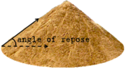](http://en.wikipedia.org/wiki/Image:Angleofrepose.png)

**Aquifer:** In hydrology, a rock layer or sequence that contains water and releases it in appreciable amounts. The rocks contain water-filled pores that, when connected, allow water to flow through their matrix. A confined aquifer is overlain by a rock layer that does not transmit water in any appreciable amount or that is impermeable. There probably are few truly confined aquifers. In an unconfined aquifer the upper surface (water table) is open to the atmosphere through permeable overlying material.

**Azimuth:** In plane surveying, a horizontal angle measured clockwise from north meridian to the direction of an object or fixed point.

|  |
| --- |
| f0071-01 |

**Basement:** A story partly underground, but having less than one-half its clear height (measured from finished floor to finished ceiling) below the curb level.

**Batter board:** One of a pair of horizontal boards which are nailed (at right angles to each other) to three posts set beyond the corners of a building excavation; used to indicate a desired location; strings, fastened to these boards, are used to indicate the exact corner of a building.

|  |
| --- |
| f0094-03 |

**Beam:** A **beam** is a [structural element](http://www.answers.com/topic/list-of-structural-elements) that is capable of withstanding [load](http://www.answers.com/topic/structural-load) primarily by resisting [bending](http://www.answers.com/topic/bending). The bending force induced into the material of the beam as a result of the external loads, own weight and external reactions to these loads is called a [bending moment](http://www.answers.com/topic/bending-moment-1).

[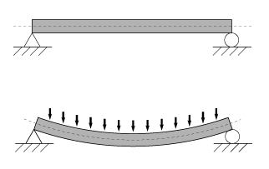](http://en.wikipedia.org/wiki/Image:Bending.png)

**Bench mark:** A permanently affixed mark that establishes the exact elevation of a place; used by Surveyors in measuring site elevations, or as a starting point for Surveys.  
 **Example:** The U.S. Coast and Geodetic Survey implants brass markers in the sidewalks of downtown areas to serve as *benchmarks.* The benchmark indicates the official elevation above sea level for the spot at which the marker is placed.

**Building paper:** A heavy, relatively cheap, durable paper, such as [asphalt paper](http://www.answers.com/topic/asphalt-paper), used in building construction, esp. in frame construction, to improve thermal insulation and weather protection and to act as a vapor barrier. Special types are: sheathing paper, used between sheathing and siding; floor lining paper, used between rough and finish floors.

**Cant:** The **cant** of a [road](http://www.answers.com/topic/road) (sometimes referred to as [camber](http://www.answers.com/topic/camber) or [cross slope](http://www.answers.com/topic/cross-slope)) or [railway](http://www.answers.com/topic/railway) (also referred to as **superelevation**) is the difference in elevation between the two edges. A cant which is not equal to zero results in a [banked turn](http://www.answers.com/topic/banked-turn), allowing vehicles to traverse the turn at higher speeds than would otherwise be possible.

**Cavity Wall:** In architecture, a double wall consisting of two wythes (vertical layers) of masonry separated by an air space and joined together by metal ties. The cavity allows moisture that penetrates the exterior wythe to drain. Cavity walling is used as both non-load-bearing infill for framed buildings and for [bearing-wall](http://www.answers.com/topic/bearing-wall-arch-in-encyclopedia) construction.

**Cellar:** A story partly underground, but having one-half or more of its clear height (measured from finished floor to finished ceiling) below the curb level.

**Certificate of Occupancy (CO):** Issued by Borough Superintendent of Department of Buildings.

**Combined sewer:** A drainage system that receives both surface runoff and sewage.

**Chiller:** Mechanical equipment used to circulate chilled water throughout a building; consists of a **compressor, condenser**, and **evaporator.**

**Crawl space:** A low or narrow space, such as one beneath the upper or lower story of a building, that gives workers access to plumbing or wiring equipment.

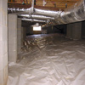

**Creep:** **Creep** is the tendency of a solid material to slowly move or deform permanently under the influence of [stresses](http://www.answers.com/topic/stress-physics). It occurs as a result of long term exposure to levels of stress that are below the [yield strength](http://www.answers.com/topic/yield-engineering) of the material. Creep is more severe in materials that are subjected to [heat](http://www.answers.com/topic/heat) for long periods, and near the melting point. Creep always increases with temperature.

**Curb cut:** A curb cut is an inclined cut in the edge of a sidewalk to permit vehicular access to a driveway, garage, parking lot or loading dock. In lower- and medium-density residential districts, the maximum width for a curb cut is 10 feet; 15 feet for paired curb cuts. There must be a minimum width of 16 feet between curb cuts to ensure adequate curbside parking.

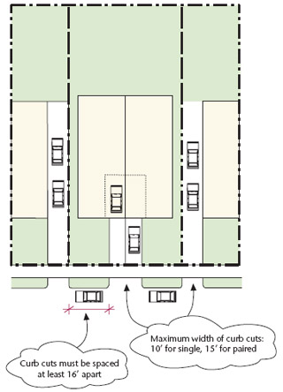

**Curb stop:** Is a valve used to isolate the building from the main for repairs, nonpayment of water bills, or flooded basements.

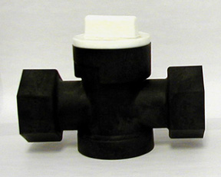

**Daylight:** The end of the pipe that is not attached to anything.

**Dead light:** The fixed, non-operable window section of a window unit.

**Design build project**

**Design–build** is a project delivery system used in the construction industry. It is a method to deliver a project in which the design and construction services are contracted by a single entity known as the **design–builder** or **design–build contractor**. In contrast to "[design–bid–build](http://en.wikipedia.org/wiki/Design%E2%80%93bid%E2%80%93build)" (or "design–tender"), design–build relies on a single point of responsibility contract and is used to minimize risks for the project owner and to reduce the delivery schedule by overlapping the design phase and construction phase of a project. "DB with its single point responsibility carries the clearest contractual remedies for the clients because the DB contractor will be responsible for all of the work on the project, regardless of the nature of the fault".

**Downtime:** Is the time a piece of equipment is unavailable for use.

**Drain tile:** A cylindrical tile with holes in the walls used at the base of a building foundation to carry away groundwater.

**Drip Cap:** A horizontal molding, fixed to a door or window frame to divert the water from the top rail, causing it to drip beyond the outside of the frame.

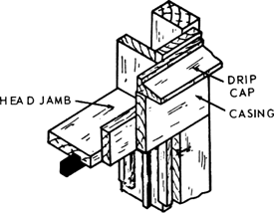

**Drip line:** An imaginary line on the soil around a tree that mirrors the circumference of the branches above. The feeder roots of a tree usually extend to or beyond this line and receive water that drips off the canopy above.

**Drum trap:** In plumbing, a cylindrical trap, with its axis in a vertical direction, having a cover plate which may be unscrewed for access; commonly used on the drainpipe from a bathtub or under a bathroom floor.

|  |
| --- |
| http://content.answers.com/main/content/img/McGrawHill/atchitecture/f0341-02.png |

**Dunnage:**

Pieces of timber which are used to provide structural support for a large item of equipment on a rooftop.

**Efflosescence:** An encrustation of soluble salts, commonly white, deposited on the surface of stone, brick, plaster, or mortar; usually caused by free alkalies leached from mortar or adjacent concrete as moisture moves through it.

[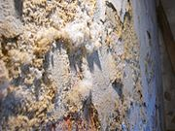](http://en.wikipedia.org/wiki/Image:Ausbl%C3%BChungen.JPG)

**Electric power:** electric power, energy dissipated in an electrical or electronic circuit or device per unit of time. The electrical energy supplied by a current to an appliance enables it to do work or provide some other form of energy such as light or heat. Electric power is usually measured in [Watts](http://www.answers.com/topic/watts), kilowatts (1,000 watts), and megawatts (1,000,000 watts). The amount of electrical energy used by an appliance is found by multiplying its consumed power by the length of time of operation. The units of electrical energy are usually watt-seconds (joules), watt-hours, or kilowatt-hours. For commercial purposes the kilowatt-hour is the unit of choice.

**Environmental Impact Statement (EIS):** Analysis of the expected effects of a development or action on the surrounding natural and fabricated environment. Such statements are required for many federally supported developments under the National Environmental Policy Act of 1969. If an action is determined to have potentially significant adverse environmental impacts, an **"Environmental Impact Statement"** is required.

**Fatigue:** In [materials science](http://www.answers.com/topic/materials-science), **fatigue** is the progressive and localized structural damage that occurs when a material is subjected to cyclic loading. The maximum [stress](http://www.answers.com/topic/stress-physics) values are less than the [ultimate tensile stress limit](http://www.answers.com/topic/tensile-strength), and may be below the [yield stress limit](http://www.answers.com/topic/tensile-strength) of the material.

Tendency for metal to crack or fracture when it is stressed repeatedly through many cycles of loading and unloading.

**Federal law of discrimination in employment:** Act as amended in 1978 prohibits jobs discrimination based on age for persons between the ages of 40 and 70.

**FHA Strap:** Metal straps that are used to repair a bearing wall “cut-out”, and to “tie together” wall corners, splices, bearing headers.

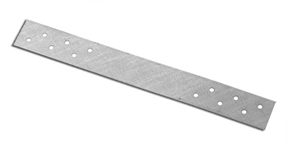

**Flat slab:** A concrete slab which is reinforced in two or more directions, usually without beams or girders to transfer the loads to supporting members

**Frontage:** The front part of a piece of property. The land between a building and the street.

**Furring:** Spacers such as wood strips or metal channels which are fastened to the joists, studs, walls, or ceiling of a building so that the finish surface may be leveled.

A method of finishing the interior face of a masonry wall to provide space for thermal insulation, to prevent moisture transmission, or to provide a level surface for finishing.

|  |
| --- |
| http://content.answers.com/main/content/img/McGrawHill/atchitecture/f0447-01.png |

**Fusible link:** A **fusible link** is a device consisting of two strips of metal soldered together with a [fusible alloy](http://en.wikipedia.org/wiki/Fusible_alloy) that is designed to melt at a specific temperature, thus allowing the two pieces to separate.

**Gasket**

A **gasket** is a [mechanical seal](http://www.answers.com/topic/seal-mechanical) that fills the space between two objects, generally to prevent leakage between the two objects while under [compression](http://www.answers.com/topic/physical-compression). Gaskets save money by allowing *"less-than-perfect"* mating surfaces on machine parts which can use a gasket to fill irregularities. Gaskets are commonly produced by cutting from sheet materials, such as gasket [paper](http://www.answers.com/topic/paper), [rubber](http://www.answers.com/topic/natural-rubber), [silicone](http://www.answers.com/topic/silicone), [metal](http://www.answers.com/topic/metal), [cork](http://www.answers.com/topic/cork), [felt](http://www.answers.com/topic/felt), [epidermis](http://www.answers.com/topic/epidermis), [neoprene](http://www.answers.com/topic/neoprene), [nitrile rubber](http://www.answers.com/topic/nitrile-rubber), [fiberglass](http://www.answers.com/topic/fiberglass), or a [plastic](http://www.answers.com/topic/plastic) [polymer](http://www.answers.com/topic/polymer).

[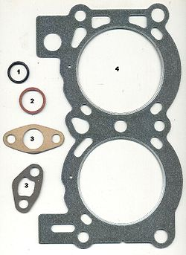](http://en.wikipedia.org/wiki/File:Gaskets.jpg)

**Generator:** machine in which mechanical energy is converted to electrical energy. Generators are made in a wide range of sizes, from very small machines with a few watts of power output to very large central-station generators providing 1000 [MW](http://www.answers.com/topic/mw-abbreviation) or more. All electrical generators utilize a magnetic field to produce an output voltage which drives the current to the load.

**Glass block:** Finished, non-bearing exterior wall to control solar heat and transmit some light.

**Globe valve:** A valve in which the flow of water is controlled by a movable spindle which lowers to a fixed seat, thereby restricting the flow through the valve opening; the spindle is fitted with a washer to provide tight closure; usually enclosed in a chamber having a globular shape.

|  |
| --- |
| f0465-01 |

**Glycol:** Used in processing equipment for removing all or most of the water from a wet gas by contacting with glycol.

**Government anchor:** Are used in the type of construction where steel beams supported on masonry walls.

**Grading plan:** A plan which shows the proposed finish of the ground surface of a given site, usually by means of contours and grade elevations.

**Grapevine:** Unofficial path of verbal communication. Rumors or scuttlebutt are spread from person to person through an informal network.

**Grit chamber:** A chamber designed to remove sand, gravel, or other heavy solids that have subsiding velocities or specific gravities substantially greater than those of the organic solids in waste water.

**Guarantee:** A formal promise or assurance (typically in writing) that certain conditions will be fulfilled, especially that a product will be repaired or replaced if not of a specified quality and durability.

**Guaranty:** According to construction contract law, a promise by a party called Guarantor to make good the mistake, debt, or default of another party.

**Haunch:** An extension, knee like protrusion of the foundation that a concrete porch or patio will rest upon for support.

**Hearth:** The fireproof area directly in front of the fire place.

**Heating oil:** **Heating oil**, or **oil heat**, also known in the United States as **No. 2 heating oil**, is a low [viscosity](http://www.answers.com/topic/viscosity), flammable liquid [petroleum product](http://www.answers.com/topic/petroleum-product) used to [fuel](http://www.answers.com/topic/fuel) building [furnaces](http://www.answers.com/topic/furnace) or [boilers](http://www.answers.com/topic/boiler). In the U.S., it must conform to [ASTM](http://www.answers.com/topic/astm-international) standard D396. [Diesel](http://www.answers.com/topic/diesel) and [kerosene](http://www.answers.com/topic/kerosene), while often confused as being similar or identical, must conform to their own respective ASTM standards.

**Hod:** A wood or metal container, usually V-shaped with a long handle and having one end open; used in masonry work to carry plaster or lime putty to the mortarboard.

**House sewer:** Located outside the building to connect with public sewer.

**Index Number:** A way of measuring and comparing changes over a period of time.

[**Intro 794-A**](http://www.nyc.gov/html/dob/downloads/pdf/intro_794a.pdf)**:** requires at least 30 hours of Department-approved training and an eight-hour refresher course every three years for all workers involved in the erection, jumping, climbing, rigging or dismantling of a climber or a tower crane.

**Intumescent:** Said of a material that swells and chars when exposed to flame and that forms an insulating fire-retardant barrier between the flame and material.

**Invert level:** The level of the lowest portion at any given section of a liquid-carrying conduit, such as a drain or a sewer, and which determines the hydraulic gradient available for moving the contained liquid.

**Isometric drawing:** A form of three-dimensional projection in which all of the principal planes are drawn parallel to corresponding established axes and at true dimensions; horizontals usually are drawn at 30° from the normal horizontal axes; verticals remain parallel to the normal vertical axis.

|  |
| --- |
| f0549-01 |

**J – 2 Occupancy:** Occupancy group J-2. Shall include buildings with three or

more dwelling units that are primarily occupied for the shelter and

sleeping accommodation of individuals on a month-to-month or longer-term

basis.

**Keyway:** If two successive contiguous concrete placements are required in any location, substantial offsets or keyways will be required in the surface of the pour first placed to bond the later placement more effectively to the first and to prevent leakage.

**Laminated glass:** Specified for skylight glazing

**Lath:** A thin strip of wood or metal, usually nailed in rows to framing supports as a substructure for plaster, shingles, slates, or tiles. A building material, such as a sheet of metal mesh, used for similar purposes.

**Layout plan:** A plan showing a scheme for an arrangement of objects and spaces.

**Law of cosine:**

[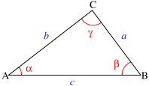](http://en.wikipedia.org/wiki/Image:Triangle_with_notations_2.svg)

c^2 = a^2 + b^2 - 2ab\cos(\gamma) , \,

**Law of sine:** In [trigonometry](http://www.answers.com/topic/trigonometry), is a statement about any [triangle](http://www.answers.com/topic/triangle) in a plane. Where the sides of the triangle are *a*, *b* and *c* and the [angles](http://www.answers.com/topic/angle) opposite those sides are *A*, *B* and *C*, then the law of sine states equality of the first three quantities below:

[](http://en.wikipedia.org/wiki/Image:Triangle_with_notations_2.svg)

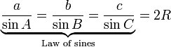

**LED:** (**L**ight **E**mitting **D**iode) A display and lighting technology used in almost every electrical and electronic product on the market, from a tiny on/off light to digital readouts, flashlights, traffic lights and perimeter lighting. LEDs are also used as the light source in multimode fibers, optical mice and laser-class printers.

**Legal Curb Level:** Curb level established by the County or By Borough President.

LOADS

A) Dead loads

Dead loads are weights of material, equipment or components that are relatively constant throughout the structure's life. Permanent loads are a wider category which includes dead loads but also includes forces set up by irreversible changes in a structure's constraints - for example, loads due to settlement, the secondary effects of pre-stress or due to shrinkage and creep in concrete.

Also, **Dead Loads** are not limited to walls, floors, roofs, ceilings, stairways, built-in partitions, finishes, cladding and other similarly incorporated architectural and structural items, and fixed services equipment, including the weight of cranes. All permanent loads are considered dead loads.

B) Live loads

Live loads, sometimes referred to as **probabilistic load** include all the forces that are variable within the object's normal operation cycle. Using the staircase example the live load would be considered to be -

* Pressure of feet on the stair treads (variable depending on usage and size)
* Wind load (if the staircase happens to be outside)

**Live loads** include environmental loads such as:

* Wind load
* Snow load
* Rain load
* Earthquake load
* Flood load

**Loft:** A loft is a building or space within a building designed for commercial or manufacturing use, generally constructed prior to 1930. In certain manufacturing districts, lofts may be converted to residential use by CPC special permit.

**Low Rise:** A structure less than seventy five feet in height.

**Manhole**

● A covered opening in a street which provides access for cleaning and repairing of a sewer beneath, or for repairing a conduit for electric underground piping or electric cables.

|  |
| --- |
| f0615-01 |

● Provide manholes at all breaks in the horizontal and vertical planes, except when the horizontal alignment is in a curve or when the use of bends has been approved.

● Maximum Manhole Spacing

Pipe Size Maximum Manhole Spacing

8-inch to 24-inch 400 feet

27-inch to 42-inch 600 feet

**Marquee:** A **marquee** is most commonly a structure placed over the entrance to a [hotel](http://www.answers.com/topic/hotel) or [theatre](http://www.answers.com/topic/theater). It has signage on the sides either stating the name of the location, or in the cases of theatres, the [movie](http://www.answers.com/topic/film) or artist now appearing at that location. The marquee is often identifiable by a surrounding cache of light bulbs, usually yellow or white, that flash intermittently or as [a string with a series of darkened bulbs that rotates around the sign](http://www.answers.com/topic/chasing-lights-1).

**Material only warranty:** Is used to limit the manufacturer’s responsibility in a construction contract.

**Mean:** The mean is when you add up a certain amount of numbers and get your total. Then you divide the total by how many numbers you counted. Then you get your MEAN.

**Median:** Median is the middle value of a set of numbers arranged from least to greatest

For example,   
  
First arrange them in least to greatest : 14, 28, 31, 34, 39, 40, 45   
  
Here, 34 is the middle value. So, 34 is the median of the given data.

**Mode:** What is occured most frequently or most often.

**Metal lath:** A mesh of metal used to provide a base for plaster.

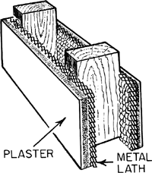

**Meter stop:** An off-on valve in a water service pipe for stopping the flow of water to

a building.

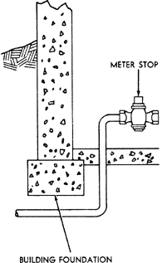

**Mezzanine:** In [architecture](http://www.answers.com/topic/architecture), a **mezzanine** or **entresol** is an intermediate [floor](http://www.answers.com/topic/floor) between main floors of a [building](http://www.answers.com/topic/building), and therefore typically not counted among the overall floors of a building. Often, a mezzanine is low-ceilinged and projects in the form of a [balcony](http://www.answers.com/topic/balcony). The term is also used for the lowest balcony in a [theatre](http://www.answers.com/topic/theater), or for the first few rows of seats in that balcony.

**Minimum thickness of sidewalk:** 4 inch.

**Minimum width of sidewalk in NYC:** Passable sidewalk for pedestrian should be 8 feet. Privately installed sidewalk should be 5 feet.

**Motor:** A machine that converts electrical into mechanical energy. Motors that develop rotational mechanical motion are most common, but linear motors are also used. A rotary motor delivers mechanical power by means of a rotating shaft extending from one or both ends of its [enclosure](http://www.answers.com/topic/enclosure).

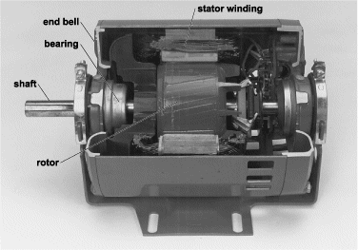

**Muck:** Valueless rock that must be fractured and removed in order to gain access to or upgrade ore known as muck.

**Mullion:** A vertical divider in the frame of window, door, or other opening.

**Muntin:** A small member which divides the glass or openings of sash or door

**Multiple Dwelling:** A building for residential use which houses several separate family units, usually three or more.

**Non-Collusive Affidavit:** Required for a bidder to submit to obtain an honest bid.

**OS & Y Valve:** When a sprinkler and/or standpipe system is installed the fire guard must make sure that the **OS & Y valve** is sealed in the **open** position. The OS & Y valve controls the main supply of waterinto the sprinkler and/or standpipe system. The position of the valve is easily determined.

**One-penny nail:** Weight 1 pound per thousand.

**Open hole inspection:** When an engineer or municipal inspector inspect the open excavation and examines the earth to determine the type of foundation that should be installed in the hole.

**Parapet:** A wall placed at the edge of a roof to prevent people from falling off. Minimum height is 42 inches. Required when the height of the structure is more than 22 feet.

**Party Wall:** A wall built along the line separating 2 properties, partly on each [parcel](http://www.answers.com/topic/parcel). Either owner has the right to use the wall and has an [easement](http://www.answers.com/topic/easement) over that part of the [adjoining](http://www.answers.com/topic/adjoining) owner's land covered by the wall.  
**Example:** The structures built on lots A and B are separated by a *party wall*.

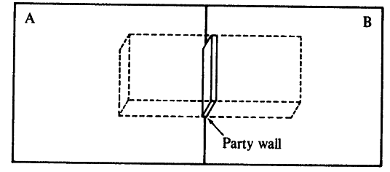

**Patterned glass:** Reduce light transmission.

**Peat:** soil material consisting of partially decomposed organic matter; found in swamps and bogs in various parts of the temperate zone. It is formed by the slow decay of successive layers of aquatic and semi aquatic plants, e.g., sedges, reeds, rushes, and mosses. One of the principal types of peat is moss peat, derived primarily from sphagnum moss; it is used in agriculture as poultry and stable litters as well as a mulch, a soil conditioner, and an acidifying agent; it is also used in industry as an insulating material. It has lowest bearing capacity.

[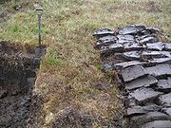](http://en.wikipedia.org/wiki/Image:Peat_Lewis.jpg)

**Pedestal:** **1.** A support for a column, statue, urn, etc., consisting in classical architecture of a base, dado, or die and a cornice, sub base, or cap; in modern design often a plain unornamented block.   
**2.** An upright compression member the height of which does not exceed three times its least lateral dimension.

|  |
| --- |
| http://content.answers.com/main/content/img/McGrawHill/atchitecture/f0710-03.png |

**Perspective view:** A form of perspective in drawing and painting in which parallel lines are represented as converging so as to give the illusion of depth and distance.

[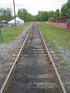](http://en.wikipedia.org/wiki/Image:Railroad-Tracks-Perspective.jpg) [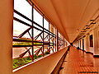](http://en.wikipedia.org/wiki/Image:Perspectivephoto.jpg)

**PERT:** Program (Project) Evaluation and Review Technique.

**Pipe Bends**

¼ Bend = 3600/4 = 900

1/8 Bend = 3600/8 = 450

1/16 Bend = 3600/16 = 22.50

1/32 Bend = 3600/32 = 11.250

**Pipeline testing**

Buried high pressure oil and gas pipelines are tested for strength by pressurising them to at least 125% of their maximum operating pressure (MAOP). Since many long distance transmission pipelines are designed to have a steel hoop stress of 80% of specified minimum yield (SMYS) at MAOP, this means that the steel is stressed to SMYS and above during the testing, and test sections must be selected to ensure that excessive plastic deformation does not occur.

Leak testing is performed by balancing changes in the measured pressure in the test section against the theoretical pressure changes calculated from changes in the measured temperature of the test section.

**Planimeter:** A **planimeter** is a [measuring instrument](http://www.answers.com/topic/meter-measuring-device) used to measure the area of an arbitrary two-dimensional shape. The most common use is to measure the area of a plane shape.

[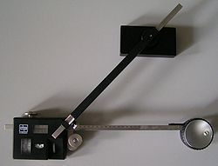](http://en.wikipedia.org/wiki/Image:Planimeter.jpg)

**Pressure relief valve:** In a [pressure tank](http://www.answers.com/topic/pressure-tank) for water storage, a pressure-actuated safety valve that is designed to open and relieve pressure automatically if the pressure within the tank exceeds the value for which it was designed to operate safely.

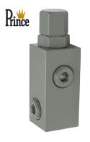

**Productivity ratio = $\frac{Outputs}{Inputs}$**

**Punch list:** A list of defects that should be repaired by the contractor.

**Putty:** A dough like cement made by mixing whiting and linseed oil, used to fill holes in woodwork and secure panes of glass.

**Quick condition:** A soil condition in which water flows upward with sufficient velocity to reduce significantly the bearing capacity of the soil through a decrease in inter granular pressure.

**Quick sand:** A bed of loose sand mixed with water forming a soft shifting mass that yields easily to pressure and tends to engulf any object resting on its surface.

**R value:** A measure of material resistance to the passage of heat.

**Riprap:** A loose assemblage of broken stones erected in water or on soft ground as a foundation. The broken stones used for such a foundation.

**RPZ valve:** A **Reduced Pressure Zone Device** is a type of [backflow prevention device](http://en.wikipedia.org/wiki/Backflow_prevention_device) used to protect [water](http://en.wikipedia.org/wiki/Water) supplies from contamination.

An RPZD is considered suitable for high hazard applications, that is, where the consequence of backflow into the [water supply](http://en.wikipedia.org/wiki/Water_supply) would cause significant harm.

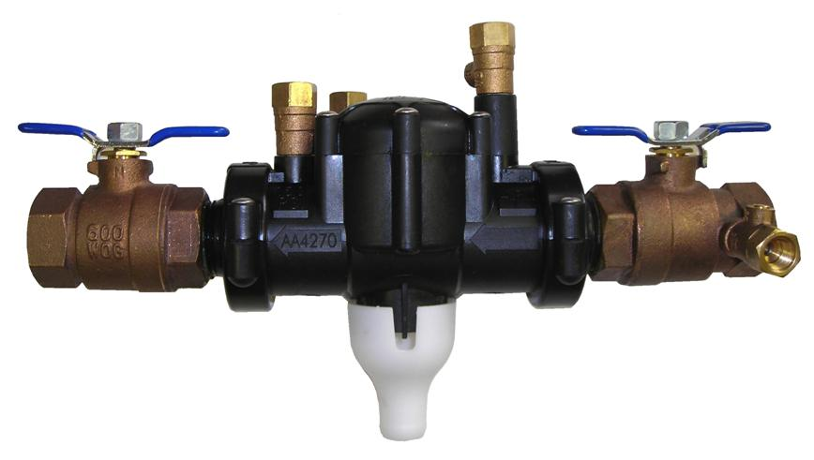

**Salamander:** A portable stove used to heat or dry buildings under construction.

**Scarifier:** An implement or machine with downward projecting tines for breaking down a road surface 2 feet or less.

**SEWER**

**Sanitary sewer:** A sewer which carries sewage (liquid or waterborne waste from plumbing fixtures) and to which storm and surface water, street runoff, and groundwater are not admitted intentionally.

**Storm sewer:** A drain used for conveying rain-water, subsurface water, condensate, cooling water, or other similar discharges, but not sewage or industrial waste, to a point of disposal.   
  
 **Combined sewer:** A drainage system that receives both surface runoff and sewage.

**Invert level:** The level of the lowest portion at any given section of a liquid- carrying conduit, such as a drain or a sewer, and which determines the hydraulic gradient available for moving the contained liquid.

**Shim:** In [engineering](http://www.answers.com/topic/engineering), a **shim** is a thin and often [tapered](http://www.answers.com/topic/taper) or [wedged](http://www.answers.com/topic/wedge-4) piece of material, used to fill small gaps or spaces between objects. Shims are typically used in order to support, adjust for better fit, or provide a level surface. Shims may also be used as [spacers](http://www.answers.com/topic/spacer) to fill gaps between parts subject to wear.

**Single strength glass:** Glass which in the US is approximately 3/32 in. (2.5 mm) thick; compare with **double-strength glass.**

**Site plan:** A [plan](http://www.answers.com/topic/plan) of a construction site showing the position and dimensions of the building to be erected and the dimensions and contours of the lot.

**Soil boring test:** Geologic engineering tests to determine the capability of the soil to support proposed improvements or to determine the strength and properties of a required building foundation. Expansive clay soil or rock outcroppings may affect the required foundation.  
 **Example:** *Soil boring tests* were performed by drilling at proposed locations for foundation piers for an [Office Building](http://www.answers.com/topic/office-building-1) to determine the depth at which bedrock was reached.

**Soil pipe:** A drainpipe that carries off wastes from a plumbing fixture, especially from a toilet.

**Soil stack:** A vertical soil pipe carrying the discharge from toilet fixtures.

|  |
| --- |
| http://content.answers.com/main/content/img/McGrawHill/atchitecture/f0907-01.png |

**Spandrel:** The roughly triangular space between the left or right exterior curve of an arch and the rectangular framework surrounding it.

The space between two arches and a horizontal molding or cornice above them. 

**Spandrel beam:** In concrete or steel construction, an exterior beam extending from column to column usually carrying an exterior wall load.

**Span of control:** Refers to individuals reporting to a common supervisor.

**Special warranty:** Most frequently applies to the work of sub-contractor.

**Stakeholder:** A person or group that a project needs or that will be affected by the project.

**Stockpile:** A supply stored for future use, usually carefully accrued and maintained.

**Sump:** As part of a drainage system, a pit in the basement to collect excess moisture and liquids. To avoid flooding, a *sump* pump may be installed to remove accumulated water in the sump pit.

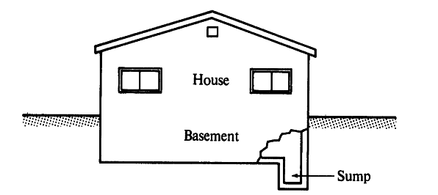

**Surge tank:** A standpipe or storage reservoir at the downstream end of a closed aqueduct or feeder pipe, as for a water wheel, to absorb sudden rises of pressure and to furnish water quickly during a drop in pressure. Also known as surge drum.

**Tactile finish:** Are generally applied to operating hardware in order to provide warnings to the handicapped.

**Tempered glass:** Glass that has been prestressed by heating followed by sudden quenching to give it two to four times the strength of ordinary glass. Also known as toughened glass.

**Toe board:** A board placed around a platform or on a sloping roof to prevent personnel or materials from falling off.

**Thermocouple:** A thermoelectric device used to measure temperatures accurately, especially one consisting of two dissimilar metals joined so that a potential difference generated between the points of contact is a measure of the temperature difference between the points.

**Transfer column:** A column in a multistory framed building that is not continuous down to the foundation, but is supported at some intermediate level where the load is transferred to adjacent columns.

**Transformer:** Device that transfers electric energy from one [alternating-current](http://www.answers.com/topic/alternating-current) [circuit](http://www.answers.com/topic/circuit) to one or more other circuits, either increasing (stepping up) or reducing (stepping down) the voltage. Uses for transformers include reducing the line voltage to operate low-voltage devices (doorbells or toy electric trains) and raising the voltage from electric [generators](http://www.answers.com/topic/generator) so that electric power can be transmitted over long distances. Transformers act through [electromagnetic induction](http://www.answers.com/topic/electromagnetic-induction); current in the primary coil induces current in the secondary coil. The secondary voltage is calculated by multiplying the primary voltage by the ratio of the number of turns in the secondary coil to that in the primary.

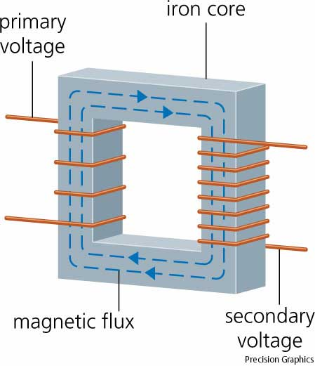

**Transition curve/Easement curve:** A curve, as on a highway, whose degree of curvature is varied to provide a gradual transition between a tangent and a simple curve, or between two simple curves which it connects. Also known as transition curve.

**True mode:** Point of greatest concentration in the distribution.

**Turnkey project:** A development in which a [Developer](http://www.answers.com/topic/developer) completes the entire project on behalf of a buyer; the developer turns over the keys to the buyer at completion.

**Example:** Many government-owned public housing projects are *turnkey projects. A* private developer undertakes all activities necessary to producing the project, including land purchases, Permits plans, and construction, and sells the project to the housing authority.

**Underwriters Laboratories:** UL does not “approve” products. Rather it evaluates products, components, materials and systems for compliance to specific requirements, and permits acceptable products to carry a UL certification mark, as long as they remain compliant with the standards. UL offers several categories of certification. Products under its listing service are said to be “UL Listed,” identified by the distinctive UL mark. In some cases, a component may be “UL Recognized,” meaning UL has found it acceptable for use in a complete UL Listed product. Other products may be “UL Classified” for specific hazards or properties. UL maintains a directory of more than 3 million products through a publicly available, online database.

**Unit assembly:** An organizational arrangement whereby different employees perform different work steps upon the same work item at the same time.

**Urethane coating:** It affords a high degree of protection

**Urethane panels:** Insulating material which has the greatest resistance to heat flow per inch of thickness.

**VENDEX:** By law, vendors under consideration for award of contracts must have complete VENDEX Questionnaires for their organization and principals on file. The completed questionnaires assist City agencies in reaching a responsibility determination.

**Vacuum breaker:** A device used to relieve a vacuum formed in a water supply line to prevent backflow. Also known as backflow preventer.

|  |
| --- |
| f1035-01 |

**Value engineering**

**Value engineering** (**VE**) is a systematic method to improve the "value" of goods or products and services by using an examination of function. Value, as defined, is the ratio of function to [cost](http://en.wikipedia.org/wiki/Cost). Value can therefore be increased by either improving the function or reducing the [cost](http://en.wikipedia.org/wiki/Cost). It is a primary tenet of value engineering that basic functions be preserved and not be reduced as a consequence of pursuing value improvements.

**Vapor barrier:** A layer of material applied to the inner (warm) surface of a concrete wall or floor to prevent absorption and condensation of moisture.

**Wainscot:**

[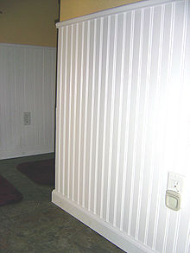](http://en.wikipedia.org/wiki/Image:Wainscotting.jpg)

**Panelling** is a [wall](http://www.answers.com/topic/wall) covering constructed from rigid or semi-rigid components. These are traditionally interlocking [wood](http://www.answers.com/topic/wood), but could be [plastic](http://www.answers.com/topic/plastic) or other materials. Panelling was developed in antiquity to make rooms in [stone](http://www.answers.com/topic/rock) buildings more comfortable. The panels served to [insulate](http://www.answers.com/topic/thermal-insulation) the room from the cold stone. In more modern [buildings](http://www.answers.com/topic/building), such panelling is often installed for [decorative purposes](http://www.answers.com/topic/interior-design-2).

**Warranty:** In construction contract law, the promise that certain facts are true as represented and they will remain so.

**Water hammer:** **1.** In water lines, a loud thumping noise that results from a sudden stoppage of the flow.   
**2.** In steam lines, water of condensation that is picked up and carried through the steam main at high velocity; when direction of the flow changes, the water particles hit the pipe walls, emitting a banging noise.

**Well point:** A hollow rod with a perforated intake at its lower end, which is pointed; driven into the ground and connected to a pump, to remove water at an excavation site.

**Wire glass:** Sheet glass containing wire mesh embedded between the two faces to prevent shattering in the event of breakage.

**Y-type fitting:** A pipe fitting with one end subdivided to form two openings, usually at a 45° angle to the run of the pipe. Also known as wye fitting.

[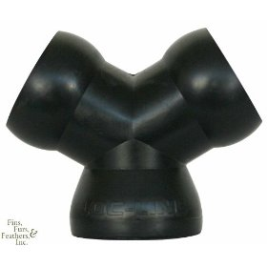](http://www.amazon.com/gp/product/images/B001EHHXK8/ref=dp_image_0?ie=UTF8&n=284507&s=kitchen)

**Zenith :** In broad terms, the **zenith** is the direction pointing directly *above* a particular location ([perpendicular](http://www.answers.com/topic/perpendicular), [orthogonal](http://www.answers.com/topic/orthogonality)). Since the concept of *being above* is itself somewhat vague, scientists define the zenith in more rigorous terms. Specifically, in [astronomy](http://www.answers.com/topic/astronomy), [geophysics](http://www.answers.com/topic/geophysics) and related sciences (e.g., [meteorology](http://www.answers.com/topic/meteorology)), the zenith at a given point is the local [vertical direction](http://www.answers.com/topic/vertical-direction) pointing away from direction of the force of [gravity](http://www.answers.com/topic/gravity) at that location.

[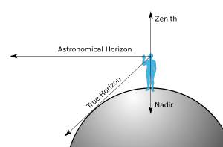](http://en.wikipedia.org/wiki/Image:Zenith-Nadir-Horizon.svg)

**PREPARING WRITTEN MATERIAL**

**Sample:**

Martin Wilson failed to take proper precautions. His failure to take proper precautions caused a personal injury accident.

Which one of the following best presents the information above?

A. Martin Wilson failed to take proper precautions that caused a personal injury accident.

B. Proper precautions, which Martin Wilson failed to take, caused a personal injury accident.

C. Martin Wilson‘s failure to take proper precautions caused a personal injury accident.

D. Martin Wilson, who failed to take proper precautions, was in a personal injury accident.

**Solution:**

**Choice A** conveys the incorrect impression that proper precautions caused a personal injury accident.

**Choice B** conveys the incorrect impression that proper precautions caused a personal injury accident.

**Choice C** best presents the original information: Martin Wilson failed to take proper precautions and this failure caused a personal injury accident.

**Choice D** states that Martin Wilson was in a personal injury accident. The original information states that Martin Wilson caused a personal injury accident, but it does not state that Martin Wilson was in a personal injury accident.

The best answer to this sample question is C.

**PRACTICE QUESTION**

Senator Martinez met with the county legislature. Then Senator Martinez announced that the meal subsidy program would start in June.

Which one of the following best presents the information given above?

A. After meeting with the county legislature, Senator Martinez announced that the meal subsidy program would start in June.

B. Senator Martinez met with the county legislature and announced that the meal subsidy program would start in June.

C. Senator Martinez announced that the meal subsidy program would start in June after a meeting with the county legislature.

D. Senator Martinez, who met with the county legislature, announced that the meal subsidy program would start in June.

The best answer to this is A.

**PRACTICE QUESTION**

Frank Colombe wrote the press release. He sent three copies to the Director. The Director then gave one of the copies to the Commissioner.

Which one of the following best presents the information given above?

A. Frank Colombe sent to the Director three copies of the press release he had written, who then gave a copy to the Commissioner.

B. Frank Colombe sent three copies of the press release he had written to the Director, who then gave one of the copies to the Commissioner.

C. The Director gave the Commissioner one of the three copies of the press release Frank Colombe had written and had been sent to him.

D. Of the three copies of the press release Frank Colombe had written and sent to the Director, one was then given to the Commissioner by him.

The best answer to this is B.

**PARAGRAPH ORGANIZATION**

**Sample:**

The following question is based upon a group of sentences. The sentences are shown out of sequence, but when correctly arranged, they form a connected, well-organized paragraph. Read the sentences, and then answer the question about the best arrangement of these sentences.

1. Eventually, they piece all of this information together and make a choice.

2. Before actually deciding upon a human services job, people usually think about several possibilities.

3. They imagine themselves in different situations, and in so doing, they probably think about their interests, goals, and abilities.

4. Choosing among occupations in the field of human services is an important decision to make.

Which one of the following is the best arrangement of these sentences?

A. 2-4-1-3

B. 2-3-4-1

C. 4-2-1-3

D. 4-2-3-1

The best answer to this sample question is D.

**Solution:**

**Choices A and C** present the information in the paragraph out of logical sequence. In both **A** and **C**, sentence 1 comes before sentence 3. The key element in the organization of this paragraph is that sentence 3 contains the information to which sentence 1 refers; therefore, in logical sequence, sentence 3 should come before sentence 1.

**Choice B** also presents the information in the paragraph out of logical sequence. Choice Bplaces sentence 4 in between sentence 1 and sentence 3, thereby interrupting the logical sequence of the information in the paragraph.

**Choice D** presents the information in the paragraph in the best logical sequence. Sentence 4 introduces the main idea of the paragraph: “choosing an occupation in the field of human services.” Sentences 2-3-1 then follow up on this idea by describing, in order, the steps involved in making such a choice. Choice **D** is the best answer to this sample question.

**PRACTICE QUESTION**

1. The phosphates in detergents are carried into sewage systems, and from there into local rivers and streams, and eventually into large bodies of water.

2. The algae absorb much of the available oxygen that is necessary to sustain marine life.

3. There is no doubt that phosphates damage the environment through a complex chain of events.

4. Phosphates are nutrients, and, as such, they aid the growth of the algae living in the water.

5. This results not only in the death of fish and other aquatic life, but also in the too-thick growth of vegetation in the water.

Which one of the following is the best arrangement of these sentences?

A. 1-3-4-2-5

B. 1-4-2-5-3

C. 3-1-4-2-5

D. 3-4-2-1-5

The best answer to this is C.

**PRACTICE QUESTION**

1. Never before has time been measured at a speed beyond the realm of experience.

2. Just how profound an effect it is having on society is as yet to be determined.

3. The computer has accelerated our sense of time beyond anything we have experienced before.

4. Though it is possible to conceive of an interval that brief and even to manipulate time at that speed, it is not possible to experience it.

5. It works in a time frame in which the nanosecond—a billionth of a second—is the primary measurement.

Which one of the following is the best arrangement of these sentences?

A. 1-2-3-5-4

B. 1-4-3-5-2

C. 3-2-5-4-1

D. 3-5-4-1-2

The best answer to this is D.

**ENSURING EFFECTIVE INTER/INTRA AGENCY COMMUNICATIONS**

**Sample:**

A staff member comes to your office, expressing anger about a decision you recently made. Which one of the following should be your **first** response to this staff member?

A. Interrupt to say you cannot discuss the situation until the staff member calms down.

B. Say you are sorry that your decision has negatively affected the staff member.

C. Listen and express understanding that your decision upset the staff member.

D. Explain the reasons for your decision to the staff member.

**Solution:**

**Choice A** is not correct. It would be inappropriate to interrupt the staff member. In addition, saying that you cannot discuss the situation until the staff member calms down will likely aggravate the staff member further.

**Choice B** is not correct. Acknowledging that your decision has negatively affected the staff member weakens your position and your decision.

**Choice C** is the correct answer to this question. By listening and expressing understanding that your decision upset the staff member, you demonstrate that you have heard and understand the staff member’s feelings and point of view.

**Choice D** is not correct. While an explanation of the reasons for your decision may be appropriate at a later time, at this moment, the staff member is angry and would not be receptive to such an explanation.

The correct answer to this sample question is C.

**UNDERSTANDING AND INTERPRETING WRITTEN MATERIAL**

**Sample:**

“Increasingly, behavior termed ‘road rage‘ is being viewed as a public health issue, because of the number of deaths and injuries related to it. Such behavior is often a reaction to the feeling that one has been treated unfairly by another driver, and it is much less likely to occur if a driver is treated fairly. ‘Fair play‘ on the road includes the observance not only of traffic regulations but also of the rules of courtesy. Courteous driving is based on common sense consideration for other drivers and a strong desire to make the roads safe for everyone. Good highway manners should become just as much a matter of habit as other kinds of manners.”

Which one of the following statements is best supported by the above selection?

A. Courteous driving contributes to road safety.

B. Those who are generally polite are also courteous drivers.

C. Unlike driving courtesy, the observance of traffic regulations is a matter of habit.

D. Being courteous when driving is more important than observing traffic regulations.

**Solution:**

To answer this question correctly, you must evaluate each choice against the written selection and determine the one that is best supported by the written selection.

**Choice A** states, “Courteous driving contributes to road safety.” Choice A is supported by the statement in the written selection that, “Courteous driving is based on…a strong desire to make the roads safe for everyone.” This is the correct answer.

**Choice B** states, “Those who are generally polite are also courteous drivers.” Choice B is not supported by the written selection. The written selection does not mention “those who are generally polite” at all. Choice B is not the correct answer to this question.

**Choice C** states, “Unlike driving courtesy, the observance of traffic regulations is a matter of habit.” Choice C is not supported by the written selection. The written selection makes no such bold statement. Instead, the written material mildly suggests that “Good highway manners should become just as much a matter of habit as other kinds of manners.” Choice C is not the correct answer to this question.

**Choice D** states, “Being courteous when driving is more important than observing traffic regulations.” Choice D is not supported by the written selection. The written selection states, “'Fair play' on the road includes the observance not only of traffic regulations but also of the rules of courtesy.” The written selection does not state that being courteous is more important than observing traffic regulations. Choice D is not the correct answer to this question.

The correct answer to this sample question is A.

**PRACTICE QUESTION**

“The increasing demands upon our highways from a growing population and the development of forms of transportation not anticipated when the highways were first built have brought about congestion, confusion, and conflict, until the yearly toll of traffic accidents is now at an appalling level. If the death and disaster that traffic accidents bring throughout the year were concentrated into one calamity, we would shudder at the tremendous catastrophe. The loss is no less catastrophic because it is spread out over time and space.”

Which one of the following statements concerning the yearly toll of traffic accidents is best supported by the passage above?

A. It is increasing the demands for safer means of transportation.

B. It has resulted in increased congestion, confusion, and conflict on our highways.

C. It has resulted mainly from the new forms of transportation.

D. It does not shock us as much as it should because the accidents do not all occur at the same time.

The correct answer is D.

**PRACTICE QUESTION**

"Depression is one of the top public health problems in the United States, and its occurrence is on the rise. One in 20 Americans develops a case of depression serious enough to require professional treatment. The incidence of depression has been escalating among Baby Boomers (Americans born in the years 1946 through 1964). The reason for this increase is that the lifestyles of this generation have become increasingly demanding while offering little support. Also, stress and poor eating habits are now more the rule than the exception, and both can disrupt brain chemistry enough to bring on depression."

Which one of the following statements is best supported by the above selection?

A. We can expect a small proportion of the population to require treatment for depression at some time in their lives.

B. Baby Boomers have the highest rate of depression in the United States.

C. Lifestyle demands are the major cause of depression in the current generation.

D. Depression can cause a disruption in the chemistry of the brain.

The correct answer is A.

**SUPERVISION**

**Sample question:**

Assume that the unit you supervise is given a new work assignment and that you are unsure about the proper procedure to use in performing this assignment. Which one of the following actions should you take **first** in this situation?

A. Obtain input from your staff.

B. Consult other unit supervisors who have had similar assignments.

C. Use an appropriate procedure from a similar assignment that you are familiar with.

D. Discuss the matter with your supervisor.

The correct answer to this sample question is D.

**Solution:**

This question asks for the action that you should take **first** in this situation.

**Choice A** is not correct. Since this assignment is new for your unit, your staff would not be expected to be more knowledgeable than you about the proper procedure.

**Choice B** is not correct. Although discussing this matter with other supervisors may increase your knowledge of the new assignment, similar assignments performed in other units may differ in some important way from your new assignment. Other units may also function differently from your unit, so the procedures used to perform similar assignments may differ accordingly.

**Choice C** is not correct. Since this assignment is new for your unit, you would have no way of knowing whether the procedure from a similar assignment is appropriate to use. You would need someone with the appropriate knowledge, usually your supervisor, to determine if the procedure from a similar assignment could be used before you actually employed this procedure in the performance of your new assignment.

**Choice D is the correct answer to this question.** Your supervisor is more likely to be informed about what procedure may be appropriate for work that he or she assigns to you than would other unit supervisors or your staff. Even if your supervisor does not know what procedure is appropriate, a decision regarding which procedure to use should be made with his or her participation, since he or she has the ultimate responsibility for your unit’s work.

**PRACTICE QUESTION**

You have a suspicion that some of your employees are not working to the best of their abilities. Which one of the following actions should you take first in this situation?

A. Arrange for these employees to take a course in organizing priorities.

B. Determine which employee is the worst offender.

C. Assess the assignments and work methods of these employees.

D. Set up a meeting with these employees to learn about any work problems they are having.

The correct answer is C.

**PRACTICE QUESTION**

As you are giving an employee a certain assignment, she expresses concern that it is too difficult. The employee is reluctant to accept the assignment. Which one of the following actions should you take first in this situation?

A. Insist that the employee take on the assignment.

B. Tell the employee that it is likely she has completed assignments of similar difficulty before.

C. Offer to share the tasks of the assignment with the employee.

D. Ask the employee why she sees the assignment as difficult.

The correct answer is D.

**ADMINISTRATIVE TECHNIQUES AND PRACTICES**

**Sample:**

A training program in your agency has received a number of negative evaluations from the participants. You have been asked to determine whether changes should be made to the training program in response to these evaluations. Which one of the following actions should you take FIRST in making this determination?

A. Review the training methods.

B. Review the content of the training materials.

C. Review the goals of the training program.

D. Review the evaluations with the training instructor.

**Solution:**

This question asks for the action that you should take FIRST in determining whether changes should be made to the training program.

**Choice A** is not correct. Although reviewing the training methods may result in changes to the program, you cannot evaluate the methods unless you have a context against which these materials can be evaluated. You must first become familiar with the training goals before you can evaluate the training methods.

**Choice B** is not correct. Although reviewing the content of the training materials may result in changes to the program, you must first know what the goals of the training program are before you can evaluate the appropriateness of the training content.

**Choice C is the correct answer to this question.** The most important consideration in determining whether changes should be made to the training program is determining whether the program met its training goals. You must first become familiar with those goals before you can make this determination.

**Choice D** is not correct. Although you may eventually review the evaluations with the training instructor, you must first become familiar with the goals of the training to provide a context against which you can discuss the content of the participant evaluations.

The correct answer to this sample question is C.

**ADMINISTRATIVE SUPERVISION**

**Sample:**

In a hallway, you observe two employees strongly arguing about which one of them is responsible for a set of tasks in a collaborative work project that you have delegated to two unit supervisors in your section. The arguing employees work for different units. Which one of the following actions is most appropriate for you to take in this situation?

A. Intercede in the employees’ argument and settle it.

B. Meet with the unit supervisors of the two employees and inform them of the situation you observed.

C. Inform one unit supervisor of the situation and ask this supervisor to take care of it.

D. Set up a meeting that includes both unit supervisors and both employees to resolve the situation.

The correct answer to this sample question is B.

**Solution:**

**Choice A** is not correct. It is not reasonable that you would be able to settle the employees’ dispute. Earlier you delegated the work project to two unit supervisors, who would normally be responsible for assigning tasks related to the project. The two unit supervisors must be consulted.

**Choice B is the correct answer to this question.** The two unit supervisors are collaborating on the work project and therefore giving the assignments. You should meet with them and tell them about the employees’ argument and the work tasks they discussed. Along with learning the point of contention, it is useful for the unit supervisors to learn that two employees had a heated argument. The unit supervisors can work out a way to handle the situation.

**Choice C** is not correct. Speaking to only one supervisor about the situation leaves the second supervisor uninformed of the situation. You cannot be assured that the first supervisor will even include the second supervisor in finding a way to settle the issue. In taking this action, you are favoring one supervisor and slighting the other.

**Choice D** is not correct. The unit supervisors need to come up with a way of handling the situation that you observed. To do this, they must be informed without the employees present. Also, by including the employees in the meeting, you may get a replay of the hallway argument, which is not helpful.

**SAMPLE QUESTION:**

You have delegated a work project to two unit supervisors and have asked them to collaborate on it. Later, you observe two employees strongly arguing about which one of them is responsible for a certain activity within the work project. The arguing employees work for different units. Which one of the following actions is most appropriate for you to take in this situation?

A. Intercede in the employees’ argument and settle it.

B. Meet with the unit supervisors of the two employees and inform them of the situation you observed.

C. Inform one unit supervisor of the situation and ask this supervisor to take care of it.

D. Set up a meeting that includes both unit supervisors and both employees to resolve the situation.

The correct answer to this sample question is choice B.

**SOLUTION:**

**Choice A** is not correct. In your position, you supervise properly by giving direction through your unit supervisors. By taking this choice, you are not allowing your unit supervisors to handle a problem involving their staff members. Also, it is not reasonable that you would be able to settle the employees’ dispute. Earlier, you delegated the work project to the two unit supervisors, who would be responsible for assigning activities related to the project. The two unit supervisors must deal with the problem.

**Choice B** is the correct answer to this question. The two unit supervisors are collaborating on the work project and therefore giving the assignments. You should meet with them and tell them about the employees’ argument. The unit supervisors should be informed about the point of contention and the fact that the two employees had a heated argument. The unit supervisors must then work out a way to handle the situation.

**Choice C** is not correct. Speaking to only one supervisor about the situation means that the second supervisor may be uninformed, or only partly informed, about the situation. You cannot be assured that the first supervisor will include the second supervisor in finding a way to settle the issue. If the first unit supervisor chooses to handle the situation on his own and speak to both employees, this supervisor would be giving direction to one employee from another unit. This is not good supervisory practice. Also, in taking Choice C, you are favoring one supervisor and slighting the other.

**Choice D** is not correct. The unit supervisors need to come up with a way of handling the situation that you observed. To do this, they must be informed without the employees present. Also, by including the employees in the meeting, you may get a replay of their earlier argument, which is not helpful.

**PRACTICE QUESTION**

Assume that you are the head of a section made up of four units, each of which is responsible for similar work. The work volume of one of the units of the section has permanently decreased to the point that the supervisor of that unit now is responsible for much less work than any of the other three unit supervisors. Of the following, which determination should you as the section head make first in this situation? \

A. Can other or additional tasks be assigned to this unit?

B. Can the unit supervisor function as assistant section head?

C. Can the unit supervisor's position be reclassified or reallocated?

D. Can the section be reorganized into three units?

The correct answer is A.

**PRACTICE QUESTION**

In which one of the following circumstances should you try to reduce turnover in the section you supervise?

A. The turnover is higher than that of other sections.

B. The turnover reduces the number of highly experienced employees.

C. The turnover lowers the efficiency of the section.

D. The turnover requires unit supervisors to spend a moderate amount of time in training new employees.

The correct answer is C.